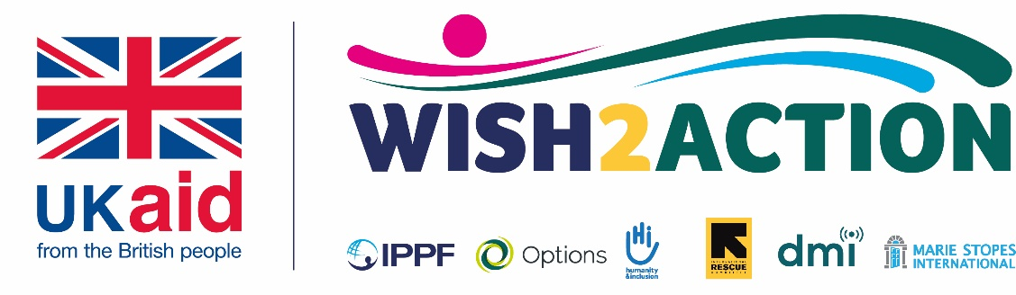

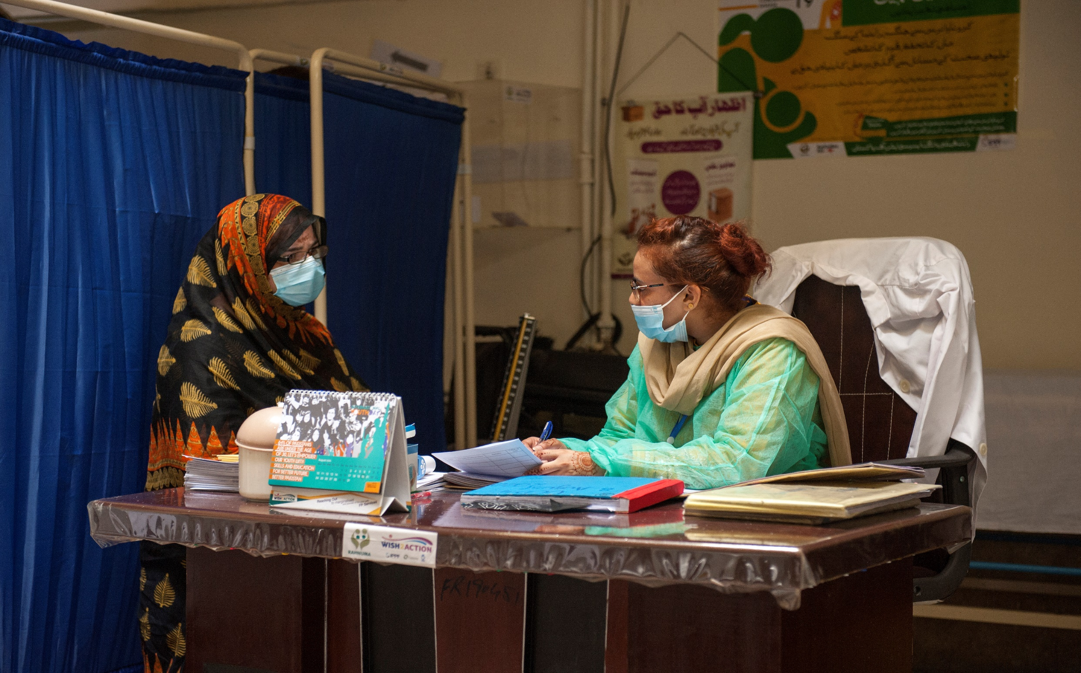
Reaching Youth with Sexual Reproductive Health and Rights (SRHR) Services: A Case Study from Pakistan/ WISH Programme

Samia Khatun, Head of Region, IPPF, WISH Programme

Reaching Youth with Sexual Reproductive Health and Rights (SRHR) Services: A Case Study from Pakistan/ WISH Programme

Pakistan with its estimated population of 225 million has a sizeable youth population. According to the UNDP Human Development Report an estimated 64 percent of the nation is under the age of 30 years while 29 percent are between the ages of 15 and 29. Pakistan now has more young people than it has in its history, and this is expected to continue to increase until at least 2050.

In light of these trends, it is important that Pakistan has policies in place that can effectively respond to the needs of its youth. Government policies are increasingly considering youth but there are some areas, such as SRHR where policies remain virtually non-existent. Sexual reproductive health of young people continues to be a taboo due to existing and widely entrenched cultural, social, and religious belief that young people, particularly unmarried young people, have no need for SRHR and family planning (FP) information and services.

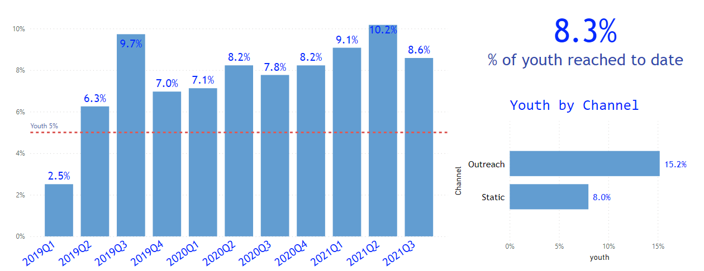
Paradoxically, young people not only need access to comprehensive SRHR information but also services that cater to their needs. Through the women’s integrated sexual health programme (WISH) programme, IPPF’s member association Rahnuma Family Planning Association of Pakistan (R-FPAP) has implemented different approaches to reach young people with SRHR information and services. Through these approaches, the programme was able to reach 8.3% of youth (of the total clients served) between Jan 2019 and Aug 2021, increasing from 2.5% in the first quarter of the programme to 10.2% in the second to last quarter (+7.7%) as seen in the figure below.

Further, there was a 203% increase in total SRHR services including FP provided to youth under 20 between 2018 (pre-WISH) and 2021 (up to September) the final year of W2A programming (2,158,094 in 2018 vs 4,378,916 in 2021).

Some of these interventions adopted are outlined below:

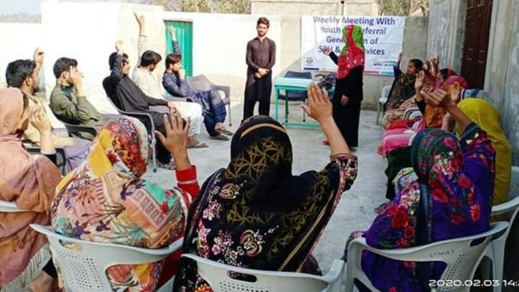
Meeting with youth members
Establishment of 20 Youth Resource centres (two in each of the ten WISH programme implementation areas). Group sensitization sessions take place at the youth resource centres weekly. These are delivered through Youth Peer Ambassadors and were continued in the COVID-19 period although the group sizes were smaller, in line with administrative government standard operating procedures (SOPs). There has been an increase in the activities conducted at the youth resource centre through the Youth Peer Ambassadors and the Youth Champions/Volunteers. A total of 1,366 sessions were conducted in the youth resources centres throughout the programme intervention period Jan 2019-Aug 2021.

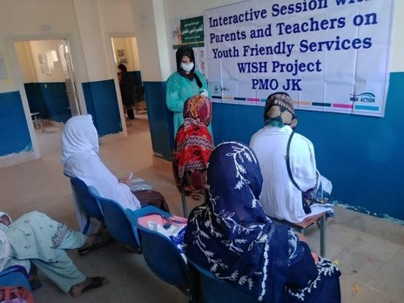
Since the beginning of the programme, weekly community awareness sessions have been conducted with men and boys, and community gatekeepers such as community leaders, parents, and teachers, who are highly influential. The sessions commonly known as Baithaks, are led by Youth Champions/Volunteers, Youth Peer Ambassadors, Social Organisers and Field Supervisors. Field activities were restricted during the COVID-19 pandemic, however, sessions continued with COVID-19 SOPs being observed. The resumption of field activities included individual and smaller group meetings/ sessions. Over 5,000 sessions were conducted in the community during programme life. These sessions are expected to have led to increased community acceptance of FP/SRH and to an increase in the number of clients accessing static clinics and an increase in the number of calls received on the helpline. The community sessions were particularly effective in reaching out of school youth and youth living in rural and poorer areas. The programme also introduced youth community theatre as an interactive approach to supplement the community dialogues.
Meeting with teachers and parents

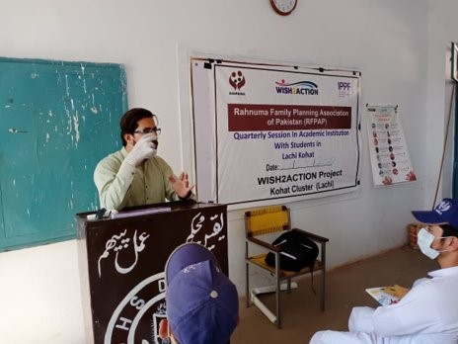
R-FPAP through its Youth Peer Ambassadors delivered Life Skill Based Education sessions at academic institutions to create awareness on SRHR and link students to Youth Friendly Services. A total of 152 sessions were conducted at academic institutions throughout the programme. During the COVID-19 period when academic institutions were closed, R-FPAP conducted sessions with young people at private tuition centres which remained open in line with the appropriate social distancing protocols. During the COVID-19 pandemic youth were mostly found in their houses/ home therefore an approach of gathering youth through Youth Peer Educators who are based in the communities was used to continue to reach youth during the pandemic.
Meetings at academic institutions

Satisfied clients of R-FPAP service also helped with referrals and meetings were regularly held with a core group of satisfied clients to support them to develop skills in using their personal experiences to encourage others in the community to seek services. R-FPAP supported the Population Welfare Department to implement its national media awareness campaign Balance for Better, this enabled R-FPAP to engage youth and communities through mass media (TV, Radio, and print) and social media including the R-FPAP Facebook, Twitter, Instagram, and LinkedIn sites. R-FPAP launched two campaigns (one in July and one in Aug 2021) to air FP/SRHR messages in collaboration with nine radio stations (reaching an estimated 1.5 million listeners) and five TV stations, organised two TV talk shows and published two articles in Pakistan’s most prominent newspaper.

Additionally, the programme sought to reach young people through a digital campaign platform, a pilot intervention in collaboration with Viamo which involved the development of audio drama content for mobile phones. This was then disseminated over a 4-week period, covering themes identified during the baseline study such as addressing harmful myths and misconceptions on SRH/FP usage, underage pregnancies, gender norms associated with contraceptive use in a highly religious culture, couples’ decision making and child spacing. The digital campaign included signposting to the R-FPAP youth helpline for counselling and referral for services. Analysis of the data shows the average number of calls received through the helpline in the three months (Apr-Jun) preceding the digital campaign was 1,076 calls per month compared to 1,314 calls per month in the two campaign intervention months and the month directly after the campaign (Jul-Sep) demonstrating a 22% increase in number of calls to the Youth Helpline (YHL). While a significant difference in attitudes from the baseline and end line study was not observed nor a significant difference in the projects key performance indicators as measured by Couple Years Protection (CYPs) generation, FP items distributed or SRHR services provided, the end line survey indicates a small shift in attitudes among young people between these two periods. For example, following the mobile campaign, slightly more respondents under 25 were likely to agree that a couple should wait until the youngest child is two years before the next pregnancy. Likewise, an increasing proportion of under 25s were likely to agree that they were open to using contraception in the future.

The programme also disseminated IEC (Information Education Communication) materials such as posters on gender-based violence, youth friendly service provision, brochures on menstruation, HIV/AIDs, youth rights, child marriage as well as guidelines on implant insertion and a peer educator toolkit.

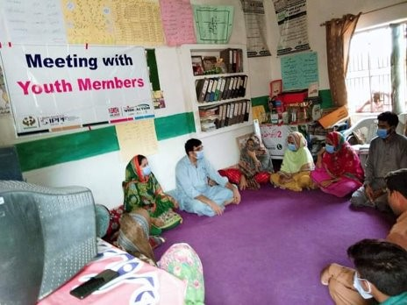
The above were important approaches for changing the narrative and providing SRHR information to young people. However, this does not automatically translate into an uptake in services. To increase service provision, R-FPAP introduced youth outreach days at the youth resource centres these were in addition to the regular outreaches that were conducted. Outreaches are an important channel for reaching youth, and in conducting outreaches at the youth resource centre R-FPAP was effectively bring services much closer to young people in an environment young people deemed as safe and private. Programme data showed that reach of young people was higher at outreaches compared to static facilities (15.2% vs 8.0%).
Meeting with youth members

R-FPAP already had a well-established youth helpline which was promoted further during the COVID-19 period when physical access was restricted. Through W2A funding the youth helpline was upgraded and new elements were introduced on the helpline for example new FP/SRHR messages have been developed to enable callers to access information at any time of the day including out of office hours when youth counsellors are not available, or the call line is busy. R-FPAP has also piloted telemedicine services, young people in some locations are now able to receive contraceptives from a registered practitioner who is able to prescribe drugs as needed (shifting from only tele counselling).

While the programme has reported great achievements and the achievements of the programme should be celebrated, there is still much that needs to be done to further reach young people with SRHR services. Firstly, there is a need to better understand which of the above interventions have been the most successful to enable replication and scale up of the most effective strategy. According to the R-FPAP team the most successful interventions were the engagement of youth led organisations in each cluster, recruitment of the youth peer ambassadors and strengthening the youth resource centres. Further, the non-refusal policy enabling access to free services and well as establishment of the cluster model approach used in the project which increased coordination between key stakeholders is thought to have also contributed to the achievements.

While community attitudes are changing and interpersonal communications are an important approach for community behaviour change, change requires time. Evidence suggests that continuation of key messages over a prolonged period is essential for changing and sustaining new social behaviours which is made difficult through the sporadic nature of programme funding. There are also further improvements needed on the supply side, for example, training of service providers on youth friendly service provision should be introduced more widely and considerations such as allocating specific budget for youth SRHR which can only be achieved through changes in policies should be given. It is through these concerted efforts that we may begin to see a strengthened health system in Pakistan that is able to meet the needs of young people, a group currently underserved by existing systems and policies, who the government cannot afford to leave behind.

https://www.ippf.org/wish
the WISH Cluster Model, is an integrated and comprehensive method of increasing access to sexual and reproductive health (SRH) and FP services for particularly vulnerable people and meeting their needs by delivery of services through a network of coordinated public and private health facilities
Unleashing the potential of a young Pakistan | Human Development Reports (undp.org)

