Dear Member Associations and IPPF Staff,

We are pleased to share with you some updates from the ‘Medical Technical Team’ at the IPPF Secretariat.

- This September we published the Client-Centred Clinical Guidelines (CCCG) for Sexual and Reproductive Healthcare which aim to equip healthcare providers across IPPF with the latest guidance and recommendations for clinical management for sexual and reproductive healthcare. The new guidelines promote a full continuum of care across all stages of the life cycle; not only prevention and treatment of disease, but promotion of healthy and satisfying sexuality and reproduction. The guidelines are currently available in English with Arabic, French and Spanish translations forthcoming by the end of the year. The guidelines were launched at a reception gathering of IMAP and key SRH UK-based partners at the Royal College of Obstetricians and Gynaecologists (RCOG) in London on the 21st of September and were introduced by DG Alvaro Bermejo and WHO HRP Director, Pascale Allotey. The team is planning regional dissemination and will share more information towards the end of the year. An animation video illustrating the guidelines and its key chapters is available here: IPPF's updated Client-Centred Clinical Guidelines (CCCG) - YouTube

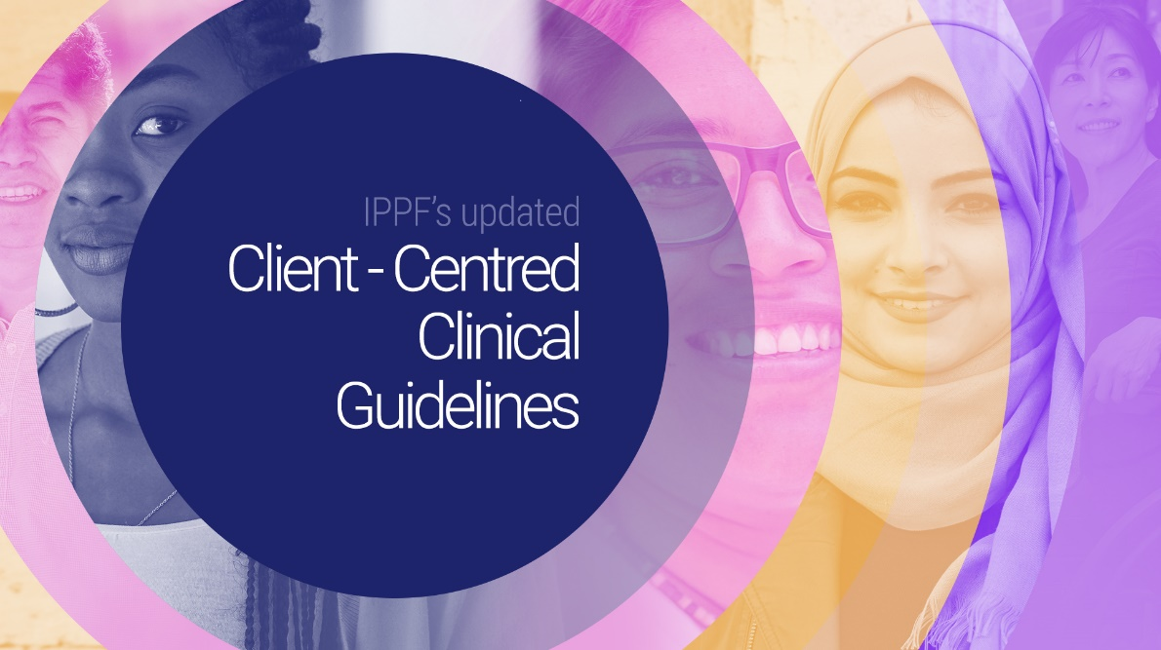

- From 20-22 September, IPPF hosted a face-to-face meeting with the newly appointed International Medical Advisory Panel (IMAP) Co-chaired by Dr Michael T. Mbizvo and Dr Chipo Gwanzura (not in attendance). The panel discussed a variety of issues among which was IPPF’s new strategy, IPPF’s 2021 Annual Performance Review, the utilisation and impact of IMAP statements as described by MAs and thematic discussions with IPPF staff on the priority issues of transgender health, HIV biomedical prevention , monkeypox, fertility care, the global impact of the overturn of Roe vs Wade and medical abortion updates. The meeting concluded with key actions for the panel, including prioritizing new IMAP statements.

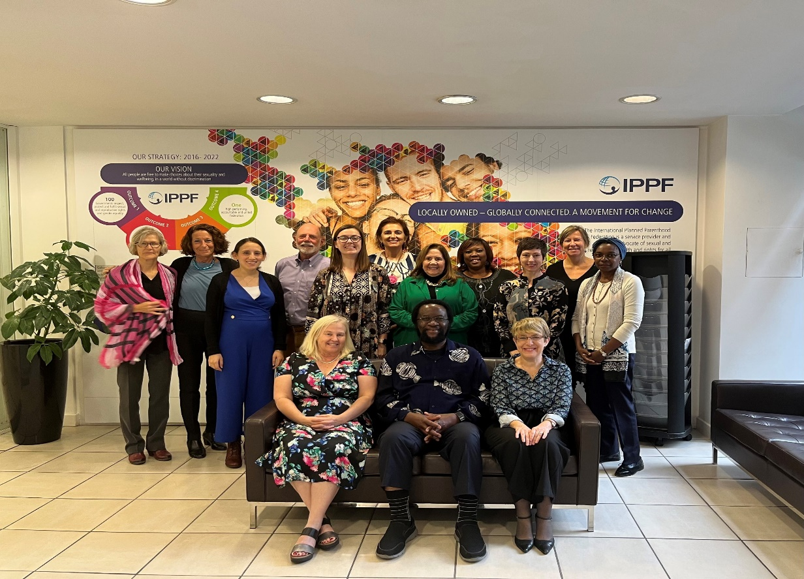

- Earlier this month, a new IMAP statement on Digital Health Interventions (DHI) for SRH was published: https://www.ippf.org/resource/imap-statement-dhi-srhr. The statement outlines IPPF’s approach to person-centred DHI, building on a hybrid model including in-person care, DHI and self-care. The statement presents evidence-informed key attributes for DHIs around safe, quality, accessible person-centered care to fulfil clients’ right to access SRH care when, where, and how they choose to. The statement is published in English, French and Spanish and the Arabic version will be available shortly. In an effort to internally and externally disseminate the statement among MAs and partners, IPPF and Vitala Global are hosting a webinar during the Digital Health Week: https://web.cvent.com/event/14f4900d-dce0-4039-8f2e-0497899ec28d/summary?RefId=Attendees&rt=YmOYAJkBF0yP1Cmr7J68ewbe to share key DHIs adaptations and innovations. This webinar is co-hosted with the MAs that contributed to the statement development: Planned Parenthood Association of Ghana (PPAG), Rahnuma-Family Planning Association of Pakistan (FPAP), Reproductive Health Association of Cambodia (RHAC), Family Planning Association of India (FPAI), Palestinian Family Planning & Protection Association (PFPPA), Profamilia – Colombia. The webinar is scheduled on October 13, 2022, | 1:30 PM- 3:30 PM GMT.To attend the webinar please register to the Digital Health Week events: Digital Health Week 2022

