PPF Charter of Values Americans and Caribbean Regional Meeting Report

Panama City, Panama, 23 September 2023

Introduction
During the Americas and Caribbean Regional Meeting held in Panama City, Panama on 23 September 2023, the Charter of Values and Global Rebrand team ran two consultation meetings on the Charter of Values and Global Rebrand. The meetings were held with:
- Youth representatives from region
- Member Associations representatives (MAs) from all associations in the region
- Staff members at the Americas and Caribbean Regional Office

There were 61 participants from the following countries in the region: Antigua, Argentina, Aruba, Bahamas, Barbados, Bermuda, Bolivia, Brazil, Chile, Colombia, Cuba, Curaçao, Dominica, Ecuador, Grenada, Guadaloupe, Guatemala, Haití, Guyana, Honduras, Jamaica, México, Perú, St Lucía, St Vincent, Suriname, Trinidad and Tobago, USA, Venezuela. This report covers the discussion focused on the Charter of Values; the outcomes of the Rebrand consultation are included in a separate report.

Objectives
The objectives of these consultations with respect to the Charter of Values were to:
  - Gather feedback from MAs and RO staff on the proposed values, to identify which resonated with them and which were not seen as relevant to IPPF.
  - Consult MAs and ROs on the proposed definitions of these core values and integrate any missing concepts and edits.

The input gathered is used to shape the final list of values and their definitions, to ensure that the Draft Charter reflects the perspectives and needs of all across the Federation.

Values so far – what do we feel

For the first exercise, participants were asked to respond to the current list of values to gauge the level of support for the value, as well as for the word being used to describe it. Upon being shown a value, they were asked to gather around a sign with an emoji, depending how they felt about the value. The options and their descriptions given were:
- No way: I really don’t agree with this value and don’t think it should be included.
- I’m confused: I don’t know why this is a value or what it means.
- Ooo YEAH!: This value really resonates with me.
- Disagree: I don’t think this should be a value.
- Love: I really support this value.
- Must include: This value really needs to be one of our core values.
- Meh/Whatever: I do not mind if this value is included or not.
Throughout this discussion, participants struggled with the Spanish translations of “principles” – shared organizational standards or beliefs – and “values” which were individual and personal motivations for action. It was clarified that we were referring to collective beliefs that guide organizational activity. It was also clarified that the values identified for IPPF maybe currently practiced in IPPF or they may be aspirational – those values that we would like IPPF to hold.

Below are the “votes” for each value and participants’ feedback; some quotes translated from Spanish using Google Translate.

Passion
- Majority of participants were in Ooh yeah, must include and love.
- Individuals felt that “passion is a place of action”.
- One participant shared a story of her experience in recruitment, suggesting that when she hired people for skills alone, they left the organization earlier, than when she hired for passion. She concluded “it’s much easier to teach practical skills, computer skills, logframes. You can’t teach passion”
- Another said that “Coming into this organization, some people work here because it’s a paying job, but the people in this room are here because we have a heart for this movement; I came here because it was a job, but over the past week I have come to understand what I’m doing here, and have developed the passion.”
- Participants who voted for love had a range of reasons for doing so: “We have to love what we do, for me it represents passion, love.”
- Another expressed her passion for the issue by saying “I am one of the founding members of my association; I retired 3 years ago but I still work with the same passion. I’m doing this not for the payment or the salary, but because I'm passionate about it.”

Solidarity
- A majority of participants were positive towards this value, split between Oooh yeah, must include and love; these votes were approximately 40 of the participants.
- One participant defined it as: “to do with teamwork; solidarity means teamwork, putting on someone else’s shoes and working toward the same goals; we can’t do anything on our own,” while another recognized that it was already part of IPPF’s new strategy: “One of the pillars of our new strategy is solidarity for change, has to do with building alliances within and outside of the organization, so it’s a value that is already supported by the strategy.”
- Some participants felt that while this value was “essential to IPPF’s survival”, we needed to go further with it; it was seen as “aspirational” not the current reality of IPPF.
- One participant linked the value of solidarity to the way that they show up every day in their roles: “For me, solidarity is a feeling, the empathy that I feel for the issues; when I see a woman that is a survivor of violence, or when I see someone that didn’t have information about contraception and has a lot of children, or when I see a girl pregnant because she wasn’t taught/didn’t receive CSE, I feel solidarity with them, and it makes me feel like I’m working on the right thing. It also has to do with us and our organization; if I have achieved certain goals, solidarity lies in sharing with others, and standing with others who are still trying to achieve those goals.
- A few participants said they were confused, and questioned if this value was being lived in practice.
- Another felt that they could not support the value without knowing how it would be defined. They commented that there was a disconnect between the values, how IPPF operates individually and collectively, and this resulted in a disconnect between what we do and what we say.
- Another “meh” participant reflected that ““My issue is how we define solidarity; what are we talking about? If it means we are all together because there’s a common mandate that we all buy into, I would say “meh”; if it means that we are all working toward the same goals, I would say “disagree”; Yes we have goals on paper, but there may be folks that are not yet bought into the framework.”
- One participant expressed doubts that solidarity is a value at all: “Of course I love solidarity, but as a value it is very complicated, related to philanthropic / political, and has been used by the government as an excuse to not implement policy. I don’t want solidarity, I want responsibility.”

Bravery/Courage
- The participants were very split on this value and many were loosely positive and many were loosely neutral or negative.
- One participant suggested that courage was not the correct word and instead recommended resilience: “It makes more sense to me to talk about resilience
- If you don't have courage, it doesn't mean that you're not going to do things. Maybe it's not your personality to go in front of a protest. Courage is a qualifying adjective that does not define an international group.”
- Echoing this, another participant reflected: “Courage at times is not just being on the front line; I have lots of trouble speaking in front of audiences, but sitting at a table having serious conversations, feeling the burden of responsibility, having the courage to acknowledge that we have to change is courageous. Doesn’t have to be on the frontline, it’s about holding those feelings, feeling your stomach crunching and knowing you have to act because it’s the right thing to do – that’s courage.”
- Another participant felt that the translation of courage as “audacia” wasn’t correct and suggested another adjective be found.
- A small group felt that for this to be relevant it needs to be explicitly linked to feminist values and gender transformation.
- Those that disagreed with this being a value did so on the basis that they may not have the support to be brave currently: “When you speak about bravery and courage; I think about “okay, I’m going back home, am I going to be brave enough to stand up for my team. I go back and I have face my government, and the board, and the team; just in our individual MAs, I don’t feel like I have support on the day-to-day. Are we brave/courageous enough to stand up and fight laws and policy?” Following this, there was agreement that we should be brave enough to do this.
- Another suggested that the challenge with agreeing or disagreeing with the value was that it is not a value, “it's something you can have or put in your strategic approach, but it is not a value” and wanted more detail on what is means in practice.
- Similarly, 8 participants responded to this value as “meh” and several shared the concern about a lack of clarity on what it means on the ground. One suggested that “it would make more sense to think about resilience, tolerance, things that are more relevant to our day-to-day work. What do we call someone brave? An activist, movement, etc. If our role is standing at a desk, this adjective might not define our roles at an international organization with many different types of roles.”
- Another asked for the more practical sides of these values to be brought out: “I try to look for the practical side on our daily work; example: when we speak about supporting sex workers for them to fight for their rights, this was the first stage in addressing this issue. And I drafted an idea as to how my institution would be welcome or not in that fight, and I thought: am I belonging to an institution fighting for the SRHR for all peoples; I know I’ll be entering into some hot spots, but to me that’s bravery, that’s strength, we need to be bold enough to find our own roles, and avoid risk or peril in our pursuit of success – i think that’s still bold.”
- A few participants did not support this value at all, mostly because it was seen as strategic – they suggested that “brave people do stupid things” and that it eliminates a lot of the planning for success. They also called for it to be defined in a situational way with a focus on outcomes, and ensuring that you are not putting yourself in harms way.

Belonging/respect
- There was majority agreement with the concepts of equality, diversity, integrity, equity but many participants did not agree with the terms “belonging/respect” to capture them.
- Inclusiveness and equity were considered better terms by some.
- One participant argued that “respect” was a strong term, especially as it related to youth inclusion: “I think we must include respect, and speaking from personal experience with youth; also think this goes hand-in-hand with belonging; I think this should be included because we should include cultural respect and a commitment to youth in this regard. It’s beautiful for us to speak about a youth-centered federation, but this needs more than just respect. It’s important to respect our spaces, opinions, processes, etc. In conversation with youth, we decided that the youth team would have our own values and principles; once we have that discussion we hope that that will be respected.”
- In questioning the terminology, one participant went back to the route of the terms, and advocated that we have stronger language to address structural inequality: “When you capture what these words feed from “fairness, justice”, I don't feel like these words describe it. Coming from a place where there are so many power inequalities, we need to shake up the language to make sure it’s capturing the power hierarchies and make sure it captures the fairness and justice we strive for.” There was applause after this contribution.
- Finally, one person specifically questioned the term “respect” as it can be used to enforce power inequalities: “In the context of the Caribbean, there is an idea that you must respect those older than you or because I have a level or authority; there’s the idea that the word “respect” can fuel inequality because of legacies like this.”

Integrity
- Universal acceptance, no discussion.

Transformational/transformative
- Many participants were confused by this value; a handful felt it should be included, but many were more ambivalent.
- Some individuals felt that it wasn’t a value, and that there was a blurring between our work and our goals: “we are seeking transformation of systems, behaviors, but that is aspirational in our work; I don’t think it’s a principle/value that will guide our daily work. Values guide behaviors, they’re not ends.”
- Another highlighted the risk associated with the term transformation and was concerned about the implications of the value if it was taken too far, or at any cost.

Defining the Values
Participants were given drafts of the definitions of the values and were asked to work in small groups on their tables to explore and edit these definitions. They were instructed to share any changes they felt necessary, indicate any additional words or concepts that needed to be included or express their feedback through art. When asked what values or terms are missing, participants suggested that the term “honesty” should be included – perhaps in the definition of “integrity”: “In an organization where we face problems with honestly on a daily basis, it needs to be included.” Below are the outcomes of each of these discussions.

Passion
Draft definition | Reflections  - Group was composed of young leaders.  - Belief that we’re all passionate, and that passion should be spread, not be carried by an individual  - Focus of this value needs to be on strength, having the inspiration to achieve your dreams, loving what you do, doing your best to attain goals, courage, dignity, mobilization, action, keep working for and with people,  - It needs to acknowledge the leadership of communities
Updated definition
Written out concepts in Spanish, not a complete definition
- Al inicio intentamos hacer una definición in filosofar alrededor
- La pasión debe ser grupal y no de una persona
- Tenemos palabras que quisimos reflejar.
- Fuerza, inspiración para lograr los sueños, dar lo mejor
- Coraje, trincheras
- Fuerza que inspira para seguir trabajando por y con las personas
- Representar a las comunidades - su trabajo es el que nos moviliza

Acronym
P -para las personas
A - Amor
S - solidaridad
I - inclusión
O - Organizados para trabajar
N - No tolerar la injusticia

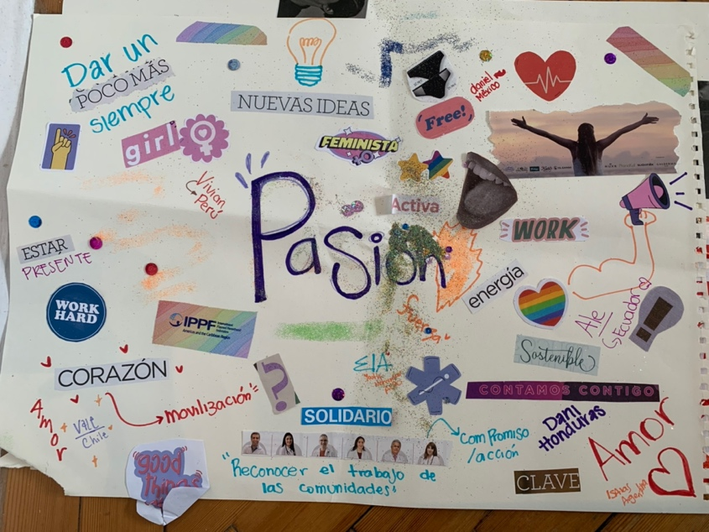

Solidarity
Draft definition | Reflections  - Generally agree with “solidarity” definition  - Could reflect keeping peace and unity inside of smaller communities; generate an agreement between communities.  - This value allows us to be more effective gamechangers because our voices our louder together
Did not re-write the definition, as generally agreed, only added reflections as above

Bravery/courage
Draft definition | Reflections  - Appeared to be a difference between the English/Spanish translation.  - Felt that the term “boldness” was accurate  - Reflected on about audacity, which leads to action – defending, actioning, boldness.  - To be bold, it’s important to have information.  - Boldness also has to do with anticipation; moving ahead of the events  - Creativity, innovation is a key part of being bold.  - Need to talk about being strategic and planning -not just reacting.  - “IPPF provides technical assistance and support to the MAs working on the ground…although courage is important for all members within organizations, if it doesn’t have all these other components, it may palace us at risk or deviate from our intended path”  - Baseline is: audacious, bold with the strategies we’ve identified. In order to be audacious/bold, you need strategy and information, you can’t just be reactive  - Suggest the term “audacity”, to go further and anticipate things to act in all  - Creativity and innovation as an essential part of being bold  - You can be bold by being a strategist and planning actions  - Emotional intelligence is needed to control oneself in risky or potentially aggressive situations.  - Audacity is to innovate; it is not reacting impulsively
Updated definition/poster reflections
- Word on the poster - Osadía, Accionar, estrategia, anticipación, creatividad, información, análisis, inteligencia emocional, defender

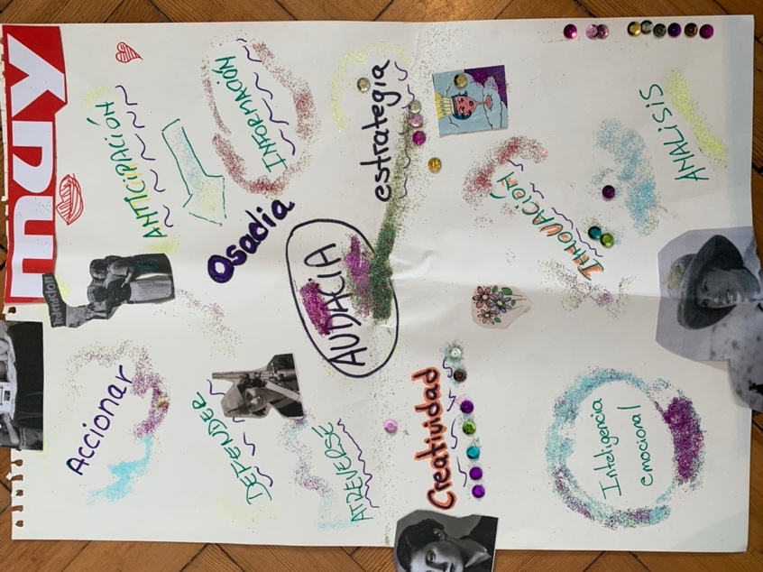

Belonging/respect (group 1)
Draft definition | Reflections  The collage represents that at the end of the day IPPF needs to include everybody, respect whatever is needed; you could have HIV, you could be queer, we want to make sure that you are included and you are respected along the way.
Updated definition

Inclusive
IPPF is the Federation that embraces diversity and promotes equity across service delivery, champions social justice, fostering and atmosphere to thrive and contribute to a more equitable and just society, regardless of age, orientation, gender identity, HIV status. IPPF’s goal is equal access to confidential SRH care that prioritise choice, bodily and reproductive autonomy, and opportunity to advance professionally in the federation.

Our craft shows that we live in a global society, we all come in different shapes and sizes, we all operate differently, but we must respect each other.

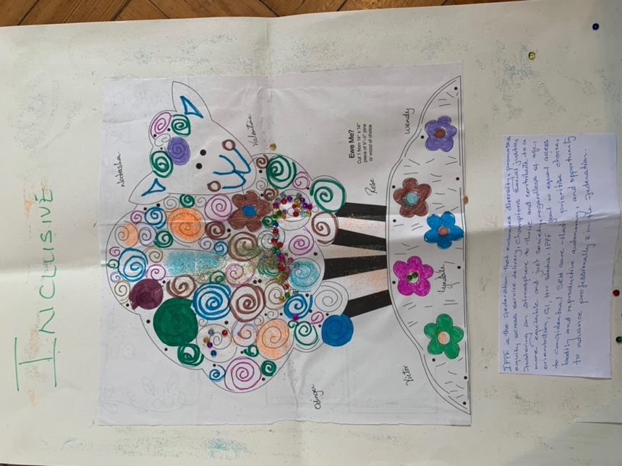
Belonging/respect (group 2)
Draft definition | Reflections  - Wanted to change the name of the value to “inclusivity” – we heard the comments of our other colleagues and we believe that using the “slash” means that the word is interchangeable, but belonging is not the same as respect. You can belong in an area but not be respected.  - Inclusivity is a better term to use.  - Definition is fine but needs to be more specific:  - Not sure about the “advancing professionally within the federation” – need more specifics here.  - Sentence - By prioritizing inclusive practices - ensure that we specify what the practices are.
Did not re-write the definition

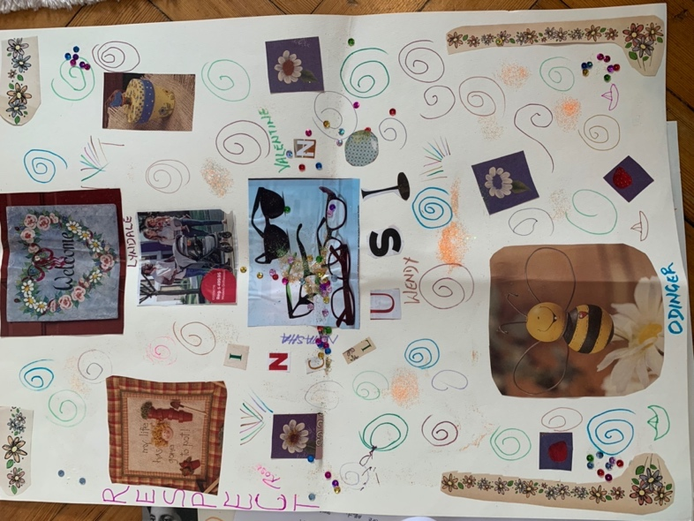

Integrity
Draft definition | Reflections  - Our team considered that integrity should not be the term defining all of the drafted content; we wanted to replace it with “transparency” as a value or principle.  - In paragraph 2, where it speaks to human/financial resources, anti-trafficking/slavery, we believe we should add sexual harassment and exploitation.  - We think this should all be under the umbrella of ethics; so we added “bioethics” so we can work on environmental changes.  - Believe we should develop other principles such as equity, diversity, and believe with the other group that talked about “inclusivity” and add in something that speaks to anti-racism and discrimination.
Did not re-write the definition in full, reflections noted above

Transformational
Draft definition | Reflections  - Discussed whether the term “transformational” should be changed, but after reviewing the definition, we collectively agreed to keep the word transformational, but adjust the definition to be in alignment.  - The existing definition wasn’t really hitting the mark, didn’t convey where we’re heading, what values we’re promoting…yes we are adjusting to the context, but we’re also seeking transformation of those local contexts into something that may break those structures that bring about the inequalities in which we work.  - Much of the discussion had to do with the fact that the definition should give us a path to follow within our own contexts.  - The definition that already existed did not specify where we are transforming. We are adapting to local contexts but we are also working to break down those structures.
Updated definition
- IPPF embraces rights-based values in its approach to advocacy and service delivery, using community-driven innovations to improve people's lives. The federation recognises local context while challenging the status quo that creates inequality and threatens tha advancement of SRHRJ around the world. We work toward a world where all people have the right and access to quality care and have the freedom to engage in the safe and pleasurable sexual and reproductive life they choose, and where these rights are respected by all.

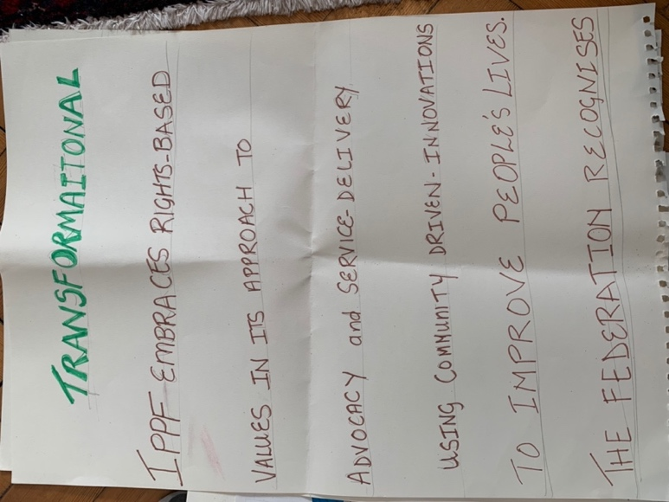

Values into Action
For the final activity, participants were asked to work in groups to identify what each value would look like in practice, according to a range of specific groups or functions. The below charts were completed by participants and include the reflections that they shared when reporting back.

Belonging/Respect
What does this value look like for……
Human resources  - adaptation/development of policies, guidelines, procedures – to include clients, staff, board members, volunteers, etc.  - Promoting volunteerism  - Meeting people where they are  - In the rush to be inclusive, make sure you don’t get the wrong people in the organistion. | What the Federation can ask of MAs, recognising the differences between MAs (in size, function, context, approach)  - Training: Staff, board, volunteers around the mission, vision, history of the org  - Widening services  - One-stop-shop for services, offering a wide range to meet all needs at once  - Outreach  - Wider reach to met people where they’re at  - Partnerships  - Working with people who share our values
Leadership  - Board being open to inclusivity; not coming with their own preconceived ideas/mandates  - Employees getting equal leadership opportunities to realize their potential  - Double-sided respect; not valuing bosses over more junior employees | How we work with LGBTQI+ populations  - respecting views and differences; knowing what you might feel might not be the same  - Creating a safe space  - Referral pathways in the case where you can’t provide all services
Are there any risks in this value?

Organizations can be exposed/vulnerable; sometimes people come into the organization who are coming in to cause challenges within the organization, not int he spirit of the organization

Commentary:
- Wanted to emphasize the commentary about intergenerational respect; need to seek a more intergenerational IPPf and build respect regardless of age and seniority

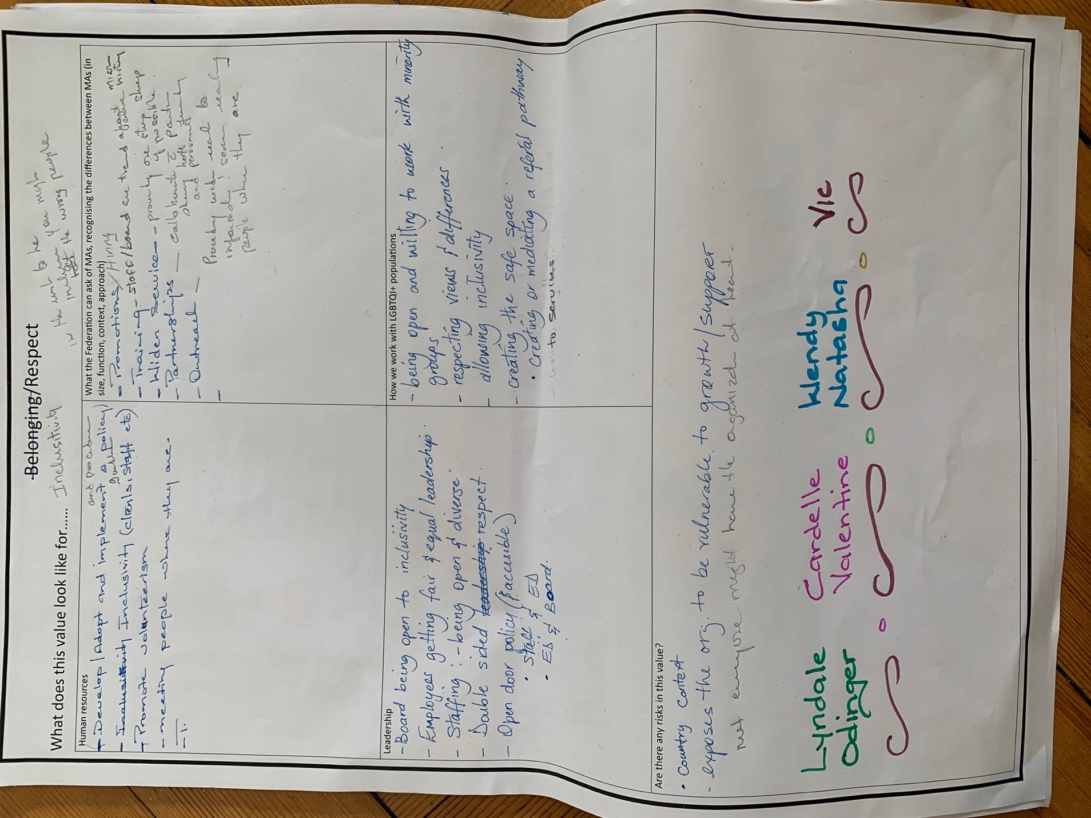

Bravery, courage
What does this value look like for……
How we speak out on issues  - Alliances in communication – ie, radio broadcasts with a more conservative view | Who we partner with and how we partner with them  - Who do we ally with? And how does this bridge alliances with others? We need to sit down at the table with even those opposed to our ideas, find shared/common ground, we find that to be bold. Sit with Catholic religious institutions, alliances with community leaders; seek common ground
What services we offer (thinking especially of those that are restricted or stigmatised)  - What type of services do we offer, esp those that are stigmatized, ie, abortion – sexual services for people with disabilities, addressing topics that are taboo | The risks we’re willing to take (ie personal security, funding, reputation)
Are there any risks in this value?

- Is “bravery” something we’re doing already, or is it aspirational?
  - Mas o menos, bit of a journey toward acting with bravery
  - We know that we’re supposed to be brave

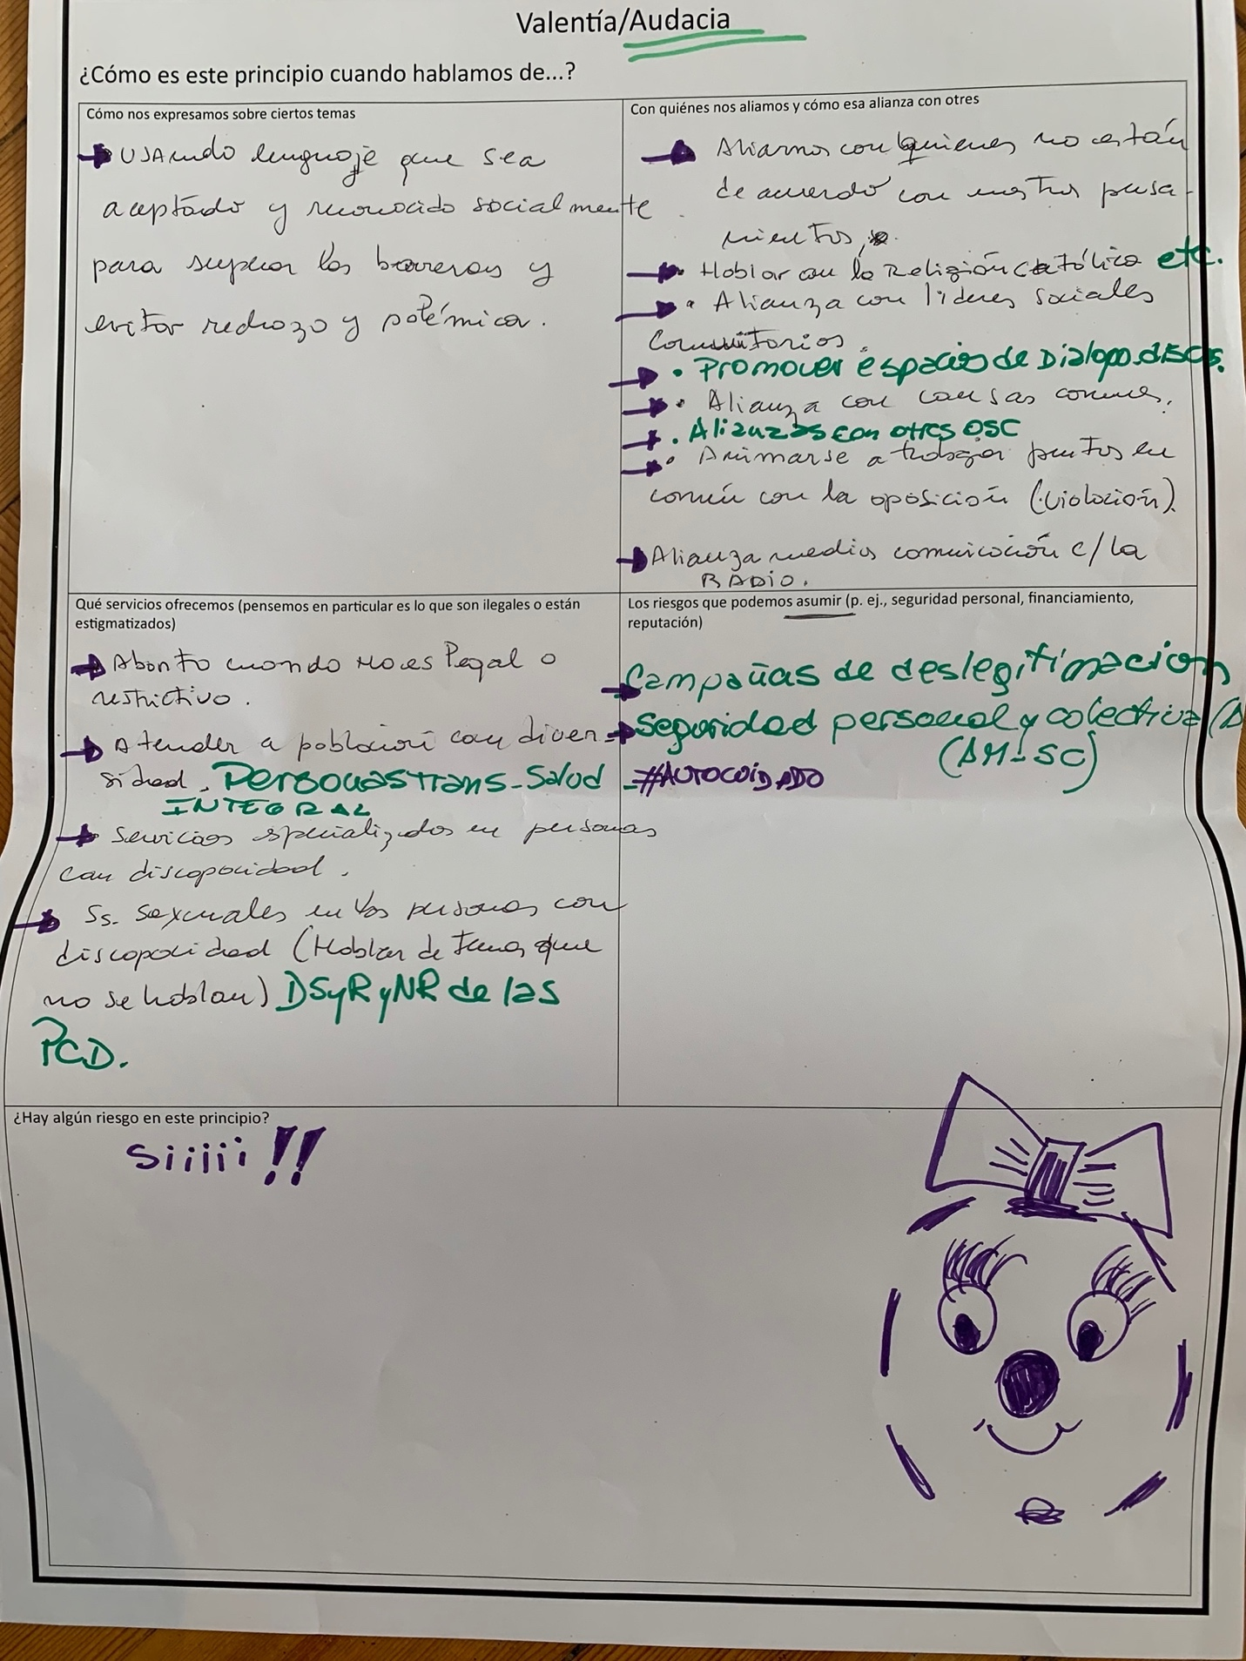

Transformative
What does this value look like for……
Programme design  - Capture the change we want, measurable, evidence based, capture voice of people in the field, participatory, recognize the wisdom of the people we serve | Advocacy  - Power dynamics and inequalities tackled  - Partner with the right person to support each other in this work, long term partnership to tackle varied and diverse needs and areas of intervention  - We are dealing with political resistance  - Partnership/collaboration key to transformation
How we use resources/funding  - Tricky  - We are often directed by our donors in terms of what areas we should go  - Work in dev our capacity to do more social enterprising to cover areas taht are not traditionally funded | How we balance “core work” (ie family planning, abortion care) with newer areas of focus  - Intersectional approach  - Implicitly if we take an intersectional approach we are able to collaborate with movements like climate change  - Making sure products are eco friendly e.g. sanitary napkins vs menstrual cups  - Keeping our hand on the pulse of what the people need, changing needs, focus interventions in that time
Are there any risks in this value?
- Political resistance
- Because we have taken a intersectional approach we might have tunnel vision, staying true to original outcomes

Are we doing this already?
- One thing I keep thinking about…at times I've been challenged…ippf has been challenged… and this is around feminism. When the split happened, the narrative was that IPPF is not sufficiently feminist; at some point I was asked whether or not I was a feminist. Action point: unpack this further through a focus group?

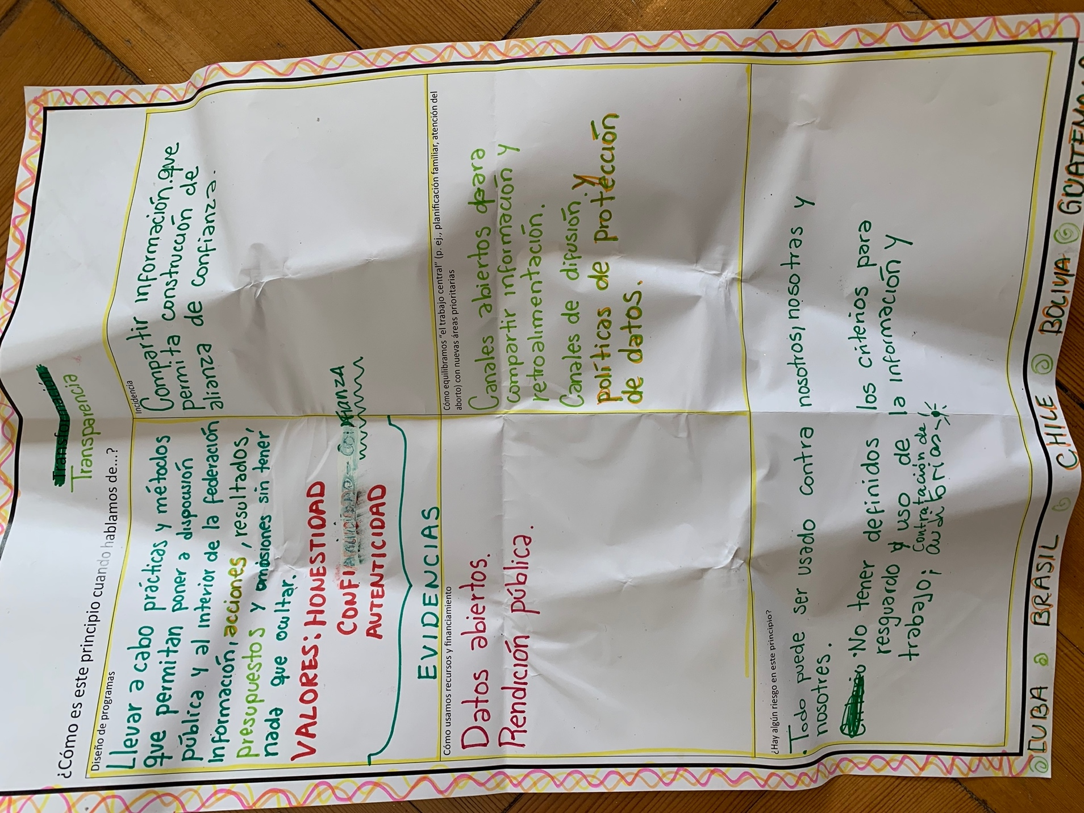

Integrity
What does this value look like for……
How we work with clients  - The concept is very complicated within each country and collaborating organization or partner.  - It is necessary to be transparent in the results, budget and even in the omissions  - Trust, authenticity, means of verification to make what we are doing transparent  - Advocacy - sharing information that allows the creation of trust alliances, from whom are we going to receive a budget?  - Resources - important to manage open data and have the practice of annual public reports of each organization  - In some contexts, sharing organizational budgets is complicated because it can put us at risk  - Balance priorities – open channels to share information and feedback with the people and organizations we work with, dissemination channels and data protection policies.  - How can we be objective when we talk about transparency? With regards to the design of programs, need to implement practices and methodologies within IPPF and externally when we talk about budget, we don’t need to hide what we do  - When it comes to values and principles, we’ve pointed out authenticity, honesty, we want to implement a mechanism so that we’re accountable for what we’re doing  - Advocacy - we want to share information that enables trustworthy alliances  - Don’t want to name certain companies or orgs that aren’t aligned with our values  - Financing:  - Important to have open data  - Need open channels for feedback  - Need data protection | How the Secretariat works with MAs
The choices that we make in the programmes we prioritise and the people we serve | How we allocate and spend funds
Are there any risks in this value?

  - Everything can be used against us
  - We don’t have defined criteria to safeguard information and data

Commentary:
  - I agree transparency is important, but integrity goes beyond financial and so on, and speaks to more
  - If you’re talking about data protection, isn’t that the opposite of transparency?
  - Data protection vs data management (internal processes of the data to avoid data leaking) vs the integrity of the data all are different concepts

Solidarity
What does this value look like for……
How we work with partners  - Chose to focus on how we work with sex workers/other marginalized communities – providing contraceptives, telehealth, screening, counseling, GBV | The public positions we take/advocacy/communications
How we work with sex workers or other marginalised communities | The relationship between the Secretariat and MAs
Are there any risks in this value?

Passion
What does this value look like for……
How we provide services  We must de-romanticize the word passion, and fill it with more ideological content, the issue of conviction is missing. There is a horizon that we dream together that has to do with what we want to achieve.  We have insisted on not having passion but perhaps commitment as a value. Passion is not the word that explains what we do. Passions come and go.  In the desire to get to the root of the meaning of words, sometimes we do not listen to each other.  Passion is what moves us. I have been working on this since I was twelve years old and if it weren't for the passion I wouldn't be here.  It is important to point out what we understand as passion, to give it a name, commitment. | The size of our ambition
Advocacy | How we work with young people
Are there any risks in this value?

- Need to add social and political context to our romanticisation of passion; we need a different world than the one we live in; we need passion, but fundamentally we need a political stance that points at the way we want to live; move away from “passion”, more about commitment that reflects what we want to say.
- At times it feels like we’re not listening to each other – “passion is the mobilizing force, that engine that propels us into action.” Passion is what fuels my commitment
- Passion is quite general; important to be specific about what we mean by passion – naming that involves speaking about commitment and the determination to transform.

Passion
What does this value look like for……
How we provide services  - Centered on people, acknowledge the leadership of communities, with people working in each organization, should be aligned with the values and principles of each organization – committed/empathetic professionals, reflecting that we’re doing what we love  - Focused on the needs of people, recognizing the leadership of communities and people who work in organizations who have values aligned with the organization | The size of our ambition  - A region where we’re seeing homogenous advances, but passion may depend on each of the contexts that may not be stable;  - Size of ambition - passion depends on each context, it is not as constant as we would like, many times it is like a roller coaster  - Advocacy without passion is like empty speech
Advocacy  - Passion reflected in advocacy; can’t imagine advocacy without passion (empty talk) | How we work with young people  - How do we work with youth? Aligned to the TOR, and the principles and values that the network will be implementing
Are there any risks in this value?
- If there is risk conveyed in this principle, it’s that we may not always share the same passion depending on external and internal factors; passion without strategy could lead to risks
  - Also, could be incarcerated for abortion advocacy in some places
- Are we already doing it?
  - Middle-to-yes
- Risk - we do not always have the same passion, it is changing, passion without strategy can lead us to risks such as being imprisoned for influencing the right to abortion. Be careful with #selfcare

