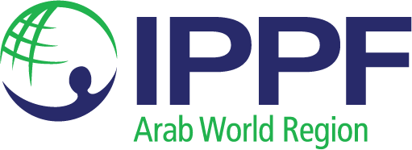
Regional Meeting on sexual rights including sex work policy and sexual and gender diversity
4-5 July 2023
Report

Contents
A. Introduction 3
B. National activities for supporting sexual and gender diversity 3
C. Priority Areas for National Intervention (working groups) 5
i. Safety and security 5
ii. Access to SRH services 5
iii. Psychological support 5
iv. Advocacy needs 6
D. Regional activities for supporting sexual and gender diversity 6
i. Resource sharing and capacity building initiatives 6
ii. How to counter opposition? 6
iii. Advocacy, communication and information sharing mechanisms 7
E. IPPF Policy on Sex Work 7
F. Establishing a Regional Platform for sexual and gender diversity 7
i. Importance of a Regional Platform (open discussion) 7
ii. Platform Structure and Objectives (working groups) 8
G. Next Steps 9
H. Charter of Values 9
Appendix 1: Agenda 12
Appendix 2: Strategy 2028 14
Appendix 4: IPPF Arab World Response Toward Minorities 16
Appendix 4: Grouping regional activities for supporting LGBT and sex workers 23

Introduction
International Planned Parenthood Federation Arab World Regional Office (IPPF AWRO) welcomed representatives from the Lesbian, Gay, Bisexual, Trans, Queer and Intersex (LGBTQI+) and sex worker communities from Pakistan, Tunisia, Morocco and Lebanon to discuss how to form a regional network.
With the support of the IPPF Hub on Sexual Orientation, Gender Identity and Expression and Sex Characteristics (SOGIESC) based at Sex og Politikk in Norway, the meeting had the following objectives:
- Identify actionable networking strategies and opportunities to enhance collaboration, partnership, and resource sharing.
- Enhance IPPF Policy on Sex Work in the MENA region
- Planning for Sexual and gender diversity work in line with IPPF strategy 2028
For the full agenda, see Appendix 1. For the list of participants, see Appendix 2.
In welcoming participants to the session, Regional Director of IPPF AWRO, Fadoua Bakhadda emphasized that the meeting is focused on hearing from the participants who have an important role in both sharing what they and their communities need, as well a being part of supporting IPPF to be open and supportive to their whole community. She recognized the context that the participants were living in, and shared that IPPF has a role to play in ensuring that they have full security in every aspect of their lives.
Mustapha Kemayel ,Assistant Regional Director, IPPF AWRO also welcomed participants and made clear that he wanted to move past the LGBTQI+ and sex worker communities being “marginalised”. He wants them to be a fully accepted part of the community, not a group on the margins.

He also introduced IPPF Strategy 2028 and its four pillars. See Appendix 3 for further details.

National activities for supporting sexual and gender diversity
Participants shared their experiences of advocating for LGBTQI+ and sex worker rights at the national level, and the country context that they are facing.
Participants from Tunisa shared that their community experiences discrimination, harassment, and physical and verbal violence on a regular basis. The legal framework commits in principle to guaranteeing all rights and services to all, but other laws prohibit access for these communities or otherwise contradict these principles. Clause 226 of the Penal Code, for example, punishes trans people or people who do not confirm to the norm of expressed sexuality. There are also restrictive laws on sex work and LGBTQI+ people specifically. Many of these laws date from the French colonial era; they have been rejected by France but are still in place in Tunisia, despite its independence. These laws are used to stigmatise and harass people, and often are used to justify invasive and undignified practices such as anal testing to “prove” same sex relations between men.
However, the community in Tunisia is pushing against these restrictions. They have a safe and secure platform that is used for individuals to express themselves. They have access to arts, theatre and cinema, to allow them to express a positive picture of their lives, and they use social media to enhance the perception of these community and also support their human rights. They have hosted a series of events, dances and awareness raising campaigns.
Participants from Pakistan shared that there is an extensive legal framework that does not support LGBTQI+ people and that sex work is openly criminalised; it’s not possible to even talk openly about sex work. Transgender is legally recognised as a third gender category and the 2018 Transgender Act allows for self-identification, the right to reflect their gender on official documents and the right to vote and run for public office, as well as access healthcare and education, and protection against discrimination.
Despite this, all of these communities face a fear of arrest and harassment, poor economic conditions, and biased public and private health service providers which limits access to care. Rahnuma Family Planning Association of Pakistan (R-FPAP) has been working to overcome some of these barriers through forming partnerships with vulnerable groups across Pakistan, providing free and subsided integrated SHR and HIV testing, offering innovative services like hormonal therapy and laser treatment. They are also piloting PReP and PeP and hosting awareness raising campaigns.
Participants from Lebanon shared that sex work is hidden, and many workers will get “artist” visas to work as sex workers. Sex work is forbidden by law, especially when it is performed by woman. A high-profile case in 2016 looked into this law specifically when a network of 75 women of Iraqi and Syrian origin were arrested; this was considered to be human trafficking. There are movements to make sex work legally accepted and for people to not be prosecuted; the “Nordic Model” is the preferred model.
In terms of LGBTQI+ rights, Clause 7 of the Lebanese Constitution creates equality for all people before the law, but as with Tunisia, this is contracted by other laws that criminalise LGBTQI+ people. Courts are usually religious and do not issue proper sentences and decisions, and laws related to domestic violence are often not implemented, resulting in impunity.
There have been suggestions that people with HIV should be isolated, and anal testing to determine sexual practice is prevalent. Often this will take place after arrest and before transfer to prison. Further, arrested people may be required to give up their phone for inspection to see if it contains any LGBTQI+ material. This should be a matter for the court to determine, but it still takes place.
The Ministry of the Interior manages these areas of the law, and they will sometimes refuse work permits for particular populations, or companies such as banks will require HIV testing prior to employment; in this way, the stigma experience by the community also has economic repercussions.
There is a great deal of stigmatisation in health services and these communities are seem as deviant; people experience discrimination in behaviour or treatment, and some tests and medications are very expensive. LGBTQI+ welcoming centers are mainly based in Beruit and other urban areas; many regions do not have access to this care. PReP is provided free by PROUD Lebanon and SIDC
Participants from Morocco made the case that providing protection for LGBTQI+ people and sex workers does not require any further human rights laws or standards; the existing core legal obligations include protection from homophobic and transphobic and sex worker violence. How ever, because sex work and LGBTQI+ people are criminalised, they actually experience violence and do not have police protection. Their human rights are not respected. Same-sex activity is illegal in Morocco and recognition for transgender people requires genital surgery, which is not available in Morocco. Trans people with an incongruent legal gender face harassment and cannot get official documentation in their chosen name.

They shared that in Morocco there are oppressive laws perpetuate societal prejudice, fuelling harassment, discrimination and violence. There are mass arrests targeting vulnerable women and LGBTQI+ people with low incomes for purposes of extortion. Members of these communities are detained for charges like homelessness, homosexuality, outraging public decency and subject to anal testing. After being arbitrarily detained, people are threatened with criminal prosecution or being exposed to their family/community. Human Rights Defenders often face persecution and restriction of their activities; they will be limited in their public associations and made be denied registration

Priority Areas for National Intervention (working groups)
Working in small groups, participants were asked to describe their priority areas for intervention in the categories of safety and security, access to SRH services, psychological support and advocacy needs.

Safety and security
- Right to confidentiality needs to be embedded at the legislative level.
- LGBTQI+ people need access to safe spaces.
- Create secure phone number and also create and publicize (safely) shared spaces.
- Training about digital security.
- Community based model in local areas.
- Sensitization of the wider community.
- Train for self-defence
- Report instances of violence to proper authorities.
- Empower communities to know their rights especially when detained and homophobic attacks, and so they can understand the services provided and what can be done in certain situations and limitations.

Access to SRH services
- Community awareness services, values clarification and attitude transformation.
- Community friendly SRHR services, including community outreach via peer educators.
- Digital SRHR information (for example via tiktok and FaceBook) so people can access information and simplify information to understand.
- Expand services through supporting NGOs outside the capital so that people can access in other regions.
- Offer free condoms and free services for SRHR.
- Host a mobile caravan to educate people.
- Invest in public awareness campaigns.
- Advocate for comprehensive sexuality education as, this would prevent spread of HIV and other infections.

Psychological support
- Face to face individual counselling
- Peer support networks, including discussion groups on mental health.
- Support interventions for sex workers, including psychological support, stipend so they can choose other work if they want (sex work should be a choice, not result of economic pressure).
- Recognition in some places that homosexuality is not a disease, as per the WHO recommendations, however some psychologists and psychiatrists still use conversation therapy which needs to be abolished.

Advocacy needs
- Need anti-discrimination laws and social protection policy.
- National level strategy on inclusion of SOGI.
- Implementation of laws on SRHR.
- Proposed amendment for the protection of LGBTQI+ people.
- Work with the public to change attitudes / social norms, including through using digital tools.
- Defend and protect the population that we work with.
- Need to create a positive and empowering dynamic around difference, including going small communities and adapt the ideas we are trying to promote into their beliefs. Show that there is difference – can’t change immediately but show that there is difference.
- Built partnerships between different components of civil society that will express the needs of the people and to have a human rights-based approach.
- Use global human rights mechanisms such as the Universal Periodic Review.
- Need to abolish criminalization.
- Religious people play an important role in this society in shifting attitudes so need to engage with them.

Regional activities for supporting sexual and gender diversity
This session opened with a presentation by Mustapha Kemayel on the importance of regional networks. See Appendix 5 for more detail.
Participants then discussed in small groups the benefit of regional networks and shared activities, and identified common challenges and needs.

Resource sharing and capacity building initiatives
Participants indicated that sustainability is a common issue that they face, and that often interventions or programmes come to an end because there is no continuity of funding. There was a strong feeling that a regional network could be useful in supporting with donor mapping and networking, and that IPPF could have a role to play in developing organisational economic sustainability. It was also suggested that IPPF may be able to fundraise on behalf of the network and act as a fiscal host.

How to counter opposition?
Participants shared that they have learned not to go “head-to-head” with the opposition, especially if they are position of high authority. It was seen as essential that they first “do no harm” and never put beneficiaries or staff at risk of backlash. In order to overcome opposition, they also suggested that they needed to break the silence around LGBTQI+ issues and create social movements that are able to advocate for their rights.

Advocacy, communication and information sharing mechanisms
Participants felt that to be effective, a regional network needs one shared regional goal. The common issues that were identified as priority for a network included tackling legal barriers, stigma and shame, as well as access to health care, education and social security including for sex workers. Challenging religious and cultural barriers and stereotypes was prioritised, as well as asking public figures to become allies (using allied privilege).
Participants thought that the network should provide support to an individual or group of individuals, including supporting un-registered organizations; also focus on peer-led/peer-supported organizations. It was important that it not be restricted to large organisations, and that smaller organisations and activists are able to participate. They felt that the network has a role to paly in helping people to connect with each other, perhaps through shared programmes and projects, and coordinated participation (tailored to context) in conferences or meetings.
With respect to information sharing, participants suggested that the network support the digitalization of information to facilitate sharing, as well as the development of toolkits and best practice models. They felt that more data and medical arguments would support them in making the case for better care, as well as coordinated research.

IPPF Policy on Sex Work
Mustapha Kemayel presented the IPPF policy on sex work, see Appendix 6 for further information. Participants welcomed this policy but confirmed that it would be implemented according to country leadership and context.

Establishing a Regional Platform for sexual and gender diversity

Importance of a Regional Platform (open discussion)
Participants explored whether or not to have a regional platform or a regional network. Tunisian participants shared their experience of having an on-line platform “Salema” where participants are able to get information, articles and videos about health and sexuality anonymously. PROUD Lebanon shared the creation of an automated application that people can ask questions to. Although it is a ChatBot, it feels like speaking to a friend and can be used in French, English and Arabic.
Participants agreed that they wanted to form a network on the grounds that Islamic countries – while diverse – have a lot of commonalities due to their religious context and that working more closely together would support them to drive change.
Participants felt that the mechanism needed use depends on the situation that they are working collectively on.
The biggest need in the MENA region was identified as a focus on community building and the creation of a network of activists and community organizations collaborate and share activities and strategies. They felt that a network could be a good place to share experiences and support, and to protect each other when there are challenges and contexts.
They felt that a platform could be useful for individuals to access and learn about health, legal frameworks or to ask questions of, but this would be different from a network that would work collaboratively on advocacy and movement building. In this way, a platform was seen as a project of the network and that the two would complement.
The agreement was that this group would create a network – in a more formalised way – to strategize and build capacity and that they would work collectively to build a platform across the region to disseminate knowledge and cater to the needs of populations across the regions.
They also felt that the network should not be too open; because of the restrictive country contexts, it would need to work in a more underground way and ensure that it was not opening itself or its members to stigma, backlash, arrest or violence.

Platform Structure and Objectives (working groups)

Governance and Membership Criteria
In forming a network, participants had a strong discussion about its structure, governance and membership.
It was agreed that network members need to be representing the community or an affiliated organization but do not have to be formal or registered. They felt that different communities should be reflected in the network to ensure diversity.
While the network can be hosted or supported by IPPF, it needs to be lead outside of IPPF and maintain a degree of independence; MAs can be a part of the network but need to demonstrate commitment to the issues and to not be a dominant force on the governance structures. It was suggested but not agreed that the MAs could be represented in an advisory capacity but that the network will be led by the community itself. Participants felt that local leadership is paramount, and the network needs to respond to what is needed/wanted at the national level, and not come in with a set agenda or specific policy.
The network will be “federal” in natures because it will reflect and give space to the specific national needs/context of every country, and it will be guided by the do no harm principle. It was agreed that it will be supported by a regional committee that can support access to different programmes, capacity building between different countries and issues.
There was a discussion about representation and membership of the network. It was agreed that the network would represent the LGBQTI+ community in all its diversity and that sex workers or sex work organisations that are members of this community would be explicitly welcome. The participants representing sex workers demanded total inclusion and respect; this was agreed and supported by all participants. Sex workers who do not affiliate with the LGBTQI+ community would not be members of this group as participants felt that the commonality of being LGBTQI+ was the most relevant link, and they expressed concern that non-LGBTQI+ sex workers were not seen as allies to the LGBTQI+ community. It was proposed that IPPF also create a separate sex work focused network that is inclusive of all sex workers, including those who are LGBTQI+.

Platform Objectives
The draft objectives of the network were agreed pending further discussion as follows:
- To advocate for rights and wellbeing of LGBTQI+ people and LGBTQI+ sex workers.
- To provide support and resources to these communities.
- To support and inform evidence-based advocacy and policy making across the region, with the goal of creating an enabling environment for these communities.
- To create a more inclusive society through education and awareness raising
- To supporting the capacity of the members of the network.
- To be intersectional and inclusive: ensuring that diverse identities, experiences, and perspectives within communities are reflect in its work.
- To work towards creating a safe environment for these communities, including safe spaces for community members and access to services (directly or via referral mechanisms).

Potential Funding Sources for Platform Establishment
IPPF AWRO indicated that there may be budget for this work in 2024, but it will not be sufficient for the full network so all members will need to participate in fundraising. A fundraising committee may be formed to support with this. Despite the role that IPPF may play in contributing funding and supporting fundraising, participants affirmed that the network should be independent.

G. Next Steps
The following next steps were agreed:
- Profile this meeting through IPPF networks.
- Creation of a small committee to work on the structure and name of the network. Members are: Anya (Morocco), Bertho (Lebanon), Amin (Tunisia), Razia (Pakistan), Tor (Norway), Mustapha (IPPF ARWO); to be based on this meeting report.
- Set up a virtual follow up meeting with all members to discuss the proposed structure and name.
- IPPF to create an email list of all participants to enable closer communication.
- After agreeing mission of the network and its structure, draft statement to announce its existence.

Charter of Values
Participants took part in a consultation on the development of the IPPF Charter of Values. After a brief introduction about what a Charter of Values is and why IPPF is undergoing a cross-Federation process to agree a Charter of Values, they were asked to create an image answering the question “If IPPF was a superhero what would it look /feel/act like.” Collectively the strongest mood from these was love, care and compassion and the need to be political and strong and feisty.

Superhero 1
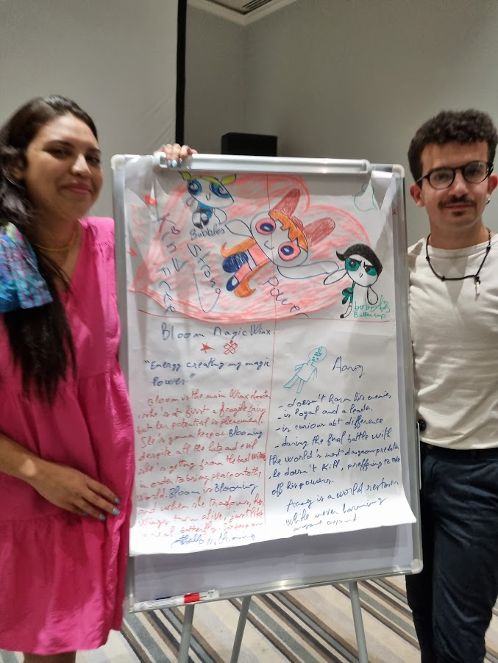
This superhero was based on current cartoons and manga characters. The Powder Puff girls were chosen because they represented being “Superbubbly, superstrong and superfriends.” They also and peace in this world and young, which was inspirational.

The word Blooming was important to this superhero, as “all of us need to keep blooming and remember the potential you have.”

Finally a third character was identified – they is the youngest character in the series and was selected because they never harms anyone, and always uses dialogue to understand, even in conflict.

Superhero 2

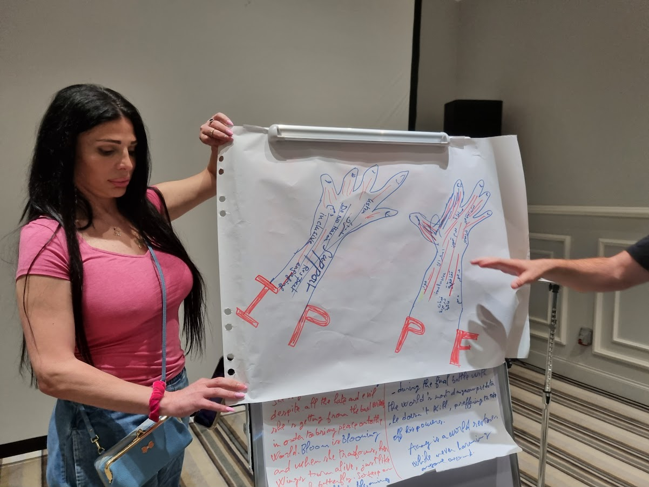
This pair of hands conceptualises IPPF as the support, not the lead. It is not the superhero; the real superheros are those on the ground, and it is IPPF’s role to help them flourish and succeed. The hands also feature key messages for IPPF to follow: So IPPF as a hand: Inclusive, do no harm, respect, engaging and listening.

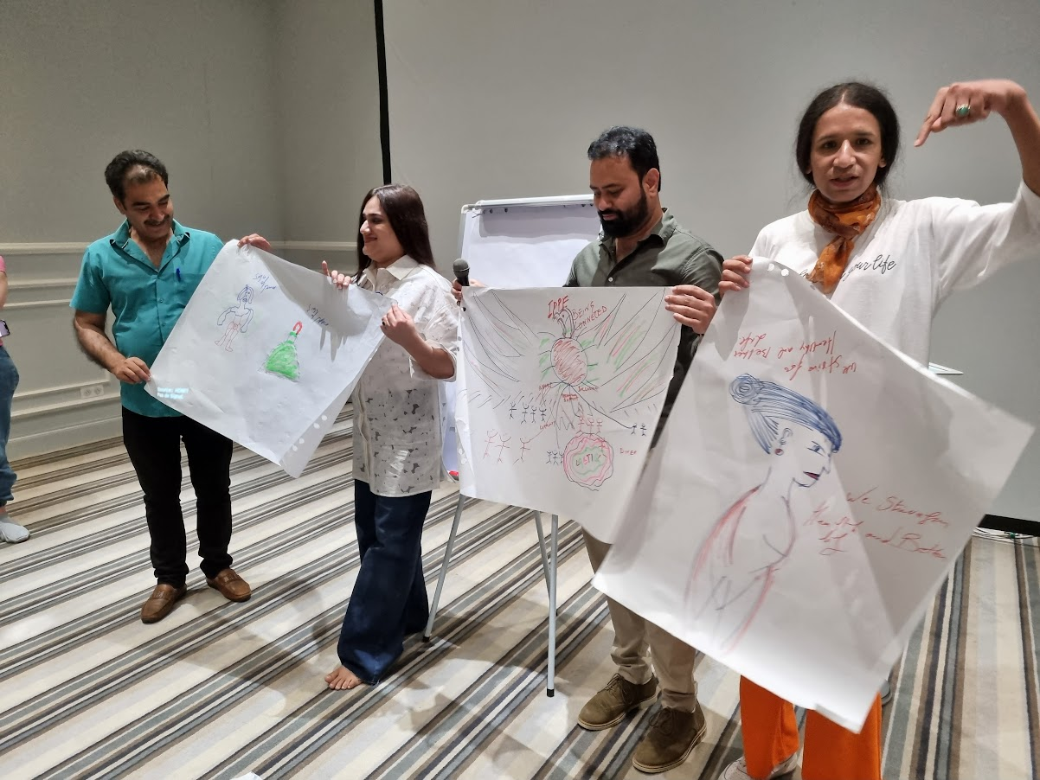
Superhero 3
These three pictures show the hero at different levels: one is a helicopter view, one is a zoom in and the other is a super-zoom. It is represented by the bird of the phoenix, rising from the ashes of challenges, and reflecting inclusion and technical support and inclusivity and tolerance. The bird is for the individual, but also organisations, caretakers etc. and whole society. This also represents that from ancient times there was more acceptance of gender diversity and sexuality. The next picture represents a transgender woman struggling to reach a better life, and the third is a sign of power and peace that we’re building together as movement.

Appendix 1: Agenda

Day 1: Tuesday 4 July 2023

Welcome and Introduction

09:00 - 09:30
a. Opening Remarks
b. Introductions of Participants: what do you want us to know about you?
c. Meeting objectives

IPPF Policy on Sex Work
09:30 - 10:00
a. Presentation of the Policy: concerns of MENA region
b. How to boost the Policy? (open discussion)

National Activities for Supporting LGBT and Sex Workers
10:00 - 11:00
a. Sharing Success Stories and Challenges from Different Countries
b. Protection of minority people: what is needed?

11:00 - 11:30: Coffee break

11:30 – 13:00
b. Priority Areas for National Intervention (working groups)
- Safety and security
- Access to SRH services
- Psychological support
c. Working groups presentations and discussion.

13:00 - 14:00 Lunch break

Regional Activities for Supporting LGBT and Sex Workers
14:00 – 15:30
- Why to be grouped regionally (open discussion)
- Identification of Common Regional Challenges and Needs (working groups)
- Resource Sharing and Capacity Building Initiatives
- How to counter opposition?
- Communication and Information Sharing Mechanisms

15:30 – 16:00 Coffee break

16:00 – 17:00
- Working groups presentations and discussion.
17:00 – 17:30 first day Wrap-up

Day 2: Wednesday 5 July 2023

Networking Strategies
9:00 – 10:00
Discussions on Networking Opportunities
- Sharing Best Practices for Collaboration and Partnership
- Identifying Potential Networking Channels and Platforms

Establishing a Regional Platform for LGBT and Sex Workers
10:00 – 11:00
a. Importance of a Regional Platform (open discussion)
b. Platform Structure and Objectives (working groups)
- Discussion on Governance and Membership Criteria
- Platform Objectives
- Potential Funding Sources for Platform Establishment

11:00 - 11:30 Coffee break

11:30 – 12:30
c. Working groups presentations and discussion.

Wrap-up and Next Steps
12:30 – 13:00
a. Summary of Key Discussions and Decisions
b. Identification of Action Points and Responsible Parties
c. Timeline for Action Plan Implementation
d. Closing Remarks and Acknowledgments

13:00 - 14:00 Lunch break

14:00 – 15:30
The group will join the Regional Training on Comprehensive Clients Centred Guidelines (CCCG) to attend a session on “Inclusion and diversity in SRHR”.

15:30 – 16:00 Coffee break

16:00 – 17:00
Developing an IPPF Charter of Values – Consultation

Appendix 2: Strategy 2028
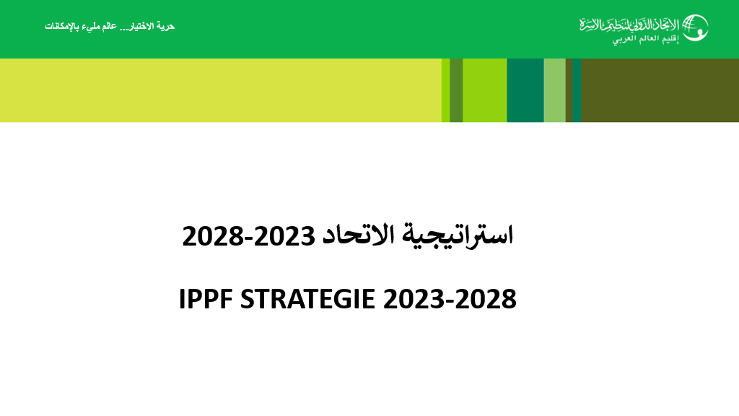

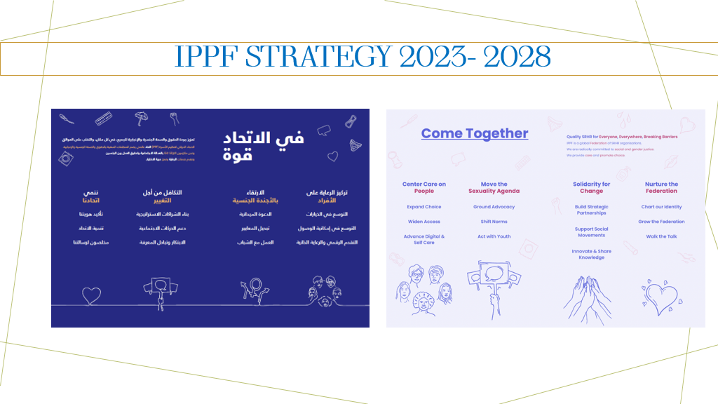
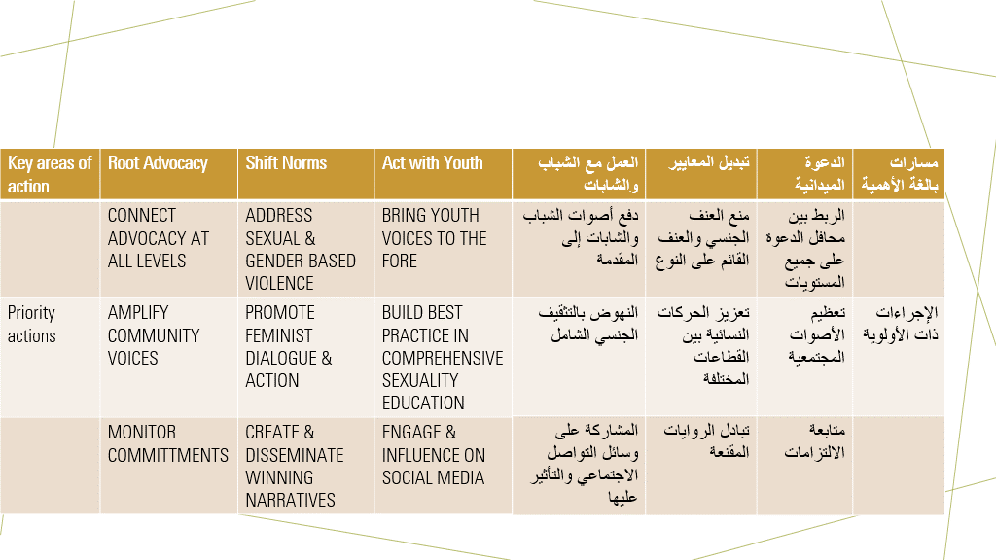
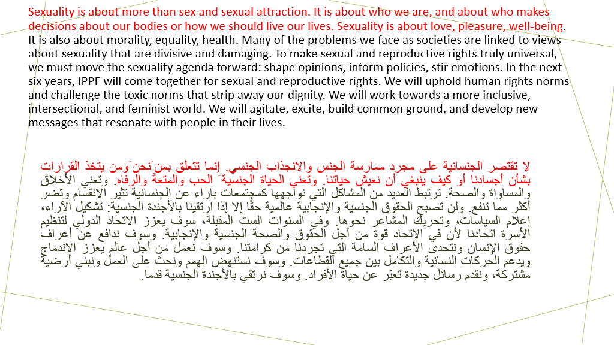

Appendix 4: IPPF Arab World Response Toward Minorities
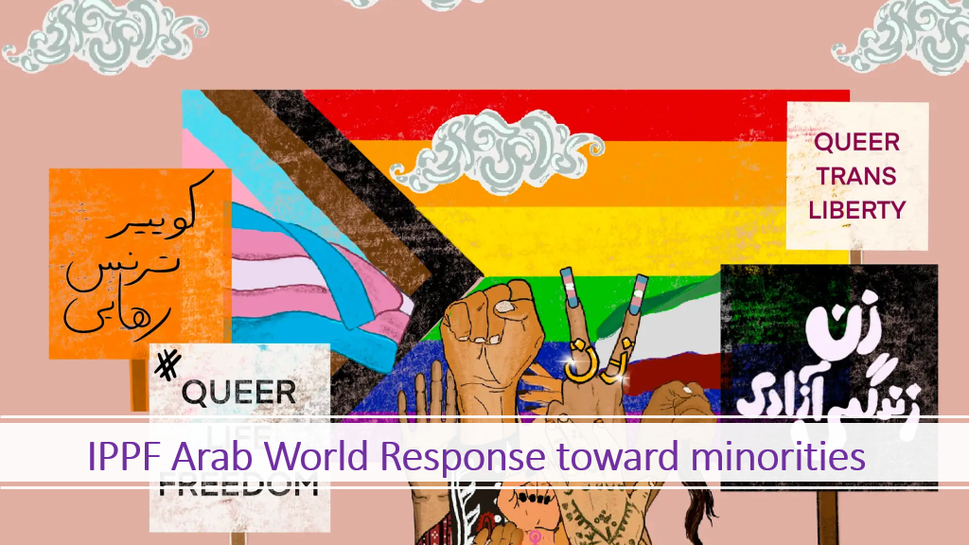
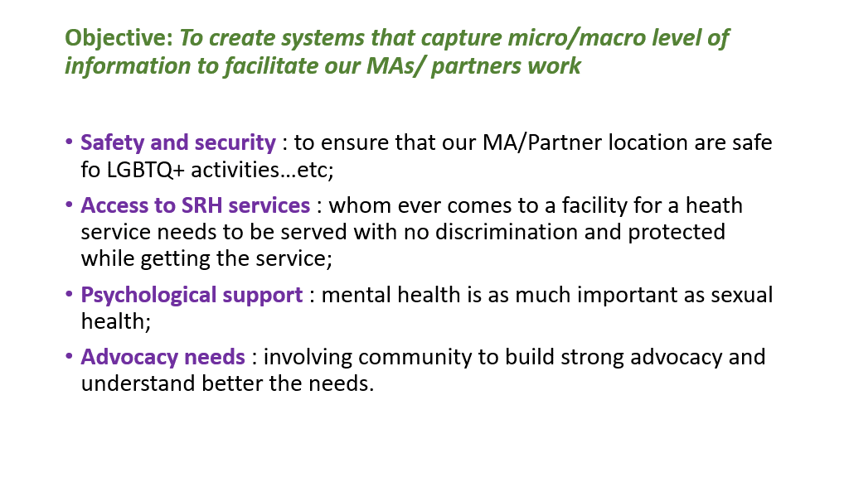
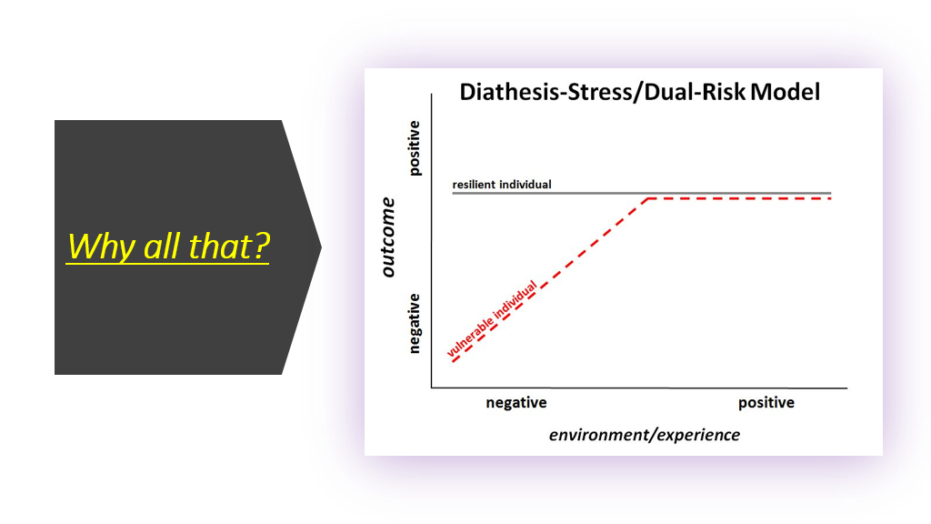
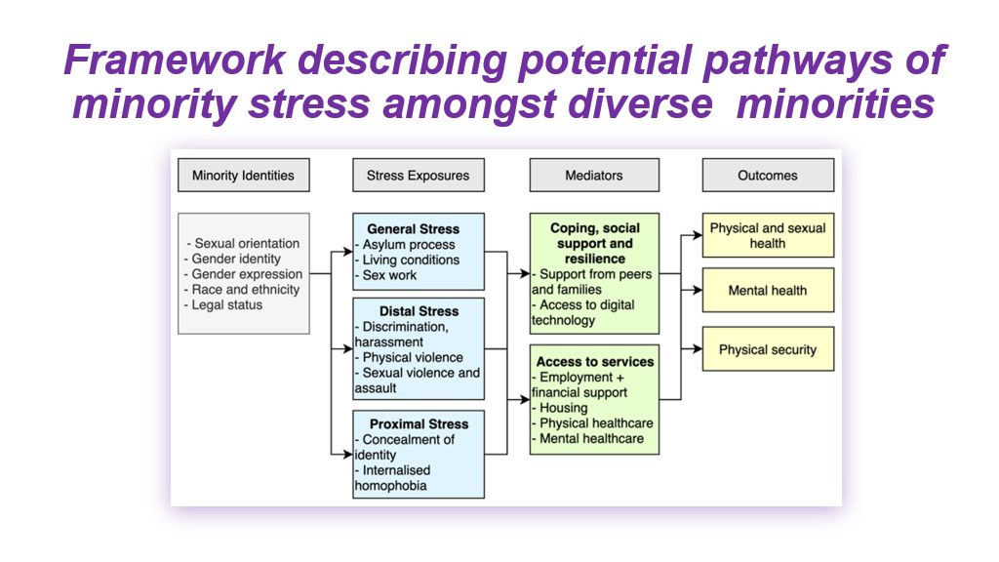
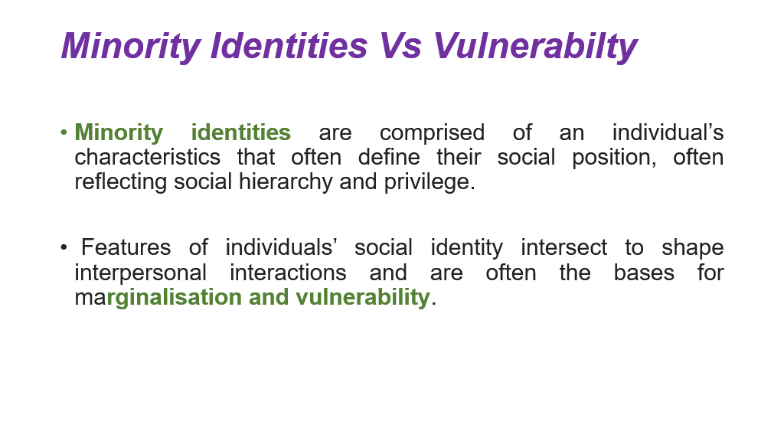
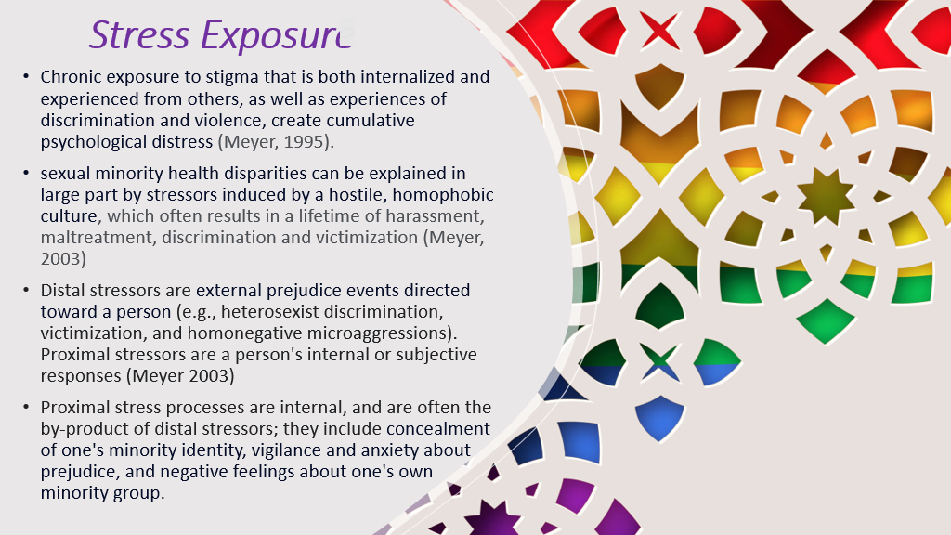

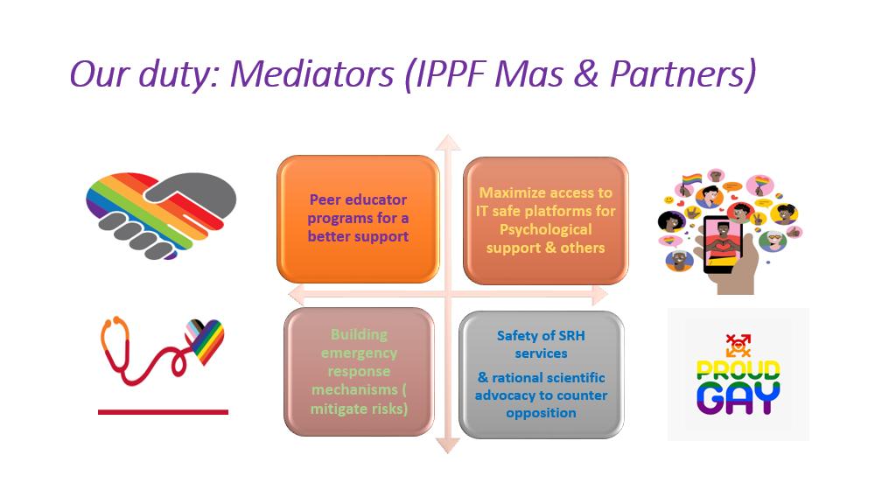

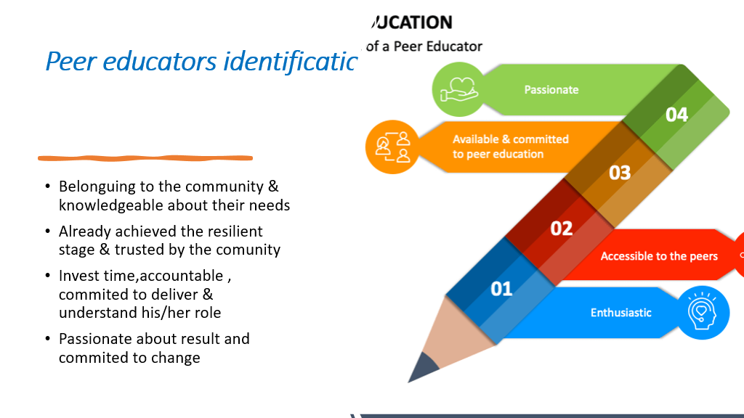
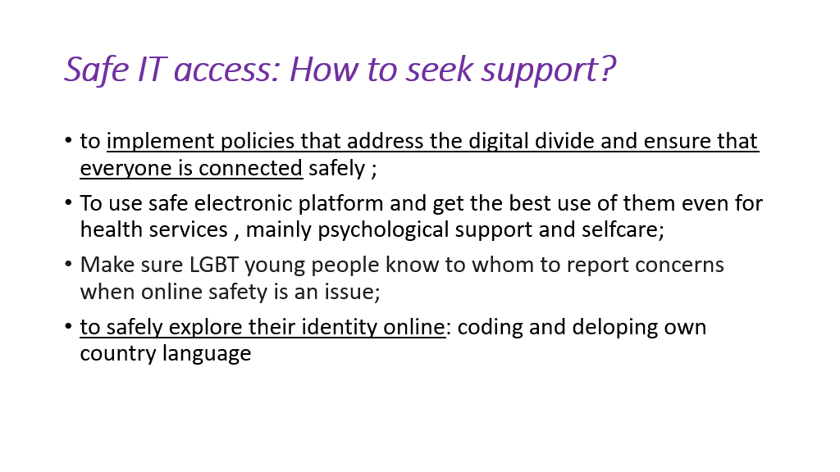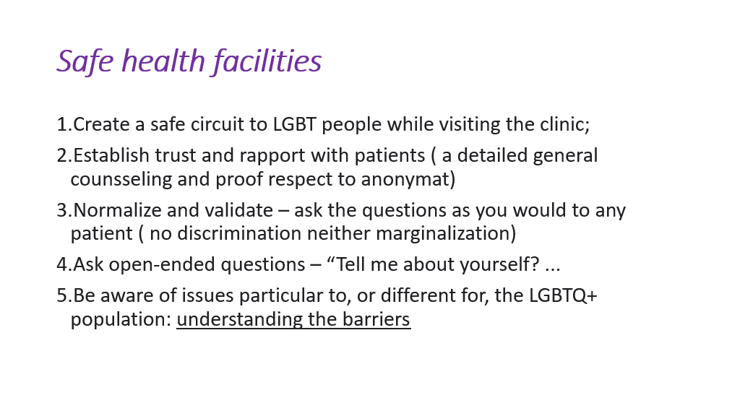
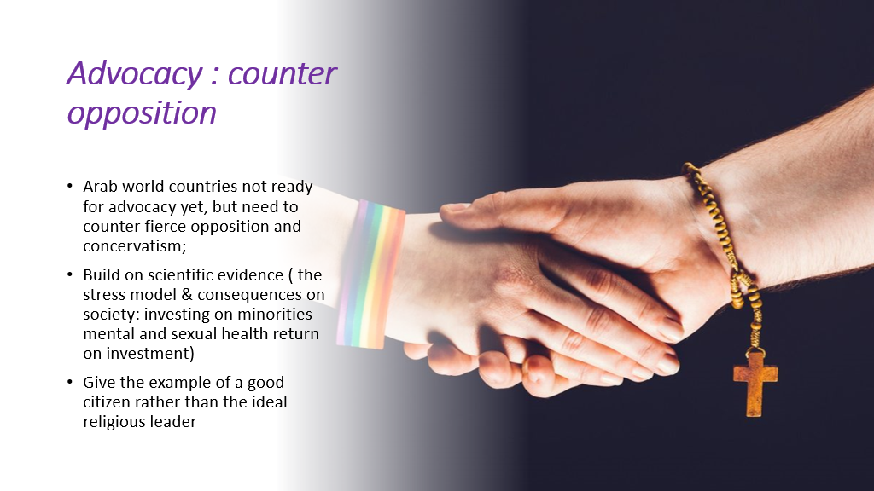

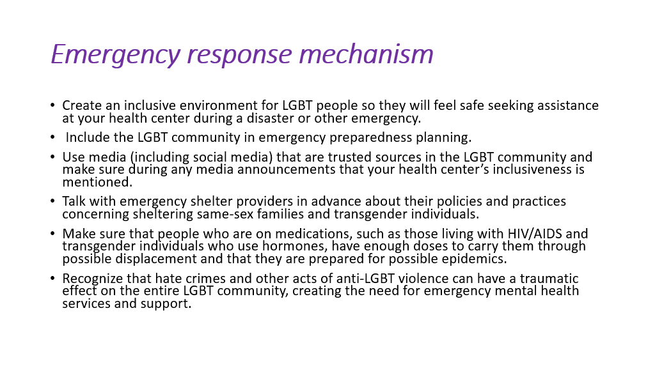
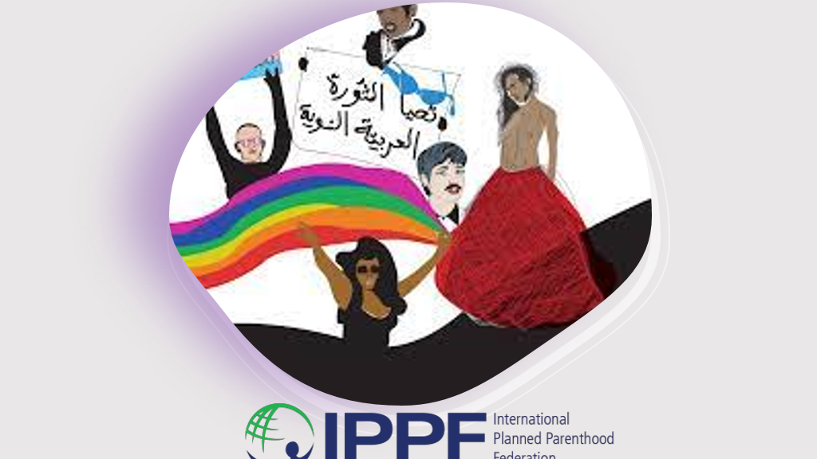

Appendix 4: Grouping regional activities for supporting LGBT and sex workers
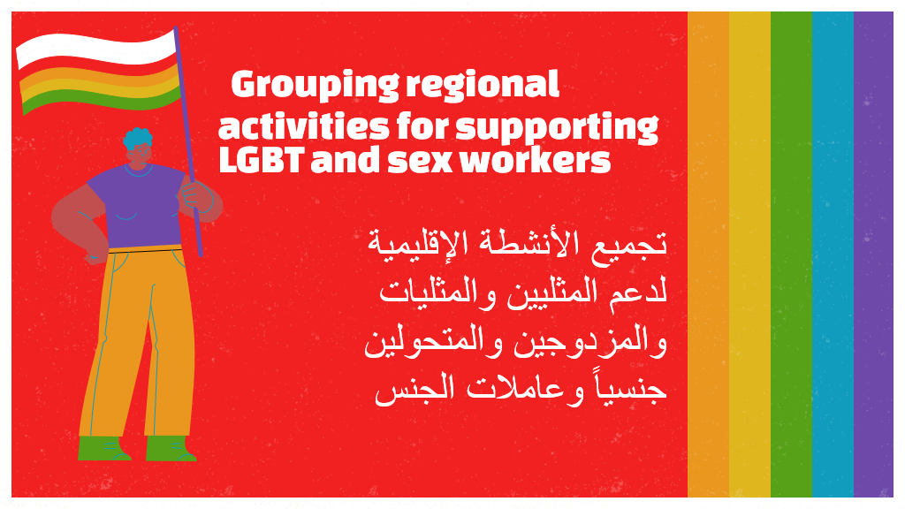
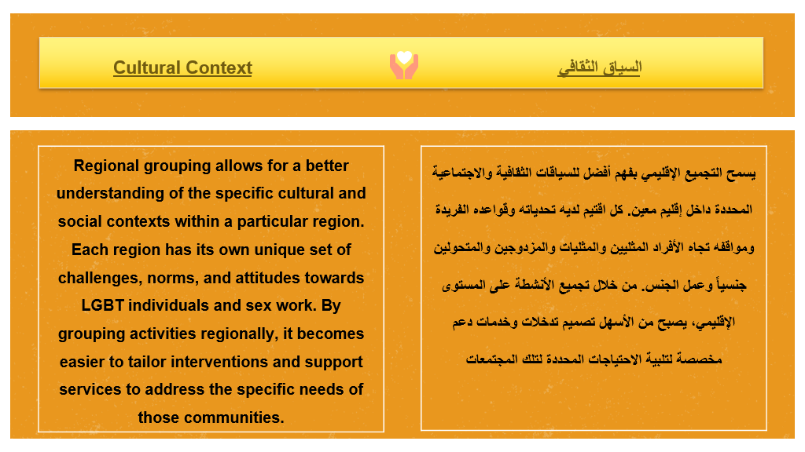
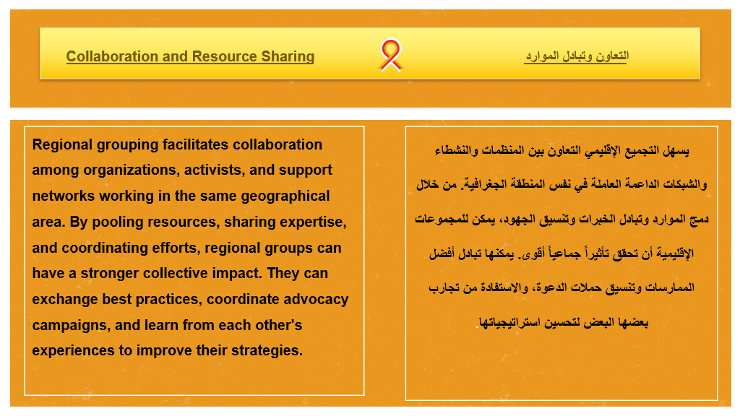
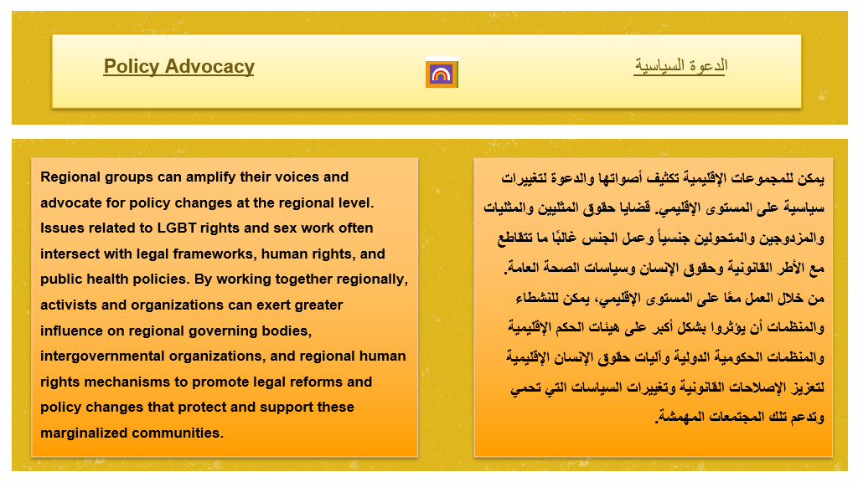
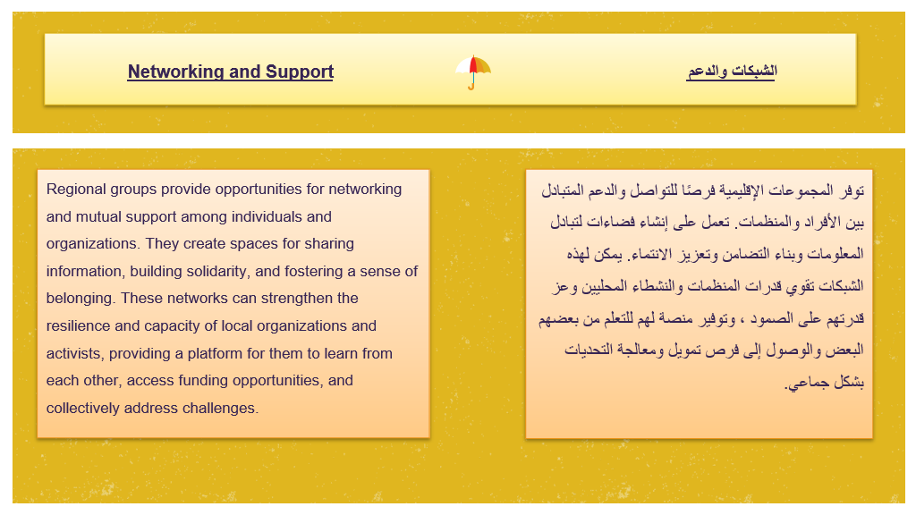

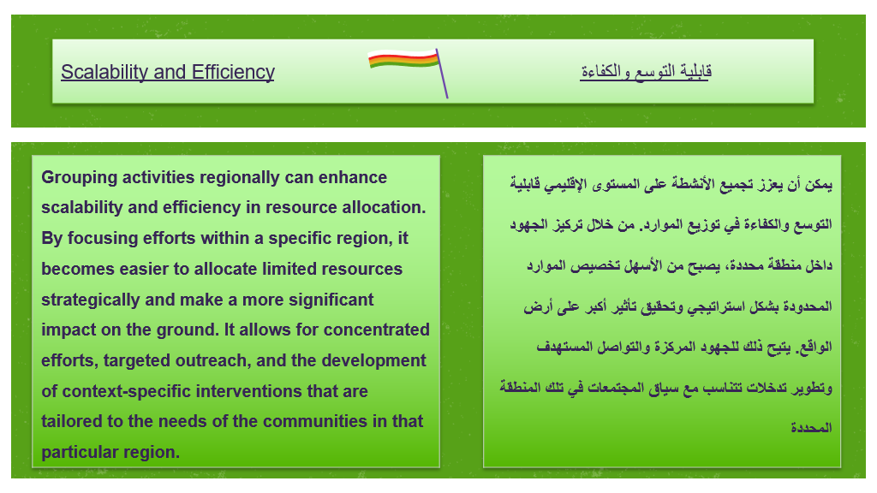
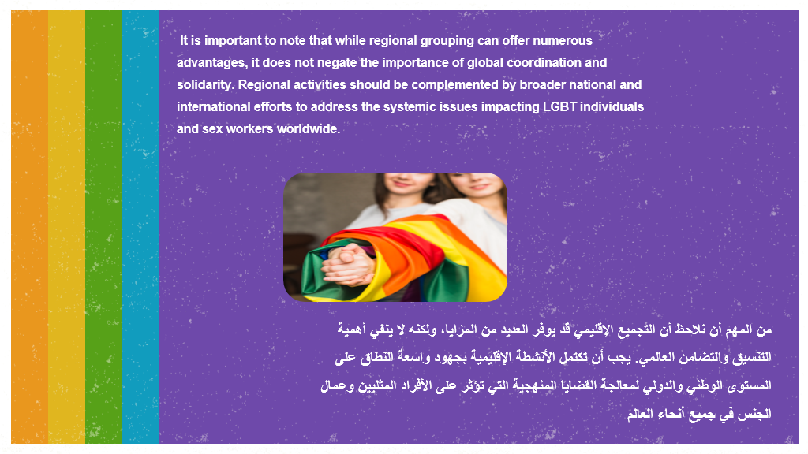

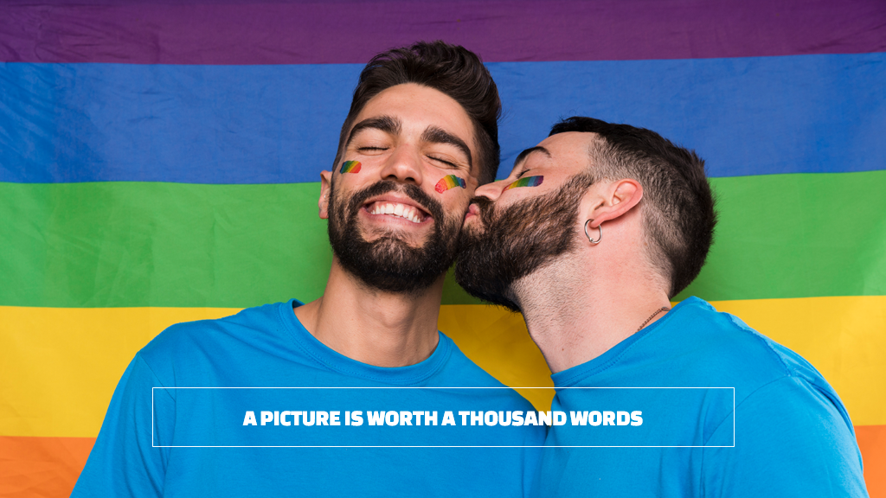

Appendix 5: IPPF Sex Work Policy

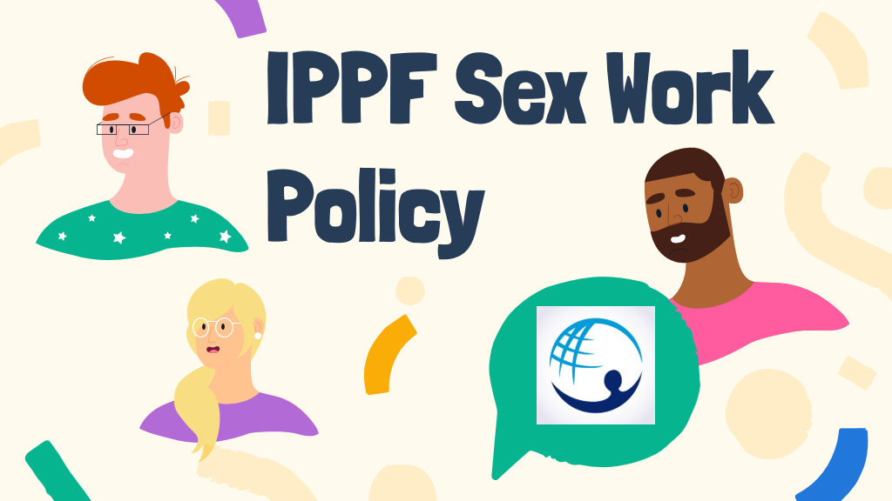
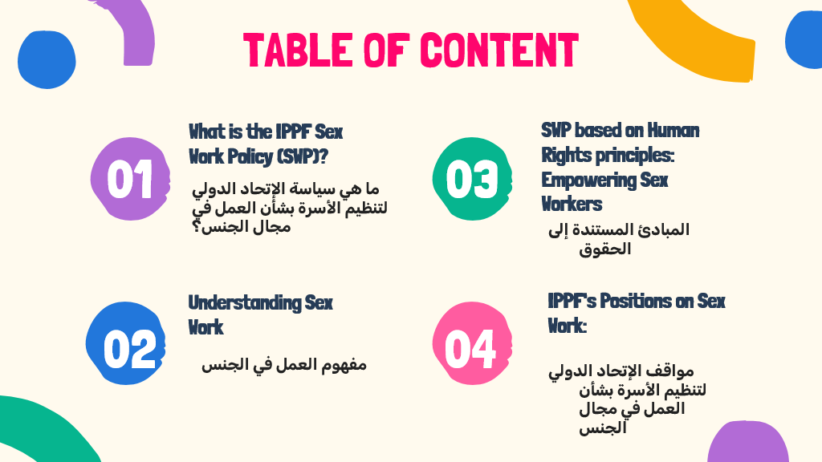

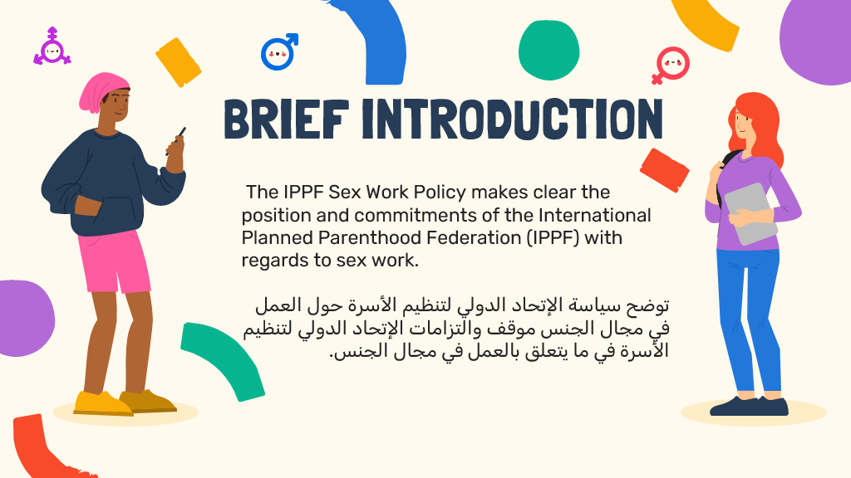

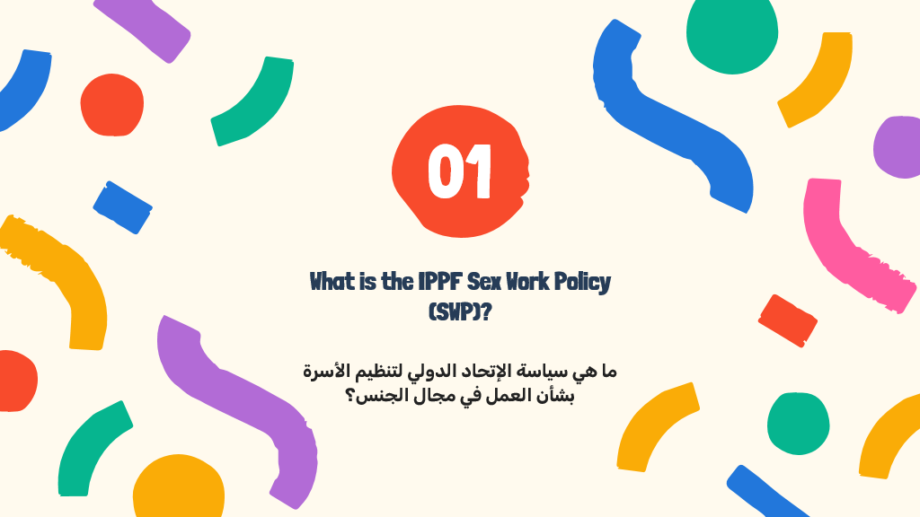
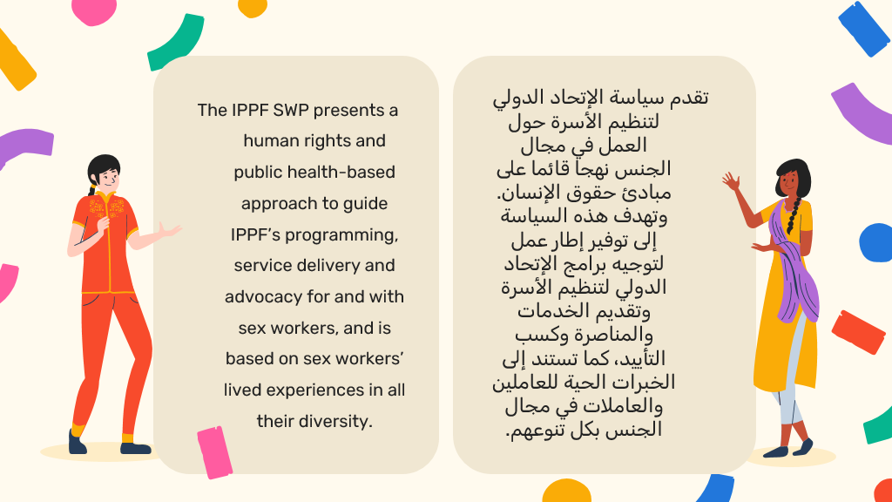
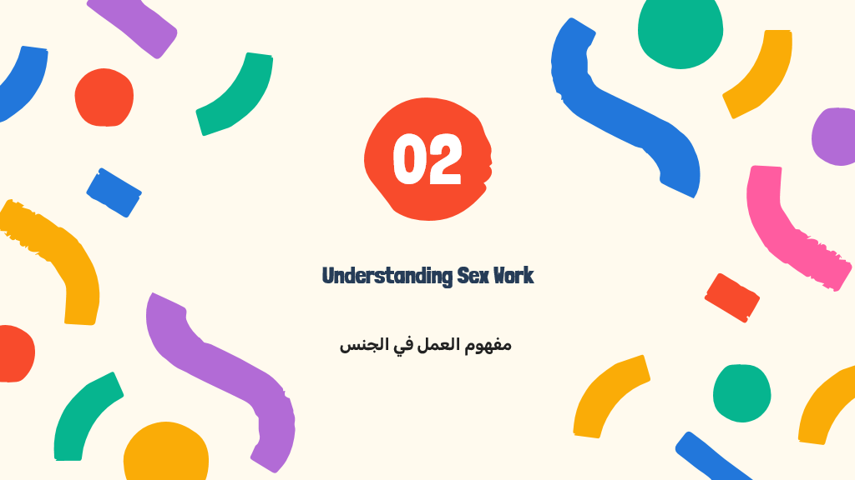
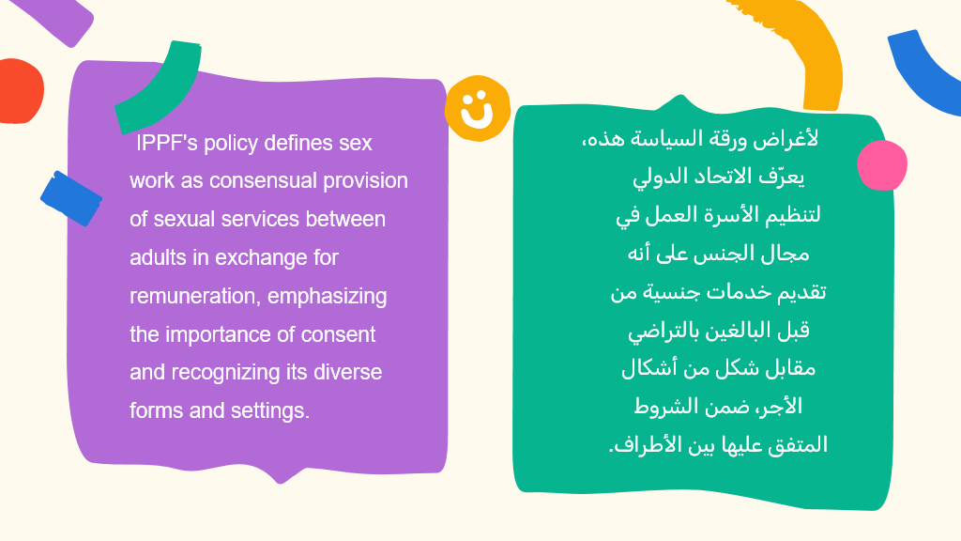v
