IPPF Charter and Rebrand Values into Action Webinar Report

Zoom, 13 July 2023

Introduction 2
Values Clusters – Gaining Consensus 3
Diversity, equity, inclusion, respect 4
Bravery, courage 5
Creativity, adaptability 6
Accountability, transparency, integrity 7
Partnership, solidarity 8
Compassion, love 9
Volunteerism 11
Passion, determination 13
Other input 14
Case Study 1 14
Case Study 2 16
Case Study 3 18
Wrap Up 20

Introduction
The IPPF Charter and Rebrand Values into Action Webinars were held on Thursday the 23th of July 2023 via Zoom. The webinars were open to the whole Federation, inclusive of MA EDs, MA volunteers, youth and secretariat staff, and were delivered with translation in French, English, Spanish and Arabic. The two webinars were hosted on the same day, with the same format but with different participants and at different times to allow for wider-spread participation.
The two virtual consultations convened a combined total of 73 people (excluding Identity Initiative staff and interpreters) from all regions.
The aim of the webinars was to update the Federation on the Charter and Rebrand process, share the proposed “values clusters” and understand how these values need to be applied in practice. This second consultation sought to prioritize the values that emerged in the first wave of consultations and refine how they are understood across regions and roles.
Both webinars were conducted in under two hours, and employed a combination of informative and interactive engagement tools to facilitate productive discussions over a short timeframe. The webinars were facilitated entirely by the Identity Initiative team.
This meeting note is a compilation of outcomes from both webinars, with consultation outcomes for each session merged together. For the agenda, participant lists and JamBoards, please refer to Annex 1, 2 and 3.

Values Clusters – Gaining Consensus
Participants were given a chance to respond to the eight values clusters that emerged during the first phase of consultations. For each cluster, they were asked to express (via mentimeter vote) how they felt about the cluster being one of IPPF’s core values. The options and their descriptions given were:
- No way: I really don’t agree with this value and don’t think it should be included.
- I’m confused: I don’t know why this is a value or what it means.
- Ooo YEAH!: This value really resononates with me.
- Disagree: I don’t think this should be a value.
- Love: I really support this value.
- Must include: This value really needs to be one of our core values.
- Meh/Whatever: I do not mind if this value is included or not.
This non-binary approach was selected to allow participants to react as they felt, and not push them into a yes/no vote that may have seemed premature or unclear given that the values are still being defined. It also allowed the Identity Initiative Team to understand the nuance around how people feel with each value, enabling further interrogation in focus group settings.
For the purposes of the below analysis, the responses have been coded as follow:
- Positive: Ooo YEAH!, Love, Must include
- Negative: No way, Disagree
- Neutral: I’m confused, Meh/Whatever
Participants were then given the opportunity to reflect further, either verbally or in the chat box.

Diversity, equity, inclusion, respect
Overall vote:
- Positive: 54
- Negative: 0
- Neutral: 2
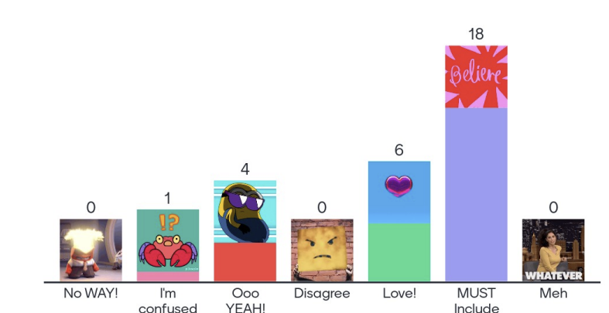
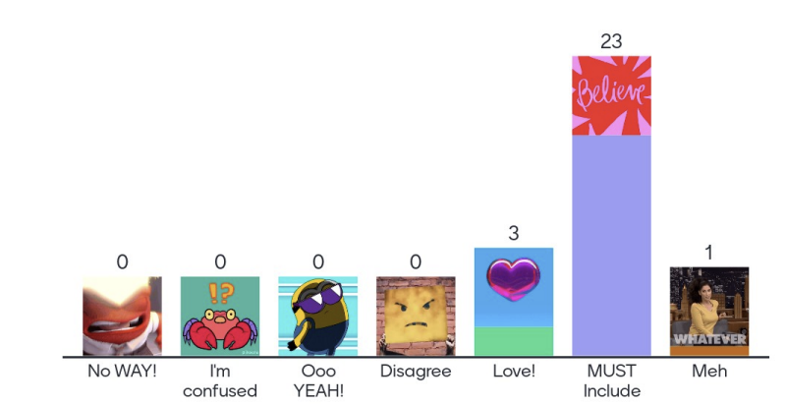

Discussion:
- This value is in line with equity/equality, should we add justice as a value
- It is a fundamental value but it must be lived internally among the MAs

Bravery, courage
Overall vote:
- Positive: 39
- Negative: 0
- Neutral: 9
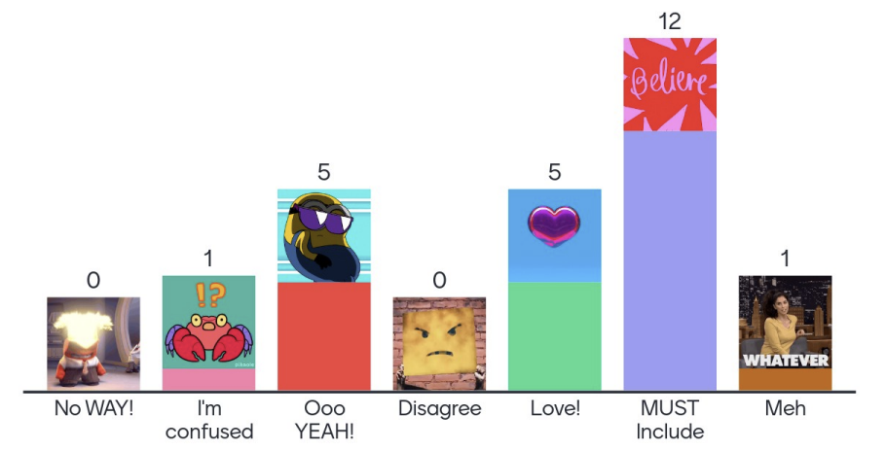
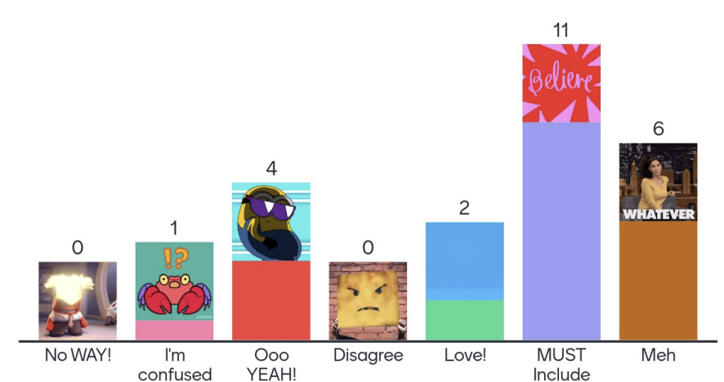
Discussion:
- Bravery and courage need to be defined as they can have many implications, some of which are not positive.
- These are not values, these are qualities.
- “Brave and Angry” - the previous IPPF slogan – is a response to the rise in the opposition, and we still need to be more proactive in responding to the opposition; we need to vev more aware to do our work in more difficult and challenging times.
- We need to place this value in the context of the world that we live in.
- If we look to the opposition, they may define themselves in the same way.

Creativity, adaptability
Overall vote:
- Positive: 37
- Negative: 2
- Neutral: 10
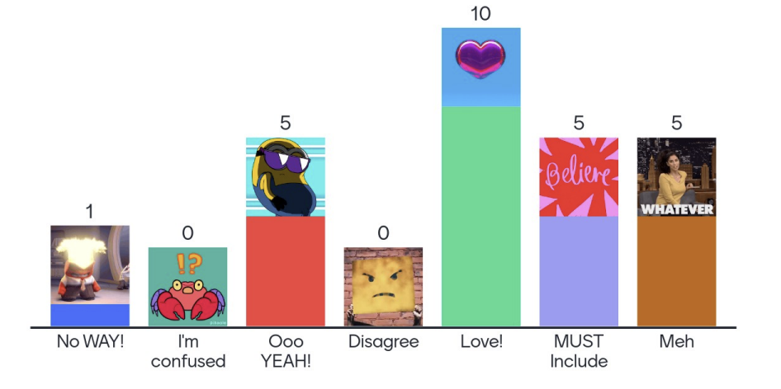
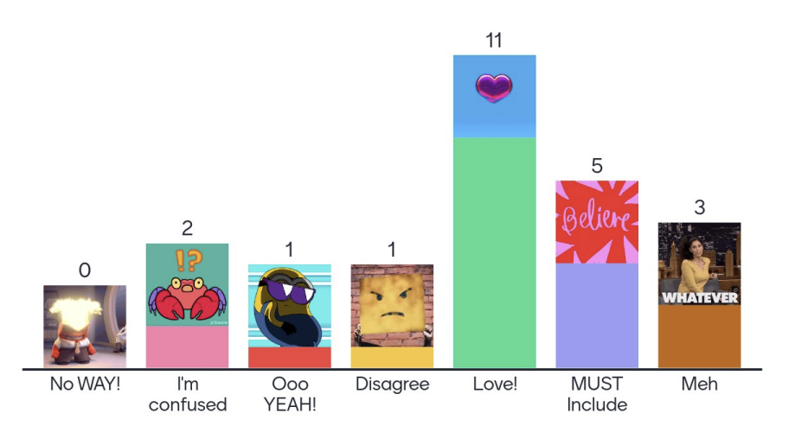
Discussion:
Participants felt that this value cluster allows IPPF to say up-to-date, though others felt that they are not values, they are approaches or ways of working. Others commented that creativity is good but adaptability can mean stepping back from other values because the situation is difficult or because we need to adapt to a global era that is more conservative than progressive.

Accountability, transparency, integrity
Overall vote:
- Positive: 47
- Negative: 0
- Neutral: 2
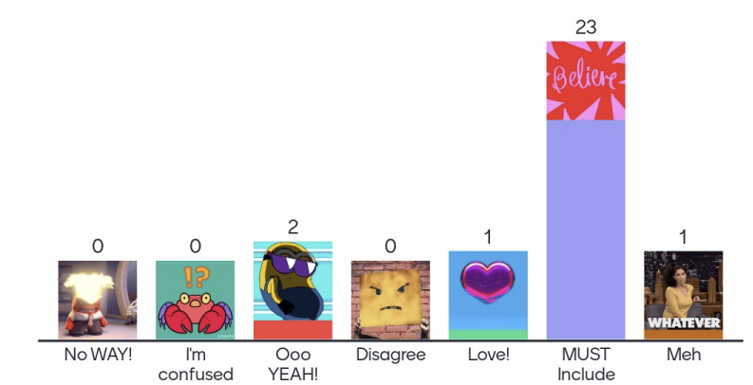
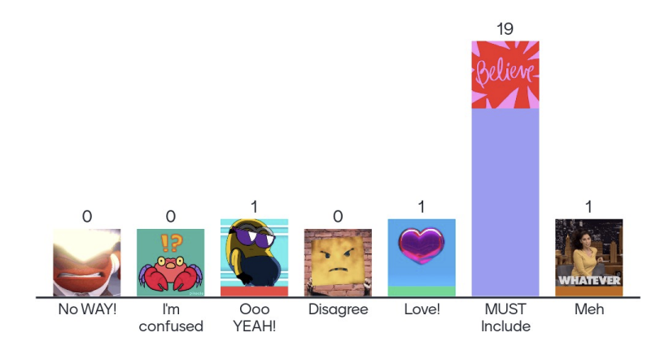
Discussion:
Participants felt that this is an area where IPPF is not doing enough, but should be doing more. Some felt that it was difficult to measure where we are and where we would like to be at the same time. Accountability towards the communities that we work with and the populations we serve is very important, and that transparency can only bring respect. There was strong consensus that this should be a value.

Partnership, solidarity
Overall vote:
- Positive: 33
- Negative: 8
- Neutral: 1
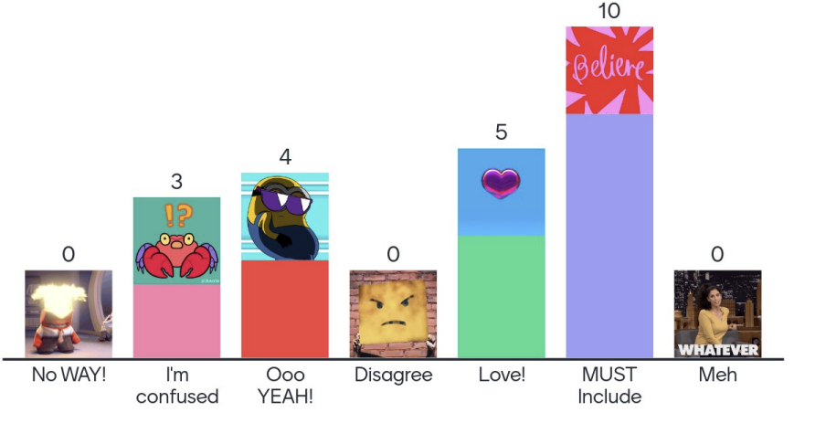
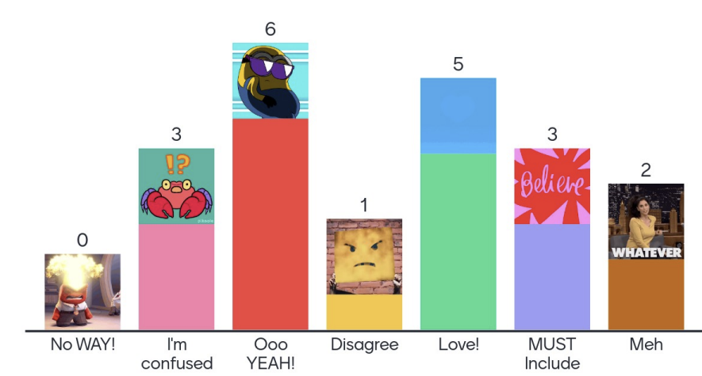
Discussion:
Participants commented that they see solidarity as a form on strength, and that the opposition is unified and strategic – so we need to be too. Some questioned whether these were a value or a strategy/way of working, while others reflected that they are terms that are used a lot in documents but that we don’t always see actions reflecting this. One participant remarked that “sometimes it is empty words that look good on paper but are not practiced.” To live these values, participants comments that IPPF needs to choose partners that share its values and vision, and that we need to be prioritizing this is in the future. Further, partnership and solidarity need to start with the value of empathy.

Compassion, love
Overall vote:
- Positive: 22
- Negative: 5
- Neutral: 19
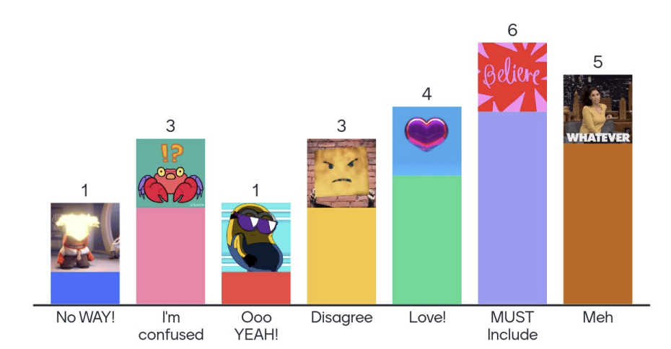
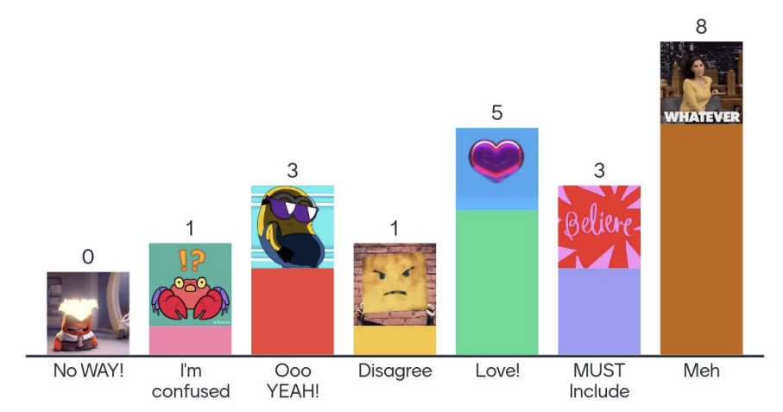
Discussion:
Participants felt that compassion and love are core values and central to the work we do. Another suggested that “love is the basis of all success. I love you so I want to help you and be by your side.” Other commented that “without love for the other we could not do the job we want to do”. Some participants linked love to acceptance and diversity: ”With love and solidarity we can accept each other.”

Several participants commented that “compassion” felt like an old-school or patronizing word.
Others quite liked it – with one person commented that “Compassion originally means suffering with. I deeply believe in that as a base for our life and work as part of our life.” They felt that “compassion is at the very heart of our work”, and suggested it linked to going the extra mile to reach people that need IPPF’s support, including in humanitarian settings.

Some participants asked how concepts like empathy and love can be translated more specifically into its practices. While they supported the sentiment that these values reflect, they suggested that wording or the final definition needs to be adjusted. In line with this, some suggested that empathy is a value, representing comprehension and understanding, but love it not a value.

Volunteerism
Overall vote:
- Positive: 22
- Negative: 11
- Neutral: 12
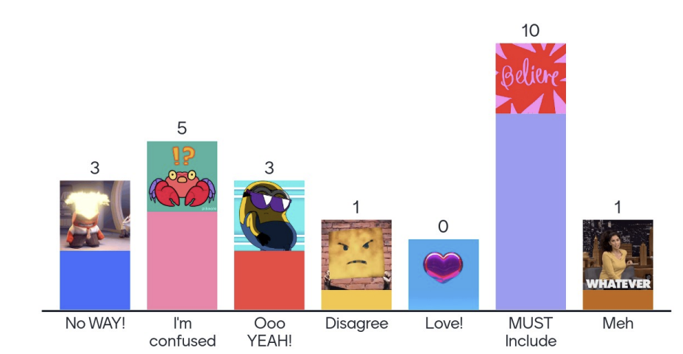
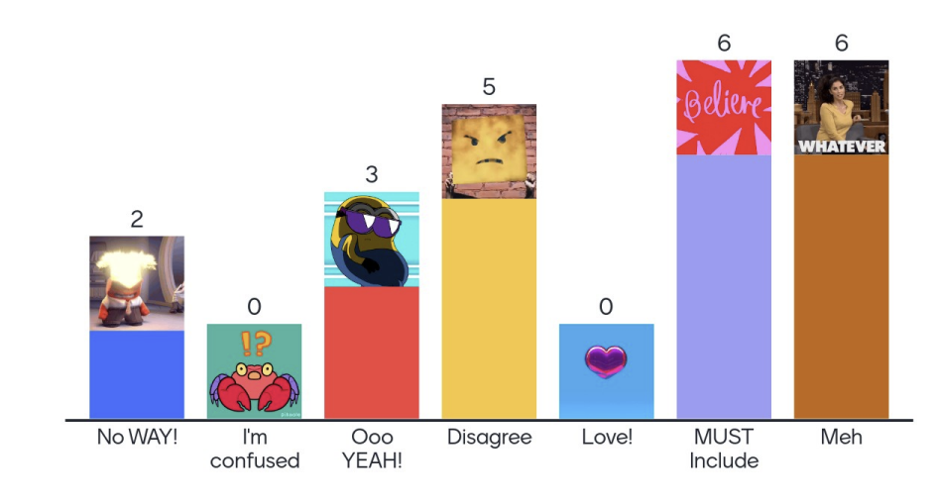
Discussion:
Participants shared wide ranging feedback on this value. Some felt that it was the backbone of the IPPF movement, and it is what makes IPPF a movement instead of a just a service delivery or advocacy organization. It was described as the “basis and creator” of IPPF and essential to its work; volunteers were seen to guarantee a certain continuity of action and to be a volunteer is to identify with the organization. Some mentioned that it is a defacto practice in governance and therefore a value.
Others felt strongly that the value needed to be redefined and/or that it is outdated. Participants mentioned that the times were changing, and that the nature of volunteerism must change with it. Some expressed concern with volunteerism, mostly “what this means for human rights, and equality, diversity and inclusion.” Linked to this, some people felt that volunteers should be compensated for their time, otherwise the only people that can volunteer are those from more privileged classes.
Others felt that volunteering must be valued in various ways, not just in financial compensation but also in providing the possibility of increasing skills through training and experience.
When exploring specifically if it should be a value, some participants suggested volunteerism was an strategy or activity, not a value, and suggested alternative words such as “service” or “activism”. This was linked to a desire to go further, beyond the traditional appraoch to volunteerism, and attract active, young people to promote SRHR, gender transformative approaches and diversity, not just people volunteering their time for services.

Passion, determination
Overall vote:
- Positive: 20
- Negative: 1
- Neutral: 21
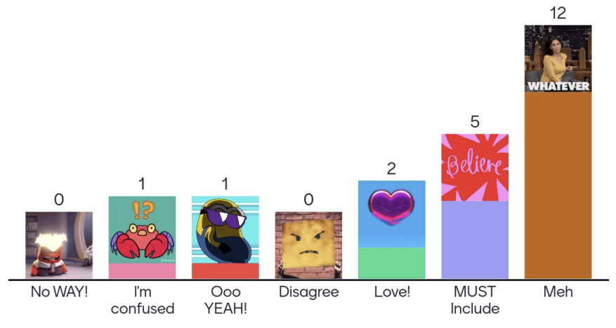
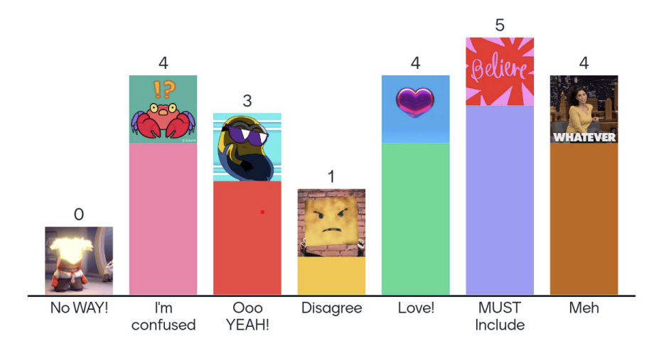
Discussion:
Some participants felt that this cluster of values was a little repetitive as there is already bravery, courage and others. Others felt that passion and determination are the unstoppable driving force that fuels IPPF’s work. They felt that passion guarantees a better quality of work and leads to creativity. It also was seen as the driving force behind doing work – even when it’s not exciting – and staying and leading.

Other input
Participants also remarked that they wanted to have an organizational behaviour descriptor attached to each of the values, and to consider how these values would work across other languages. Some also suggested that there were too many and suggested reducing the number of values clusters. Others suggested integrating references to freedom of choice, individual responsibility and pleasure into the Charter of Values.

Case Study 1
Case Study 1: The government is passing restrictive laws on LGBTIQ people. What should the local MA and the Federation as a whole do to demonstrate that it is being brave and in solidarity with LGBTQI people.
In response to this case study participants suggested that actions that would reflect the values of bravery and solidarity included actions related to advocacy, partnership, protection of advocates and activists, service and internal change.
Advocacy
- Having clear public positions on these issues and implementing a clear advocacy plan to deliver change.
- Organize public hearings with local LGBTQI networks to raise awareness on the issues faced by these communities, and advocate with the government.
- Use IPPF’s power and influence to draw attention to the challenges faced (with permission of local advocates).
- Organize regional meetings with progressive parliamentarians from the region to influence decision makers, as well as international advocacy.
- Identify entry points for initial discussion and sensitization of Government representatives through peer support strategy (neighboring country government) with similar culture.
- Speak up and louder on human rights alongside SRHR.
- Provide educational programs to promote understanding and acceptance of LGBT+ identities. Conduct training sessions for healthcare professionals, educators, and community leaders on LGBT+ issues and human rights.
- Write an Op-Ed/ participate in an interview for local media about the harms of such laws on the health and well-being of the LGBT community.
- Communication strategies / campaigns to disseminate the actions we are doing with the population of diversity. directed narratives.
- promote spaces for dialogue, design communication strategies to counter hate speech.
- React publicly as national associations and as a Federation, regardless of where it is happening.
- Speak up publicly and express support even if this is affecting / will affect eventual government funding for the MA or Federation.

Partnership
- Collaborate and strategize with local organizations that are leading this work.
- Work with partners to have a collective stance on this.
- Create a network bringing together the community to network.
- Support social movements related to the LGBT community.
- Connect MA to other MAs who have been in a similar situation to exchange learning/strategies.
- conduct outreach/ community days in solidarity with the LGBT community to hear what they are worried about and ways that the MA can try to meet their needs/mitigate harm.
- Collaborate with civil society to build support and pressure.
- A broad alliance with as many organizations as possible can reduce risk.
- Act as a true community that resists before these injustices.

Protection of advocates and activists
- Ensure that those that will be undertaking the actions are aware of the risks they will face, and work with our partners to have mitigations in place to manage the risk.
- If it is not safe for the MA, and its staff and clients, to publicly react, explore how the secretariat can take the lead in the advocacy work (press releases, joint declarations, etc.).
- Provide safety and security to activists.
- Ensure that our partners and volunteers understand the risks they are likely to face and have the capacity to manage the risks they will be facing.
- Ensure that the MA and staff/ volunteers etc feel support from Secretariat to be brave to speak out.
- Reach out to LGBTIQ+ ; explore with them what the most impactful way of acting in defending their rights, show public support, enhance, partner of LGBTIQ+ organisations.

Internal change
- Including more LGBTQI people into teams.

Services
- Create services that are accessible to that community, that are confidential and responsive to the SRH needs of the LGBT community.
- Showing solidarity could mean ensuring the community have access to services and a renewed commitment to service provision that is non-discriminatory.
- Speak publicly and continue services.
- Work with IEC activities on SRH rights and guarantee access to comprehensive health and SRH services for these groups.

Case Study 2
Case Study 2: An MA is updating its standards for client care. How do they make sure that the values of diversity, inclusion and empathy are reflected?
Participants spoke to the importance of ensuring a robust consultative process, developing inclusive policies and reflecting diversity, inclusion and empathy in the daily work of the Federation.
Hold a Robust Consultative Process
Participants spoke to the importance of consulting with clients, community leaders, and other stakeholders to ensure that the standards of care are inclusive, culturally sensitive, and responsive to needs of marginalized groups. They highlighted that clients need to be meaningfully involved in all stages of the consultative in order to understand their expectations for the standards. Such consultations would need to allow a diversity of respondents to inform them, and to be conducted in a safe and inclusive way. Consultative tools and methods to consider would include surveys, community meetings and focus groups.
Prioritize Inclusive Policies
Participants highlighted that IPPF would need to lead by example in working with the MA to revise their policies and support the MA in mainstreaming inclusion in all their processes in line with good practices from other MAs. The IPPF accreditation process was identified as a key point for the MA, in that it provides progressive standards that MAs must adhere to. Participants urged the MA to go through the IPPF accreditation process first, before reviewing its protocols, policies and standards. Following this, participants recommended that the MA adopt standards that reflect diversity, inclusion and empathy, as well as promote a gender-transformative approach to service provision.
Figure 1: Participant Quote
Having been recently arrested as an LGBTQIA+ activist, the best form of solidarity in that moment was human resources; we had lawyers who *volunteered* or demonstrated *solidarity* to get us out of detention. Despite being brave enough to speak out against religious hate speech, homophobia is still entrenched. So speaking out might help in one instance but in the long-term, you remain targeted and risk losing out on more 'domestic' opportunities. You risk also losing out on the partnerships and alliances you built over the years in the background because they don't want to compromise themselves.

The MA was encouraged to pay particular attention to the inclusion of transgender care, internal examination, HIV services, and considerations for the creation of a welcoming/friendly environment adapted to the needs of marginalized populations. Participants agreed on the need to prioritize the provision of comprehensive services and quality of care for all in the revised standards.
Provide Inclusive Services
Participants recommended that the MA follow up policy updates with a wide range of actions that would demonstrate diversity, inclusion and empathy. One of the agreed actions was to hire diverse staff and train them on these proposed values. Participants highlighted that training staff would help create a supportive organizational culture that reflects diversity, inclusion and empathy in practice., especially within service provision.
The MA was advised to create a welcoming space for clients with accessible visuals that would ensure that diverse clients feel safe and welcome. In order to do this, participants recommended that diverse local groups be consulted to design services according to their needs. Building feedback and evaluative mechanisms within service provision was highlighted as a way of further embedding the perspectives and voices of prospective clients to sustain improvements in the standards of care.

Case Study 3
Case Study 3: Many girls, women and transgender men and non-binary people are unable to access abortion services due to a combination of restrictive laws, humanitarian crises, socio-economic barriers and other obstacles. How can MAs and the Federation as a whole demonstrate creativity and innovation to increase access to abortion?
Participants spoke to the need for the federation to integrate digital and self-care services, conduct outreach activities, work with networks of service providers, explore legal solutions and provide better leadership and financing for access to abortion.
Integrate with Digital and Self-Care Services
Participants proposed that access to abortion be increased by integrating abortion services within self-care and digital models of service delivery. Examples given included using online services, mobile applications, telemedicine and self-care checking of availability of misoprostol. These digital health and self-care interventions would need to be delivered to the full extent permitted by the law.
Conduct Community & Social Media Outreach
Participants recommended that the federation invest in conducting community and social media outreach to increase access to abortion. This outreach would serve to generate demand for serves by sharing clear information on where people are able to get safe abortion services and to raise awareness on the importance of abortion as a service. Participants recommended the use of evidence-based multimedia and community outreach campaigns, using gender-inclusive and -empathetic communication materials in different languages. They urged that these campaigns be created in close consultation with targeted groups in order to reach them using the channels, methods and messages that they relate to best. The campaigns would also need to be delivered by trained service providers alongside the targeted groups, including LGBTQI+ people.

Work with Secure Service Provider Networks Delivering Quality & Inclusive Services
The federation was advised to combine safe service provision with targeted outreach to specific vulnerable communities through trusted safe networks and communication channels. These services would need to be accessible and safe for marginalized communities and include elements such as harm-reduction counselling and support for abortion self-care. In order to do this, participants recommended that the federation identify and work with local support networks as well as trained service providers with the capacity to provide the abortion care. The identified service providers would need to ensure that all information availed would be gender-inclusive to cater for diverse clients.

Figure 2: Participant Quote
These are all initiatives that we’d like to see and we’ve started, but we have to be sure we have the common purpose and how the MA should be an example and reflect the quality services in all we do.

Identify & Exploit Legal Loopholes
In contexts with restrictive laws, some participants advised the federation to find gaps in the law and operate within those spaces. For example, in contexts where the law permits abortion “if client is in danger”, then an MA can identify a “danger”, and that will then legalize the service. Other examples of working around the law included providing referrals and financial support for clients to access abortion from a neighboring country and building alliances with organizations that provide information on what to do when the country context does not allow access to the service. One participant shared the experience of Orientame in Colombia which worked "outside the law" for many years but managed to still provide an impeccable abortion service.

Advocate
Participants broadly agreed on the need to advocate for the inclusion of safe abortion in country laws, in contexts where abortion is illegal. The federation was urged to advocate for safe abortion services to be made accessible for marginalized people, working alongside community-based activist groups to target decision-makers. Some participants recommended that the federation advocate for abortion services to be included in the humanitarian response, and to have a broadened legal definition of who qualifies to receive abortion services. In order to deliver on these recommendations, one participant highlighted that the federation members needed to understand that they are advocacy agents with all governments for access to SRHR services regardless of their ideology.

Strong Leadership
The federation was urged to take the lead in identifying opportunities to advance medical abortion self-care. Some MAs gave examples of how such leadership would work in practice. In Ecuador they positioned CEMOPLAF as a leader in rights-based sexual and reproductive health that guarantees access to services (safe abortion and tele-abortion). In Colombia, Profamilia referred people who needed an abortion to their clinics before the rulings decriminalizing abortion in the country came out.

Financing
Participants also recommended that the federation provide funding to MAs and local organizations to design tailored programs to better provide information, attention and care to the people that undergo or consider abortion. The federation would also need to avail resources for MAs to go to the territories where people that need abortion live, instead of relying exclusively on them to travel to static sites.

Wrap Up

Participants were invited to share their key takeaways and recommendations from the webinars, as the sessions ended. Most participants agreed that the webinars were productive and used a good methodology to facilitate discussion on the Charter and Rebrand. With regards to recommendations, participants spoke to the need to rethink the federation’s approach to values, link values to action and convene more consultations on both the Charter and Rebrand. Federation members were encouraged to keep working together and maintain momentum in providing services to marginalized communities.
Rethink Approach to Values
The facilitators were asked to consider trimming down on the proposed principles and to provide more precision in the definition of values and related terms. One participant highlighted that there are too many values, and that there is need to group similar ones and provide clarity on the chosen ones. In streamlining the values, the federation was reminded to focus on values in line with Strategy 28, such as diversity, inclusion and creativity. The facilitators were urged to give further thought to the validity of love and compassion as values, as well as to consider exploring substantive equality as a basic principle of human rights.
Figure 3: Participant Quote
We have to start talking for “substantial equality” as a basic principle of fundamental rights according to which every society should strive to ensure equal results and fair conditions for prosperity of socially excluded and vulnerable people. Not only equality.

Link Values to Action
Participants reiterated the importance of connecting values to actions. They acknowledged that values are not empty words, and that the federation would need to act in a way that demonstrates the values identified. Some participants recommended the introduction of accountability measures and feedback mechanisms to monitor the extent to which the federation adhered to the identified values. Members of the secretariat were called upon to be role models of these values, in ‘practicing what they preach’. Some participants spoke to the need to ensure shared understanding of the values within the federation, and that the values would need to be documented in various IPPF guidance documents and capacity statements.
Figure 4: Participant Quote
It will be interesting if, for each of the proposed values of the federation, we could develop a sort of 'litmus test' that will give us the sign on how committed we are in upholding each

Well-Run Productive Session with Good Methodology
Most participants agreed that the webinars were productive, and that the methodology used for the sessions was well thought through. Some of the adjectives used to describe the webinar were that it was thought-provoking, well-run, interesting, fantastic, gratifying, informative, good and great. Participants spoke to the usefulness of the case studies in triggering diverse conversation on difficult issues and facilitating the collective exchange of ideas. Some participants recognized the value of the webinar in advancing Strategy 28 and lauded the consultation process for bringing the federation together. One participant who had taken part in focus group discussions on the values, conveyed pleasure in recognizing concerns that were raised in focus groups, being raised in the federation-wide consultations as well.
Figure 5: Participant Quote
These spaces are very important. I love to see that we share similar doubts, but also similar purposes; that we can question the status quo - that we can change, that resignations have to be made to make room for new and innovative ideas

Have More Consultations
Some participants encouraged the federation to convene more consultations in order to bring in different views. One participant singled out the need to consult MAs and incorporate their inputs. The federation was implored to avail resources for broader consultations at MA-level, and to do so expediently while being mindful of how rapidly political contexts change. One participant requested that the facilitators provide clarity of the scope of work in their consultations as it wasn’t clear if the consultations included discussions on the rebrand.
Maintain Energy, Momentum and Leadership
Some participants encouraged federation members to maintain energy and momentum in advancing SRHR. Some participants conveyed optimism for the future, with one participant calling for the federation to be as “strong and demanding worldwide as FIFA”. Participants also urged the federation to continue its work to provide comprehensive SRHR services to all.
Participants acknowledged that there was more work to be done and that the federation needed to maintain momentum in getting this work done. In this regard, one participant called for more activism from federation members, while another called for the federation to demonstrate more love, passion and empathy for all people. Another participant urged the federation to keep prioritizing access to safe abortion, in a non-discriminatory way.
Figure 6: Participant Quote
We cannot talk about the health, wellbeing and rights of girls and women, of the LGTBI+ community if we do not take into account inclusion, empathy and solidarity.

With regards to leadership, participants highlighted the need for the federation to take a stand on political matters, as guided by organizations on the ground. MAs were encouraged to continue planning, transforming and motivating health work in their territories and to not give up the quest for SRHR for all.

Figure 7: Participant Quote
I think it's time to be very together and together. Difficult times are coming for Latin America and our countries

