IPPF Charter and Rebrand Values into Action Webinar Report

Zoom, 11 October 2023

​​
​
​
​
​
​
​
​
​
​
​
​
​
​
​
​​

Introduction
The IPPF Charter and Rebrand Values into Action Webinars were held on Wednesday, 11 October via Zoom. The webinars were open to the whole Federation, inclusive of MA EDs, MA volunteers, youth and secretariat staff, and were delivered with translation in French, English, Spanish and Arabic. The two webinars were hosted on the same day, with the same format but with different participants and at different times to allow for wider-spread participation.

The aim of the webinars was to update the Federation on the Charter and Rebrand process, share the proposed short list of values, and to get wide feedback on the draft defintions of two of the values – justice/inclusion and transformation. This consultation built on the refining of values clusters that took place across Summer 2023 and the drafting of definition that has taken place through regional consultations from August to October.

Both webinars were conducted in under two hours, and employed a combination of informative and interactive engagement tools to facilitate productive discussions over a short timeframe. The webinars were facilitated entirely by the Identity Initiative team.
This meeting note is a compilation of outcomes from both webinars, with consultation outcomes for each session merged together.

Proposed values – Gaining Consensus

The objective of the opening exercise was to gain feedback from participants on the short list of proposed values. They were asked to share their reaction to each value through an indicative “vote”. The voting options were:
- No way: I really don’t agree with this value and don’t think it should be included.
- I’m confused: I don’t know why this is a value or what it means.
- Ooo YEAH!: This value really resonates with me.
- Disagree: I don’t think this should be a value.
- Love: I really support this value.
- Must include: This value really needs to be one of our core values.
- Meh/Whatever: I do not mind if this value is included or not.

They then had the option to comment on each value. Below are the notes per value, along with the mentimeter voting outcomes. Participants were then asked to share via WordCloud any words or concepts that they felt were most important to them for the Charter of Values.

Passion

A vast majority of participants supported the inclusion of the value of passion, while some suggested that it needed to be clarified; ie was it referring to sexual passion, commitment or services, and it needs to convey more clearly why we care about our work and these issues. Another felt it was difficult to link direct to SRHR issues and as a result is not unique to our movement – as he commented “even racists have passion”. This was supported by another participant who further suggested that it is a way of working rather than a value, and that the value should be a commitment to the empowerment of our people.

Other felt that passion is central to our ability to do our work, even in challenging circumstances, arguing that it was a fundamental value, and that without it we would be more prone to giving up when faced with opposition.

One participant felt that the value of volunteerism should replace the value of passion, as it is passionate volunteers that drive MAs, while another felt that the definition should address issues of biases or exclusions based on being passionate.

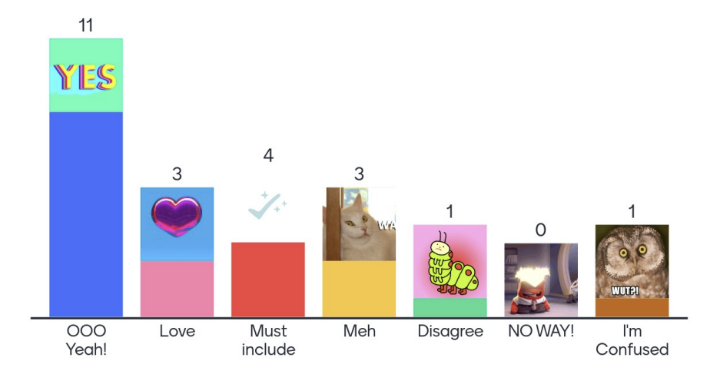

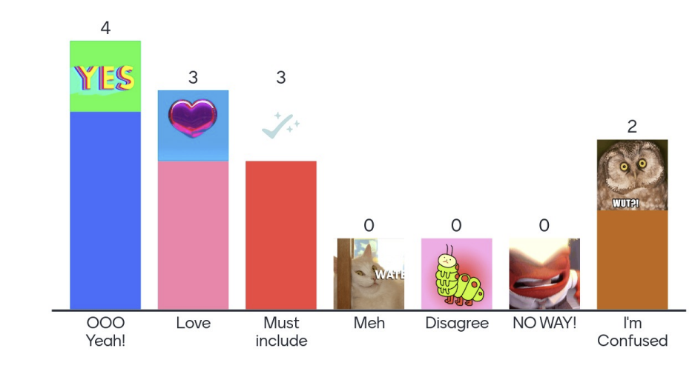

Solidarity
One participant felt that this value should be listed first, as it is the most important thing for the IPPF movement; due to strong consensus, there was limited discussion.
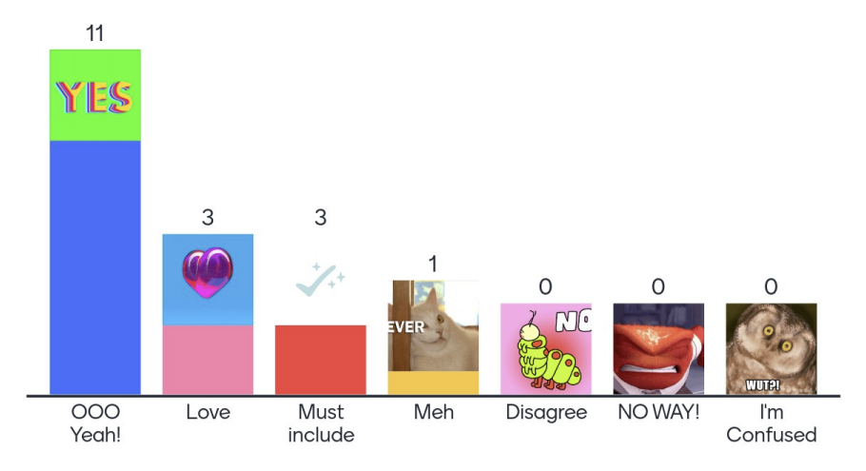
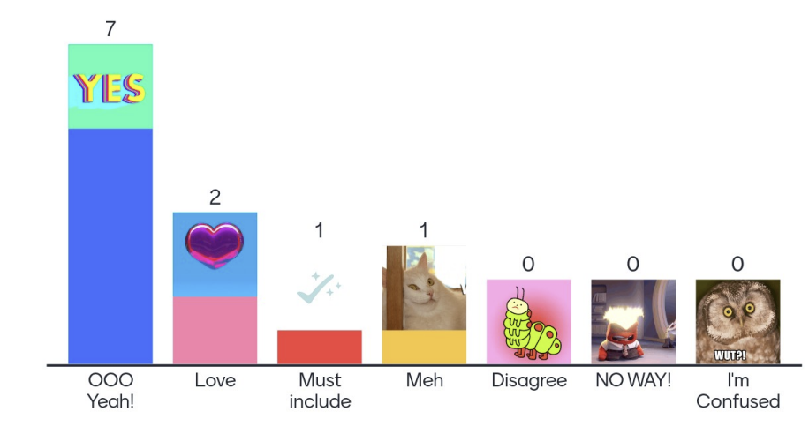

Courage
While courage had a great deal of support, participants shared that they were concerned it wasn’t a core value, or suggested it should be contextualized. One participant suggested it should be understood as “political courage” while another felt it was important to distinguish between personal courage and institutional courage. Those in support of the value felt it was essential to reach our goals and that without it, it would not be possible to make progress. Finally, a participant suggested that “commitment” may be a better term than courage.

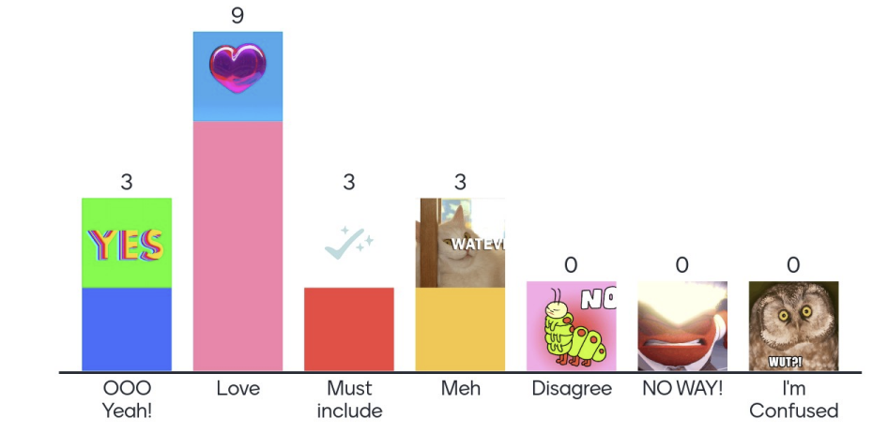
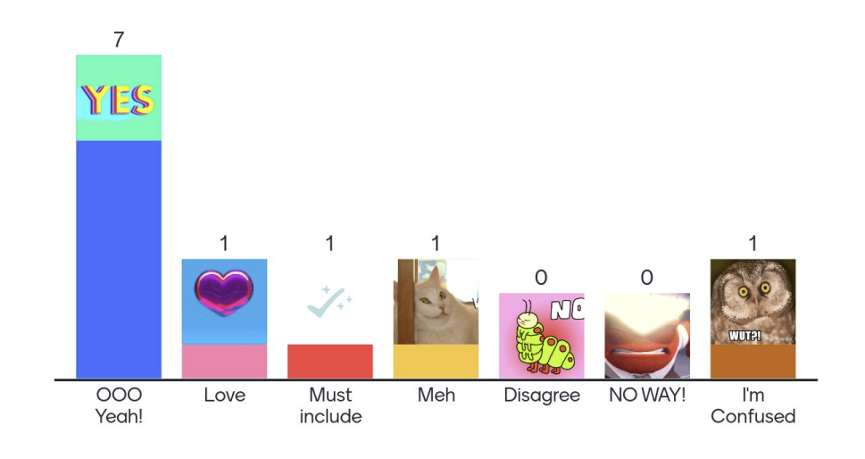
Inclusion
There was support for the use of the term “inclusive” or “social inclusion” to capture this value, while others suggested that it needed a clearer more accessible term.

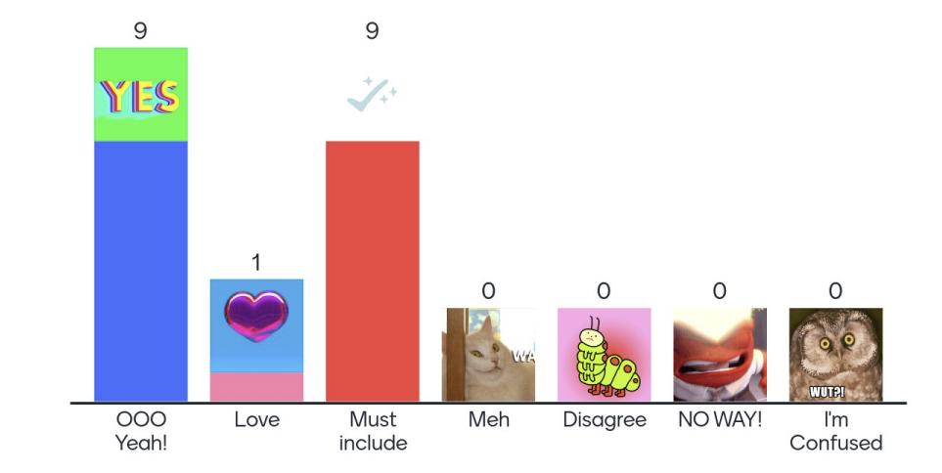

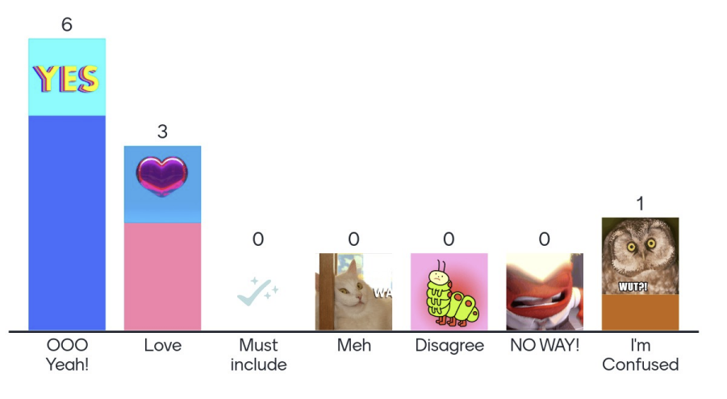
Integrity
There was strong support for the term integrity, and many felt it should be accompanied by the terms accountability and transparency. Another participant felt that accountability was a better term because integrity is broader and more complex; it can span personal, moral or religious contexts. The definition should also include all levels from the secretariat to the service providers in clinics and community outreach.
ntegrity:
Extra must include x1
Chris: Thanks to the accreditation process, we are well prepared to live up to this promise (because that is what a value is: a standard you want to live up to..
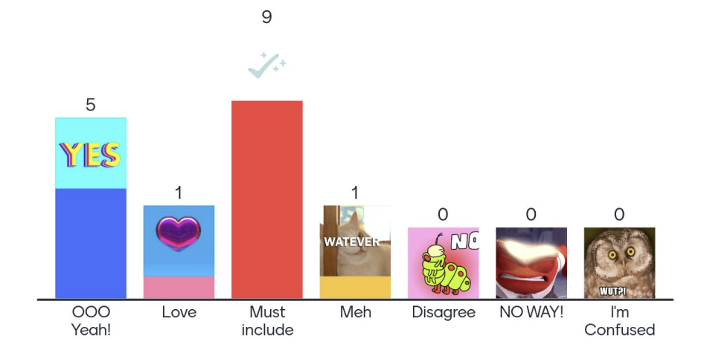
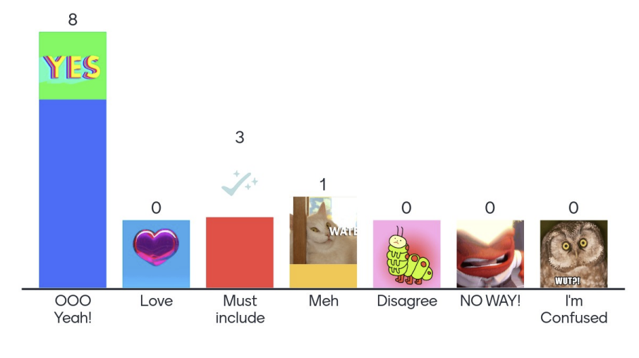
Transformational
Adaptability was suggested as a better term to use for this series of concepts; some expressed concern that the word transformational was too abstract or did not work in other languages (ie French). Participants pointed out that it is an important value because it recognizes that political, social, economic contexts need to transform to realise change, and not just internal factors. Another participant felt it could be interpreted in different ways: “For example, in Uganda now we could say there is transformational work regarding criminalization of same sex relationships...so not in the direction of inclusion and justice.”
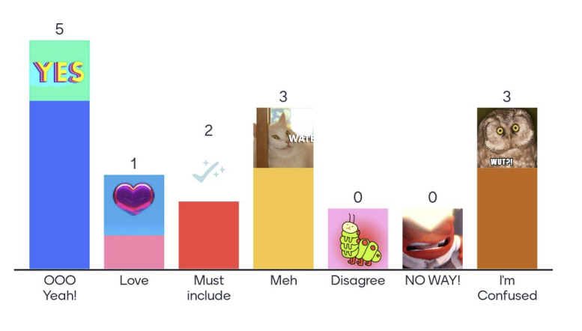
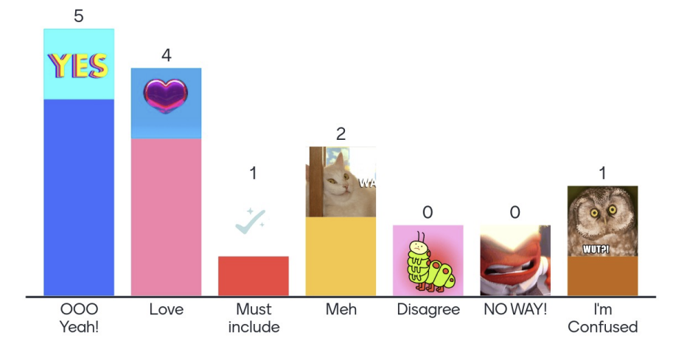
Word Cloud of important/missing concepts

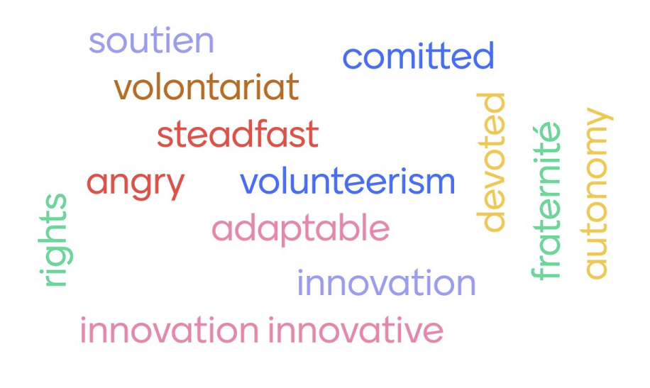

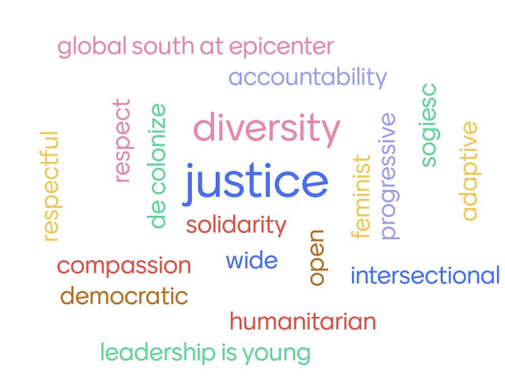

Workshopping Definitions: Justice/Inclusion

Definition shared:
IPPF embraces diversity and promotes equity across service delivery, advocacy and workplace culture. We champion social justice and foster an atmosphere for members and stakeholders to thrive and contribute to a more just and equitable society regardless of age, race or ethnicity, religion, gender identity or expression, sexuality, HIV status, engagement in sex work or any other status. IPPF welcome the richness that living in a global society brings and commits to celebrating the diversity of its member associations, employees, volunteers, partners and everyone it has contact with. We strive for a world where everyone has equal access to SRH care that prioritises their pleasure, choice, and bodily and reproductive autonomy.​

Comments and edits:
Participants shared comments on the definition via jamboard; these have been edited for clarity:
- In “regardless of” section, include sex, political belief, economic status, nationality, disability, marginalised groups, gender, intersexuality
- In contrast: keeping "HIV status" is like promoting further stigma when it should just be seen as one of many chronic infections which has treatment.
- Need to include diversity of clients in the groups we serve, and articulate engagement with marginalized and disadvantaged sectors as a key concept in this definition
- Need to include concept of intersectionality and the universality of justice and inclusion across IPPF MAs; need to clarify if this is social inclusion or inclusivity of particular marginalized groups
- Delete last sentence as it mostly defines the type of SRHR care we are offering
- Acceptance is a more suitable term than “justice”
- The definition is great. I would still go with Justice as the overarching concept.
- Don’t use acronyms
- We strive for a world where everyone has equal AND EQUITABLE access to SRH care: ADD EQUITABLE BECAUSE EQUAL AND EQUITABLE ARE DIFFERENT
- No inclusion = No justice
- Other terms that were seen as valuable included: Diversity, Acceptance, Non-discriminatory , Tolerance, Accessibility, client-friendly spaces, bodily autonomy, choice, pleasure, holistic
- Inclusion also means leaving no one behind and Universal health coverage.

Transformational

Definition shared:
IPPF embraces rights-based values in its approach to advocacy and service-delivery, using community-driven innovations to improve people’s lives. We recognise local context while challenging the status quo that creates inequality and threats that advance SRHR around the world. We work towards a world where all people have access to quality care and have the freedom to engage in the full and pleasurable sexual and reproductive life that they choose, and where these rights are respected by all.

Comments and edits:
Participants shared comments on the definition via jamboard; these have been edited for clarity:
- I think we need to articulate here the capacity of IPPF on the aspect of adaptive management, by adapting we transform our strategies and approaches in delivering SRHR services, partnerships and collaboration, etc To make it appropriate to the changing situations
- I believe we need to be more specific/clear about the need to challenge the status quo. That we need to be creative and innovative in an ever changing context/world.
- ...recognize local context, willing to innovate and adapt while challenging the status quo'
- “and where these rights are respected by all..” : Include reference to SRHR as being part of human rights
- Include reference to our activities being based on scientific studies and depend on the sociological, economic and political situation of the countries concerned.
- Need to make specific reference to both being transformational in the sense of transforming for good people lives and in the sense of being able to evolve and transform the way we do things - the way we transform our narratives, our clinical guidelines, our advocacy strategies
- Terms to include: justice with rights based, innovation, gender-transformative, sharing experience between IPPF members.

Reflections on Independence
Participants had the opportunity to reflect on the concept of independence; below ar their reflections, edited for clarity:
- Independence: local solutions + unified spirit and work more closely with women from diversities! Communities!
- We need to a unified vision! But this needs to go beyond, secretariate! More to bring MAs on board. We need newness! and this will really help
- MA centric inward approach (taking into consideration local context, needs of clients etc) and mix of inwards and outward approach as part of federation.
- This is democracy, once the values and strategy have been discussed by the MAs and confirmed, we must apply and be united.
- Maybe unified in adopting the values but independent in implementing it nationally/translating it into national action?
- Provide the necessary assistance to members through directives that take their realities into account
- Secretariat provides the framework for MAs. MAs are equal partners to implement as appropriate - working within the framework provided. Secretariat monitoring role.

