**RBM E-TOOLKIT MESSAGING FOR MA FORUM**

**ENGLISH MESSAGE**

**IPPF EN is launching, inside IPPF Learning Academy, the Results Based Management (RBM) E-toolkit.**

**About the RBM E-TOOLKIT:**

It is a digital resource for interactive learning and practice that can improve your project design and implementation journey. Can be used both online and offline, making it accessible to everyone.

The e-toolkit is designed to help beginners and intermediate level RBM knowledge holders. Can be used by any staff and interns within IPPF Secretariat, Member Associations and Collaborative Partners, interested in developing their understanding and skills in project design and management.

The online version of the E-Toolkit can **be accessed via** **IPPF Academy Platform (M&E Section) -** [**Course: RBM E-toolkit (ippf.org)**](https://academy.ippf.org/course/view.php?id=12)**.** If you do not yet have an account for IPPF Academy Platform contact Anemarie Gasser at [agasser@ippf.org](mailto:agasser@ippf.org) for support. For use in unstable/ poor internet connection environments, **an offline replica** of the learning package can be downloaded [here.](https://drive.google.com/file/d/1KEZ8fg7lyjd7-v_jHeg2eD29qj2ZR5Lr/view?usp=sharing)

The RBM E-Toolbox is composed of micro-learning modules. Each module is a short lesson, with a maximum duration of 30 minutes, focused on key concepts, practical steps, and tools to be used during project design stage. Practice worksheets are downloadable for direct use in your organization.

The current first iteration of the E-Toolbox is focused on project design/ planning. You can find guidance on **how to develop a Project Theory of Change**, through structured analytical steps as problem identification and formulation; context analysis (using PEA approach/ Political Economy Analysis); stakeholder analysis (using Power Analysis tool); problem analysis & diagraming (using Problem Tree, 5 Whys and Rich Picture methods); solutions & pathway for change identification and diagraming; assumption identification within pathway for change; Theory of change narrative and visualization.

The 2024 second iteration will include also Guidance on how to develop a M&E Framework and Plan; how to prepare for M&E Implementation during project life.

[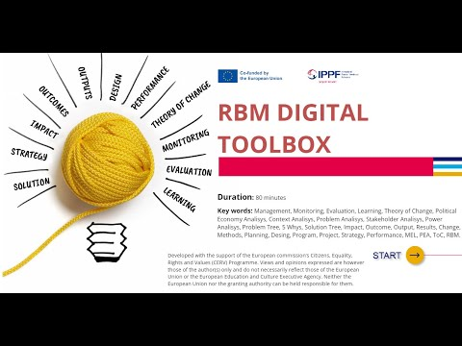](https://www.youtube.com/embed/X7OJ_EEsurU?feature=oembed)

About the RBM E-TOOLKIT LAUNCH EVENT:

For all those intersted to find out more about the E-Toolkit and eventualy start using it, **1-hour launch event will be delivered** in 2 identical online meetings (to acomodate various time zones):

* 17 November 2023, 11:00 a.m. (Belgium Hour) - [register here](https://events.teams.microsoft.com/event/155d7a27-a575-4b6a-8143-48390f091478@56af9532-501a-404c-995d-80633a35c0ac)
* 20 November 2023, 15:00 p.m. (Belgium Hour) - [register here](https://events.teams.microsoft.com/event/df12d3b4-e727-4e8d-b178-75aa61728891@56af9532-501a-404c-995d-80633a35c0ac)

During the launch event we will:

* introduce to the E-toolbox - what it is, how it can help you, where you can find it, how to use it
* make a live demo on how to access it and interact with the E-toolbox
* clarify the type and level of personalised support IPPF EN is making available to those that are interested to subscribe as first cohort of e-toolbox users and testers in the next 5 months.

Join us for our RBM e-toolkit launch event to see if this is the right tool for you or for the MAs that you interact with. We look forward to seeing you online!