IPPF Charter of Values South Asia Regional Meeting Report

Delhi, India 20-25 August 2023

Contents
Introduction 3
Youth Consultation 5
Member Association Consultation 8
Reflecting on “values clusters” 8
Values in Action 13
Pen to Paper 20
Consultation with Community Groups 21
South Asia Regional Office 24

Introduction
During the South Asia Regional Office (SARO) meeting held in Delhi, India from August 20 to 25, 2023, the Charter of Values and Global Rebrand team ran four consultation meetings on the Charter of Values and Global Rebrand. The meetings were held with:
- Youth representatives from the South Asia Regional Youth Network (SARYN)
- Member Associations representatives (MAs) from all associations in the region
- Members and representatives from the SRHRJ community in India
- Staff members at South Asia Regional Office.
In total, the team consulted 87 individuals from all countries in the region. This report covers the discussion focused on the Charter of Values; the outcomes of the Rebrand consultation are included in a separate report.

Objectives
The objectives of these consultations with respect to the Charter of Values were to:
- Gather feedback from diverse stakeholders on the proposed “values clusters”, to identify which resonated with them and which were not seen as relevant to IPPF.
- Gather alternative values or values descriptions to enhance or replace those in the “values clusters.”

The input gathered is used to prioritise and refine the “values clusters”, define the values, and inform the overall direction of the Charter of Values. These “values clusters” were developed out of consultations that took place from January to July 2023.

The “values clusters” consulted on across all sessions were:
- Diversity, equality, equity, inclusion, respect
- Bravery, courage
- Adaptability, creativity, flexibility, innovation
- Accountability, transparency, integrity
- Partnership, community, solidarity
- Compassion, empathy, love
- Volunteerism
- Passion, determination

Youth Consultation
The consultation with youth was attended by 15 individuals from the region. Following ice-breaker sessions, participants were asked to reflect on how they felt about the draft “values clusters.” Upon being shown a particular cluster, they were asked to gather around a sign with an emoji, depending how they felt about the value. The options and their descriptions given were:
- No way: I really don’t agree with this value and don’t think it should be included.
- I’m confused: I don’t know why this is a value or what it means.
- Ooo YEAH!: This value really resonates with me.
- Disagree: I don’t think this should be a value.
- Love: I really support this value.
- Must include: This value really needs to be one of our core values.
- Meh/Whatever: I do not mind if this value is included or not.

After this, they were asked to indicate (using a sticker on a poster) which values are “must keep” and which they would be happy to drop. Participants also shared comments on what it means for young people on post-it notes. Following are the outcomes per value, with direct quotes from participants indicated:

Diversity, equity, equality, inclusion, respect
- Strong and universal support.
- “Need to include work with key populations.”
- “Including all the diverse groups and respecting everyone’s equality and rights.”
- “IPPF works in global spaces, and it works for humanity, so it has to be as diverse and inclusive as possible providing everyone with equity and equality and respect.”
- “To me, being respectful is to spend more time listening to someone when they walk to me, as opposed to weighing my opinion down their throat.”
- “Being a global space, it means to include all groups and respecting all their opinions and rights.”
- 9 votes for “must include.”

Bravery and courage
- Participants were divided on this value; some felt it was important for our work, while others felt it was too divisive and combative.
- “It is brave to lead in an area that others find challenging.”
- “Being brave means being bold and jumping in and acting, even if the possibility of success is very minimal.”
- “It’s good if it’s actually for impact.”
- 4 votes for “must include.”
- 8 votes for “happy to drop.”

Adaptability, creativity, innovation and flexibility
- Many thought that this was an important value and necessary to the work of IPPF, while others expressed concern that adaptability could be used as an excuse to not be brave.
- Some participants felt that it was more of a process, as opposed to a value; it wasn’t seen as “something that defines us.”
- “Creativity and innovation is important to keep finding new things and a way to do our work. It helps us to do our work more effectively.”
- “We need to be agile and adaptable.”
- “Adaptability is often used against bravery.”
- 1 vote for “must include.”
- 8 votes for “happy to drop.”

Accountability, transparency, integrity
- This was not seen as relevant or engaging to some participants, while others saw it as important to governance.
- “Accountability, transparency and integrity are important and core values – so must include.”
- “Set in systemic procedures to ensure accountability.”
- “We acknowledge the possibility of a practice being outdated and maybe abuse, and change.”
- Not seen as a “must include” or a “happy to drop.”

Partnership, community, solidarity
- This was viewed very positively by the participants, and many expressed it as being central to our work.
- “Supporting (financially and with technical know-how) grassroots levels and activities.”
- “Nothing for us without us: solidarity is the foundation for any well build group/community. Without it things can fall apart.”
- “Engage with diverse groups.”
- “Maintaining working relationships and excellent communications with external organisations or internal subcommittees.”
- 7 votes for “must include.”

Compassion, empathy, love
- Participants were divided on this.
- Some really liked the concept of love as a value, and felt it spoke to them and their work. Other felt that it wasn’t the best word to describe work: “what is love anyways”?
- There was broad support for empathy, but more limited support for compassion, which was seen to be patronising.
- “Putting yourself in others’ shoes and speaking from their point of view.”
- “Making available services that allow our communities to embrace their bodies and truths. Bringing self-autonomy and capacity to them.”
- “Believing that love has the power to address conflicting opinions.”
- “Empathy and love are better than compassion.”
- “If you don’t have compassion, you might not be as dedicated.”
- 7 votes for “must include.”
- 1 vote for “happy to drop.”

Volunteerism
- Participants were very divided on this; some felt it was core to IPPF and represented a great opportunity for them. Others felt it was tokenistic and exploitative, and that it was being implemented in a top-down way. It was also framed as being a cultural issue, with some suggesting it was part of the culture of the region, and others saying it was a manifestation of colonial thinking.
- “Volunteerism is important because it is what IPPF is built upon and what makes us as a community drive and lead organisation.”
- Volunteerism should be dealt with respect and should be acknowledged and motivated regularly.”
- “Volunteerism is needed and important due to it gives youth a chance to speak and voice their own experience and opinion and is the main idea of the organisation.”
- “Free labour and exploitation.”
- “Volunteerism is important because it allows access to young people.”
- 2 votes for “must include.”
- 8 votes for “happy to drop.”

Passion and determination
- Participants supported the idea of passion but acknowledged that it can lead to burn out and exploitation, so it needs to be a value that takes place within a safer space.
- “If you are passionate about any things/job go into it with full of determination.”
- “It has to be in a safe space, so it’s not abused to make you work.”
- “We have to make it a value so that we actually encourage it.”
- 2 votes for “must include.”

Member Association Consultation

A day-long consultation was held with the Executive Directors and Youth Representatives of MAs across the SARO region. There were 40 participants from India, Bangladesh, Afghanistan, Sri Lanka, the Maldives, Sri Lanka and Bhutan. Further participants from Bangladesh and Afghanistan also joined online. The day opened with a session of yoga and an ice-breaker, followed by a short history of IPPF from Director of Programmes, Manuelle Hurwitz. Based on her long experience with IPPF, Manuelle set the tone of the day by linking the strong history of IPPF as a family planning movement to its current evolution into an organisation that works across the full range of sexual and reproductive health and rights issues. She traced the challenges of IPPF over the years, including its history as a male dominated institution and its timidity around providing abortion care. These issues were addressed over time, and she described 1995 as a watershed moment where gender equality began to be mainstreamed and youth leadership became part of the fabric of IPPF. It was also a time where IPPF engaged more and more with contraceptive technologies, shifting and adapting to the changing times. This walk-through of IPPF’s recent history provided a strong foundation for the discussions of the day. It demonstrated its ability to respond to changing needs and care for changing populations, while also being strong and brave enough to stand up for its values and to make difficult decisions when needed.

Reflecting on “values clusters”

Following this inspirational opening, participants were asked to reflect on the “values clusters” and share their informal/emotional responses to them. As with the youth consultation, the possible reactions to each cluster were: No way, Disagree, I’m confused, Meh, Must include, Love, and Ooo YEAH!

Diversity and inclusion
- The response to this values cluster was universally popular, with reactions split between must include, Oooo YEAH! and love.
- Respect was a key measure for this group, and the need to ensure a more diverse workforce across volunteers, workers, consultants included.
- Participants felt that systems and processes need to be made in a way that fosters diversity and inclusion.
- One participant noted that the concept of respect can be heavily gendered and would require values clarifications and attitude transformation.
- There was a desire for leadership to speak openly about these values and make clear that this is what they stand for, as well as to do more to show respect.
- “It’s not just diversity. It’s inclusion.”
- “Belonging is expected from me. Inclusion is an effort we do for others.”
- “There could be no inclusion without respect. And no equity without equality.”
- One participant suggested that “plurality” was a stronger word to encapsulate these concepts.
- 22 votes for “must include.”

Bravery/Courage
- Most participants reacted to this positively, though 6 chose I’m confused and 2 chose Meh.
- Participants suggested that everyone working for LGBTQ people needs to be brave because it goes against social norms, as is offering services to everyone without discrimination.
- It was noted that there are risks associated with this value, including the safety of providers and the risk of organisational collapse if is targeted due to associations with particular communities or actions.
- Some participants also felt that it could possibly evoke war or conflict-like language, which would not be appropriate.
- Responsibility was suggested as an alternative word to bravery.
- “This could be a crusade and jihad. We have to be bold to the nuances of culture. We have to be discrete.”
- “In the case of Afghanistan - if we’re not bold or brave we have to close. It’s about finding workarounds. We’re in the context of the Taliban. When I went to the youth the conference, I noticed the virtue police and had to separate girls and boys. The last time the Taliban came, we closed down. Now we’re still going.”
- “Bravery and courage are part of the battlefield. We have to use words intelligently so that we are not misunderstood. We are not armed to the battlefield.”
- 6 votes for “must include.”
- 8 votes for “happy to drop.”

Creativity, innovation, adaptability, flexibility
- Participants were divided on this value with 7 stating it’s a must include, 5 love it, 3 were I’m confused and 8 were Meh.
- Participants felt that these values need to be reflected in the Charter and that in restrictive settings, they give MAs the room to operate and “allow them to survive.”
- They felt they were relevant to strategy and strategy alignment: “how many times have you been expected to be creative in designing and coming up with strategy?!!”
- They felt that these values were relevant to outward facing work, but also towards internal systems and organisational strengthening, and that they cut across all values.
- One participant specifically linked this value to the current trend to be financially sustainable, which requires different, smart solutions, and to be less dependent on donor funding. Another felt that change is important to stay relevant.
- “It signals that in an ever-changing world we’re not being complacent. There’s so much context nuance in our work and flexibility is needed to consider all parties and views. It’s important to think differently.”
- “To be relevant and sustainable and effective, we should nurture it or it will be lost.”
- However, some felt that it wasn’t clear what counted as “Innovative” and challenged its inclusion: “I thought this was obvious of any organisation that’s progressive.”
- Some participants questioned whether it was a value: “creativity and innovation is important. But I’m not sure it’s a value or a property of what we’re doing.”
- Others felt that it was used as an excuse to not advance: “In Nepal we’re taught to be flexible. But that’s why we don’t progress.” “Be adaptable and flexible is sometimes used as an argument against working on something.”
- 7 votes for “must have.”
- 16 votes for “happy to drop.”

Compassion, empathy, love
- A majority of participants responded to this value cluster positively, while about a quarter responded that they felt Meh about it.
- Participants preferred the term solidarity in place of empathy and did not support compassion and love.
- Some felt that the term compassion was “old school” and not relevant for a modern and progressive organisation: “I like empathy. But I find compassion patronizing. We are not in that word anymore. And love is too abstract.”
- “It’s too old school. USAID might love us but they don’t support our cause. Communities need rights. It should be solidarity in action, not empathy.”
- With respect to love, one participant commented that: “this is a value an individual lives with. But as an organisation it should be more professional. This makes us weak.” Further: “Love is not a value. It’s a feeling.”
- “I think empathy are driving emotions.”
- 4 votes for “must have.”
- 12 votes for “happy to drop.”

Accountability, transparency, integrity
- There was consensus that this value cluster must be included in the Charter, but concern about the specific terminology used.
- It was felt to include engagement with local communities through regular community consultations – “We need to listen to the community we serve.”
- It was also interpreted as expressing a commitment to local solutions to local problems.
- Participants felt that the Secretariat needs to be transparent, as it is accountable to the people that the MAs serve as well as the MAs; they expressed a need for it to “walk the talk.” This included respecting the decisions and priorities of MAs.
- This was also felt as very applicable to every aspect of IPPF’s work, from programmes (which should be needs-based), finance, data collection, statistics and reporting. It also entails begin able to adapt to feedback and criticism, and pivot when required.
- Some participants did not like the term transparency, as they felt it may suggest that all client data should be made public; they preferred integrity and accountability.
- “There is a risk that transparency will mean that critics of the organisation have additional material to use against us.”
- 14 votes for “must include.”

Partnership, solidarity, community
- There was consensus that this is a relevant value that should be included in the Charter.
- Participants defined it as “respective, equal partnership,” which encompasses the inclusion of voices from a diverse range of communities that IPPF and MAs work with.
- They felt it included the attributes of empathy, equality, and community, and being non-judgemental.
- There was an understanding that this value requires clear lines of communication between the MAs and Secretariate and towards the public.
- Risks related to this value were raised, including conflict on power dynamic, miscommunications, and safety for marginalised communities.
- 9 votes for “must include.”
- 1 vote for “happy to drop.”

Volunteerism
- The reactions to this value were divided, with a majority supporting its inclusion and a substantial and passionate minority resisting its inclusion.
- Those in support suggested that it does not lead to exploitation because “it’s selfless. You know your limits. You have the understanding that you’re doing to this to serve.”
- They also suggested that volunteerism has made a big contribution to trans rights.
- Others suggested it was exploitative and an outdated value that we need to move away from. One participant commented that “we lose skilled people because of this.”
- There was agreement that the contributions of volunteers should always be acknowledged.
- 7 votes for “must include.”
- 7 votes for “happy to drop.”

Passion and determination
- This values cluster also had a mixed response, with many participants loving it, but 5 suggesting that they are confused and 3 feeling Meh.
- Participants felt that passion resulted in people-centred services, and a future facing and equitable organisation. It meant that people have to believe in the organisation, and enables us to leverage our strengths and joint power.
- It was also felt that passion means that we have to be ready to take risks and challenges. This may support our work with young people as it will allow is to work unconventionally to engage them.
- Risks associated with these values include that passion may make us too rigid to change; we may not listen to others and instead be strong minded because we are very determined. May be too much and result in public fatigue.
- 1 vote for “must include.”
- 4 votes for “happy to drop.”

Other values to consider
Participants suggested that the following values could be integrated into the Charter of Values:
- Leadership
- Honesty
- Perseverance
- Resilience
- Stay relevant
- Plurality
- Opportunity = volunteerism

Values in Action
After expressing their views on the values clusters, participants worked in groups to understand better what they mean in practice across different aspects of IPPF’s functions, and towards particular communities. Below are the notes gathered from participants during this exercise.

Diversity, equity, equality, inclusion, respect

What does this value look like for……
Human resources  - Systems and processes fostering more DEI  - Organisational policy ensuring DEI  - Move beyond respect for the individual into the acceptance  - More diverse workforce (field staff, paid staff and consultants)  - Ensuring discipline and accountability though not disrespect or cancel culture  - How do you foster this and create a culture? | What the Federation can ask of MAs, recognising the differences between MAs (in size, function, context, approach)  - Gendered – challenge society  - Values clarification for attitude transformation – discussing biases and approaches  - Capacity building  - Grievance addressal mechanism, (looking at consent, triggers and safety)  - Human rights framework for discussing what it means
Leadership  - Leadership speaking openly  - Grievance addressal mechanisms spoken about  - Expanding on our principles and our bodies in action  - Courageous conversations without board and service providers  - Appropriate cultural context but bring it in strategically | How we work with LGBTQI+ populations  - Looking at access and services  - Expanding digital interfaces  - Bangladesh example: sexuality education and using and understanding context – adapting and integrating (using ways and means attitudes)  - Always begin with MA readiness
Are there any risks in this value?
- DEI championing is disrespected in the name of passion
- How to practice mutual respect?
- Respect needs to be understood as a gendered concept
- Is there understanding of readiness – are board and trustees aligned? If not, there is a risk (nucleus of people that do not want to do it)
- Social ostracization/pressure
- Legal/practice positioning – survival of the MA may be at risk

Bravery, courage

What does this value look like for……
How we speak out on issues  - Nomenclature  - Abortion care  - Empowering Communities  - Serving the people | Who we partner with and how we partner with them  - Scholars  - Religious leaders  - Communities (sex workers, LGBTQI)  - Joint advocacy for policy reform
What services we offer (thinking especially of those that are illegal or stigmatised)  - Under 18, stigmatized  - CSW (CSE?)  - Religious leaders  - Proposal: create international referrals mechanism | The risks we’re willing to take (ie personal security, funding, reputation)  - Safety of the providers
Are there any risks in this value?

- Risk to life

Creativity, innovation, adaptability, flexibility

What does this value look like for……
Programme design  - Having effective and informed approaches  - Learning and incorporating throughout the programmatic cycle  - Design thinking – centre on people  - Risk mapping and mitigation | Advocacy  - Across the three tiers of advocacy  - Contextualisation across diverse communities/political contexts  - Active listening to deepest motivations  - Finding a way out, an approach
How we use resources/funding  - Diversification  - New funding sources/modes  - Innovative proposal design  - Sustainability and exit strategies | How we balance “core work” (ie family planning, abortion care) with newer areas of focus  - By being creative, that is the whole point of this value cluster  - MNM and abortion care / SMA SRHR and mix regulations  - Integrating it into existing programmes
Are there any risks in this value?

- Doing innovation for innovations’ sake – you need to refine and contextualise innovating
- Short sighted
- Conflicting with some of the other values (ie excuse finding)
- Definition – needs to be defined

Accountability, transparency, integrity

What does this value look like for……
How we work with clients  - Bottom-up approach  - Building a holistic response  - Regular community consultation  - Engaging communities is co-creation of design interventions  - Local solutions to local problems | How the Secretariat works with MAs  - Walk the talk!!!  - Respect country level differences (country priorities are prioritised)  - Secretariat is accountable to regional communities and brings learnings to the country level.  - Pushes viability of MAs globally
The choices that we make in the programmes we prioritise and the people we serve  - People centred care  - Transparency at all levels: financial, non-financial, results, outcomes  - Adaptability to feedback  - Strengthening aspects of programmes  - Needs-based services | How we allocate and spend funds  - Respect equity across regions and countries  - Think for profit initiatives  - Think of sub-national priorities
Are there any risks in this value?

- Losing control of the narrative!

Partnership, solidarity, community

What does this value look like for……
How we work with partners  - Equitable relationships  - Respect, understanding and accountability  - Charing power dynamics  - Inclusivity | The public positions we take/advocacy/communications  - Inclusive  - Communications – strong  - Internal mechanism to take public positions  - Bottom-up approach including communities (ie LGBTQI, women with disabilities)
How we work with sex workers or other marginalised communities  - How to be an ally  - Moral values such as empathy and the belief of equity and equality  - Representation  - Non-judgemental, confidentiality, privacy | The relationship between the Secretariat and MAs  - Mutual understanding  - Understanding of country context  - Mutual representation  - Equal opportunity for all – without fear  - Clear communications channels
Are there any risks in this value?

- Conflict
- Risk of misunderstanding
- Safety

Passion, determination

What does this value look like for……
How we provide services  - People-centred services – for marginalised, closer to community demand, rights and services  - Partnership | The size of our ambition  - Future-facing, equitable and radical  - High ambition
Advocacy  - Believe in organisational values and strengths  - Communicate  - Be part of other movements  - Increasing risk appetite | How we work with young people  - Engage young people at every level  - Positive discrimination  - Being unconventional/going out of the box
Are there any risks in this value?

- Too rigid
- Not listening to others
- Not too collaborative
- Don’t create safe spaces for disagreement
- Risk of government backlash
- Public fatigue
- Security

Pen to Paper
Finally, participants were asked to “put pen to paper” and draft sample sections of the Charter. The objective of this exercise was to understand how they were imaging the Chater and to identify any key issues that should be reflected in the final text.

Diversity, equality, equity, respect, inclusion | IPPF commits to being a respectful and inclusive Federation by embracing individuals and communities in all their diversity.
Bravery/courage | IPPF commits to cultivate a culture where MAs address sensitive issues in a diverse and transparent manner, demonstrating brave and courageous acts.
Passion/determination | IPPF embodies SRHRJ through access to people-centred, rights-based care with agency of choice.  We believe that every person/people in all their diversities have access to quality information and care.
Accountability, transparency, integrity | IPPF commits to fostering integrity and always remain accountable and transparent to ourselves and our communities.
Partnership and solidarity | IPPF commits to work in solidarity representing all diverse communities.  MAs will enhance and leverage equitable inter and intra sectoral partnerships

Consultation with Community Groups

The Charter of Values team held a consultation workshop with individuals representing community organisations in India. Invited by the South Asia Regional Office, these individuals represented LGBTQI, sex work, people living with HIV, and people who inject drugs communities. They all worked with the MA or regional office but are not formal members of IPPF.
The session opened with individuals sharing their motivations for undertaking their activism. Many talked about their personal stories of coming out at a young age or becoming HIV positive and feeling alone; they started their work as a way of ensuring that no one had to go through the same struggles that they did. They shared feelings of loss – either from alienation from families, death of friends and loved ones, or because of loneliness. From some of these difficult roots, they found inspiration, saying “If I will not work for my community, who will?”

Participants were then asked to create an art piece that is a visual representation of “If IPPF was a person/superhero, what would they look like."

Superhero 1
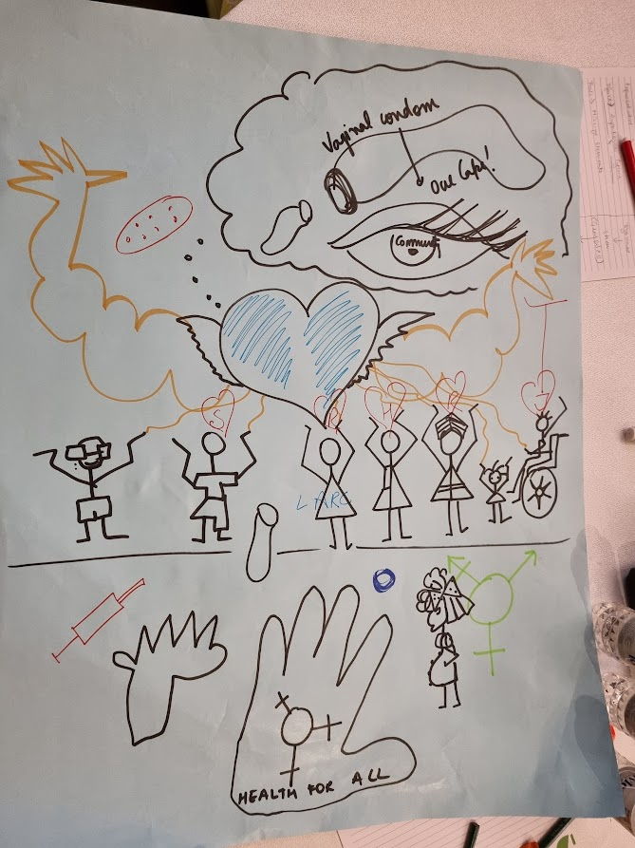
This superhero symbolises the importance of partnerships and the veins/electricity bolts represent that there is a power and energy in partnerships. It also represents the global strategy of IPPF – a globally connected Federation with country owners. It also represents grassroots action and visibility.

Superhero 2
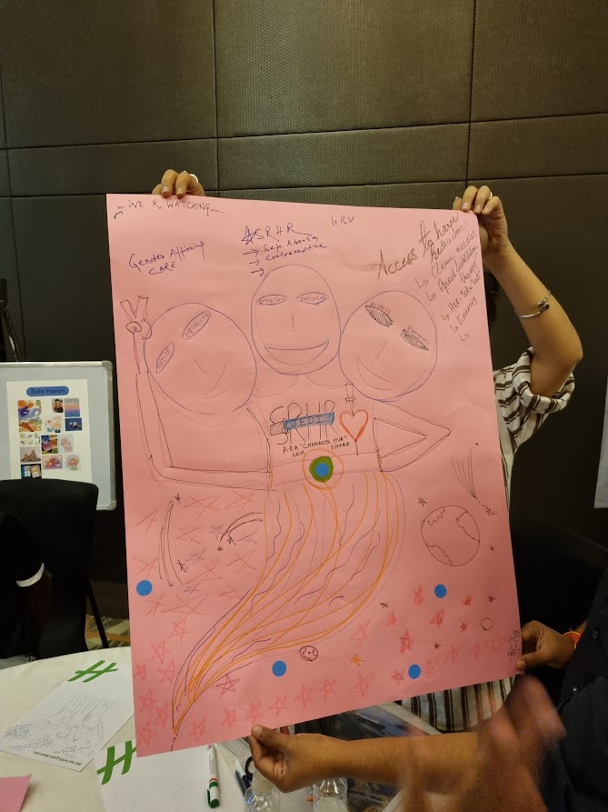
This superhero represents the force of multiple people. The heart is visible in one of the people, which reflects all the elements. The many eyes represent different ways of seeing and understanding different communities. It represents a group of power workers who ensure access to clean needles and harm reduction. It reflects interconnection between all the SRHR issues – you can’t discuss any issue in isolation; they’re all connected. Gender based violence is also reflected here.

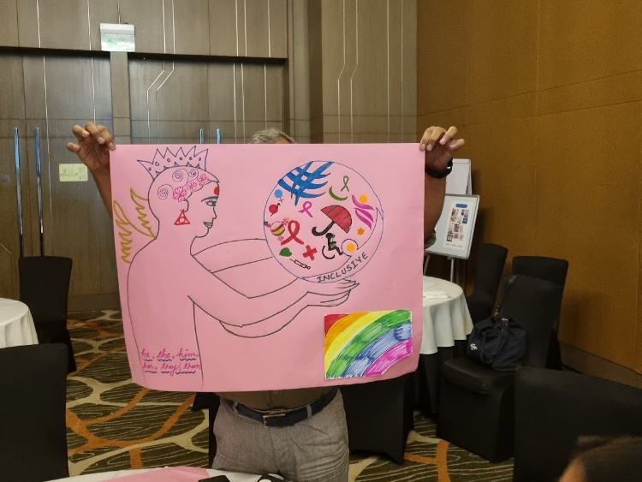
Superhero 3
This isn’t one single person, it is a move away from able bodied super heroes. It represents different diversities. It has large, strong hands, a large heart which believes in SRHRJ, and wings. Its large eyes are focused on communities - not looking everywhere. Mental health issues, people with different gender expressions and different backgrounds are reflected, as are a range of services. This hero is focused; although IPPF needs to be a feminist organisation, and intersectional, it must also accept that it needs to focus its work. At times IPPF will leave out some people because it isn’t possible to work everywhere. It also represents that it’s okay to not be strong all the time and it’s okay to lose focus and then come back. Heart is representing the health and human beings; the heart is genderless.

Following this superhero exercise, participants shared some of their questions and concerns for IPPF. These included:

- A desire for more clarity on who IPPF is now and what its priorities are.
- How inclusive IPPF is of trans and queer identities; one participant challenged that “Inclusivity is the most abusive word. You talk about it, but you don’t walk the talk. Where are the inclusivity policies? How far will IPPF go to walk the talk?”
- The need to ensure radical solidarity at the MA level.
- The need to ensure accountability for the commitments made in the Charter or updated Strategy 2028.
- Whether there was the space to rethink the name of the organisation; participants felt that the use of the term “family” in “family planning” was heteronormative and should be changed.
- The importance of policy advocacy for change at the ground level.
- The need to increase access to SRHR care for those who needed it.
- The perception that Family Planning India is not inclusive of men, and that MAs are not safe spaces for trans women; how can we make MAs a safe space?
- The need to reach communities in the tribal areas.

South Asia Regional Office
The final consultation held was with 15 regional office staff at the South Asia Office. Mostly representing IT and finance, this was an important opportunity to understand how staff feel about the proposed values. As with other sessions, the participants were shown the list of proposed values and asked to react to it, triggering discussion. The outcomes and reflections are below:

Diversity, equality, equity, respect, inclusion
- Overwhelming support for the inclusion of this value.

Bravery/courage
- 9 individuals were supportive, while 7 identified as I’m confused.
- Participants felt that it was good, but questioned whether it was a value.
- One argued that “instead of bravery and courage we need diplomacy.”
- There were also suggestions that “you have to consider geopolitics” and “you can’t be brave everywhere.”
- Some suggested that it was difficult value for MAs, but easier for IPPF to commit to.
- Those in support argued that “Planned parenthood is connected to abortion and often gets a bad reputation, which requires bravery.”

Creativity, innovation, adaptability, flexibility
- Consensus that this should be a value and is key to IPPF’s work.

Accountability
- Strong support for this value, though concern that in making it a value, it may indicate that it is not something that is actually happening at IPPF. It should be seen as given.
- Those in support of this value suggest that is needed because it reinforces what we should practise. The people we are serving needs to know what IPPF stands for, so it matters. We need to tell them we are accountable.
- Although, it’s a given, “you have to remind people of what’s expected of us.”

Partnership, solidarity, community
- Most participants felt this should be included.
- They preferred the term “solidarity”, and not the other two terms as much.
- Solidary was seen as more about standing with subjects, whereas community is the one that reflects this work.
- There is a link between this value and the value on diversity; the partnership that we’re doing is part of our diversity and inclusion. Need to see how we can partner with organisations that don’t share our values.
- Some felt that without this we cannot even do our work need partnership to reach community.
- For this reason, participants felt that this value could be integrated under diversity.

Compassion, empathy, love
- 12 participants suggested this should be included, while 5 identified as I’m confused.
- Some felt that this was not a value but was an expression of emotion; it wasn’t clear why a separate value is needed for this.
- One participant suggested compassion was “a very white word.”
- It was argued that it could be included under inclusion, as that cannot take place without empathy and compassion. Others disagreed and felt that inclusion is different to care: You can include people, but you can still not care for them. Inclusion can also mean you are including people who are not a part of your values.
- Participants equated compassion with feeling sympathy and felt that empathy is a much better term. Others argued that it is needed when we are providing care and services.
- One participant suggested that “should replace the word “love” with “care.” All these words are positive, but until they are all elaborated, we won’t be able to understand that as much.”

Volunteerism
- The response to this value was mixed, with some participants supporting it, other disagreeing and some aligning with I’m confused.
- Some participants felt that it was “it’s a part of the business. Not a value.” Further, they stated that “we have so many volunteers, but it is the way we work and not a value. Anyone can work for IPPF whether or not they like to volunteer. How is it a value?”
- Others suggested that it cannot be applied to staff members, so there is an inherent contradiction in having it as a value.
- Others felt that volunteerism is unpaid labour and exploitation.
- Some supported the value of volunteerism because our programmes have many volunteers, and without them we will not be in the place we are right now.

Passion/Determination
- This value had a mixed response with a large number of respondents in the Meh category.
- One participant argued that “everything we do includes passion so why is it a value? I think of passion under love and compassion. Determination was covered by accountability and courage.”
- Others felt that it is necessary because it is what drives us, and “if we don't have this we can’t practise the rest of the values. This is the most important value.”

