IPPF Template – Website Management Guide
Developed by Qrolic Technologies
📧 info@qrolic.com
🌐 www.qrolic.com
Website Details:
- Website Admin: https://your-site-name/wp-admin/
- Platform: WordPress

Table of Contents
- Introduction
- Logging In
- Understanding Website Content
- Managing Pages
- Managing Services
- Managing Testimonials
- Managing Blogs
- Managing Careers
- Managing Updates & Announcements
- Managing Resources
- Managing Our Achievements
- Editing with Gutenberg Blocks and Patterns
- Managing Menus
- Editing Header and Footer
- Managing Media (Images, Videos, Files)
- Managing Templates
- Managing Contact Form
- Managing Donate Form
- Managing Events
- Clinic Map Section
- Need Help?

1. Introduction
Welcome to the IPPF Website Management Guide.
The IPPF website is developed using a custom WordPress Block Theme, which allows you to manage all website content easily through the WordPress Block Editor (Gutenberg).
All pages, sections, and layouts are built using reusable blocks, making content updates simple, flexible, and consistent across the website.
This guide is designed to help you confidently manage and update the website, including:
- Updating website content (text, images, buttons, sections)
- Adding or editing services & events
- Managing testimonials
- Updating images or text blocks
- Adding and managing careers
- Adding blogs, resources, announcements etc.

2. Logging In
- Open your browser and go to:
https://your-site-name/wp-admin/
Enter the username and password shared with you by the Qrolic team.
If you have not received credentials or forgot them, please contact us at info@qrolic.com.
- Once logged in, you will be on the WordPress Dashboard — this is your main control panel.

3. Understanding Website Content
The IPPF website is structured using different content types to keep information organized and easy to manage. Each content type serves a specific purpose and can be managed directly from the WordPress Dashboard.
- Pages: Used for core website sections such as Home, About Us, Contact Us, and other static pages.
- Services (Custom Post Type): Used to create, edit, and manage the services offered by IPPF. Each service has its own dedicated page.
- Testimonials (Custom Post Type): Used to add and update testimonials, including feedback from clients, partners, or team members.
- Blog (Custom Post Type): Used to publish articles, news, and informational content related to IPPF.
- Careers (Custom Post Type): Used to add and manage job openings and career opportunities.
- Updates & Announcements (Custom Post Type): Used to publish press releases, official updates, and important announcements.
- Resources (Custom Post Type): Used to upload and manage downloadable resources such as PDFs, guides, reports, or learning materials.
- Our Achievements (Custom Post Type): Used to add and update achievement that display in Celebrating Our Achievements section in home page

Where to Manage Content
All of the above content types can be accessed and managed from the left-hand menu in the WordPress Dashboard. From there, you can:
- Add new content
- Edit existing content
- Update text, images, and other blocks
- Publish or unpublish items as needed
You can manage all of these from the left-hand menu in the WordPress Dashboard.

4. Managing Pages
You can edit all main website pages directly from the WordPress Dashboard using the Block Editor.

Steps to Edit a Page
- From the left-hand menu, go to Pages → All Pages.
- Locate the page you want to edit (for example: Home, About, Contact).
- Click Edit below the page name.
- The page will open in the Gutenberg (Block) Editor.
- Click on any text, image, button, or section you want to update.
- Make the required changes.
- Click the Save button in the top-right corner to apply your changes.

5. Managing Services
Services on the IPPF website are managed using a Custom Post Type called Services. You can edit existing services or create new ones using the WordPress Block Editor.

Edit an Existing Service
- From the left-hand menu, go to Services → All Services.
- Hover over the service you want to update and click Edit.
- The service content will open in the Gutenberg Editor.
- You can update:
  - Text content
  - Images
  - Buttons
  - Layout blocks or patterns
- After making the required changes, click the Save / Update button in the top-right corner.

Create a New Service
- From the WordPress Dashboard, go to Services → Add New.
- Enter the Service Title at the top.
- To add content:
  - Click the “+” (Plus) icon on the left side of the editor.
  - Select Patterns.
  - Choose the appropriate Service Pattern from the list.
- The selected pattern will automatically add the predefined layout and structure for the service page.
- Update the text, images, and other content inside the pattern as required.
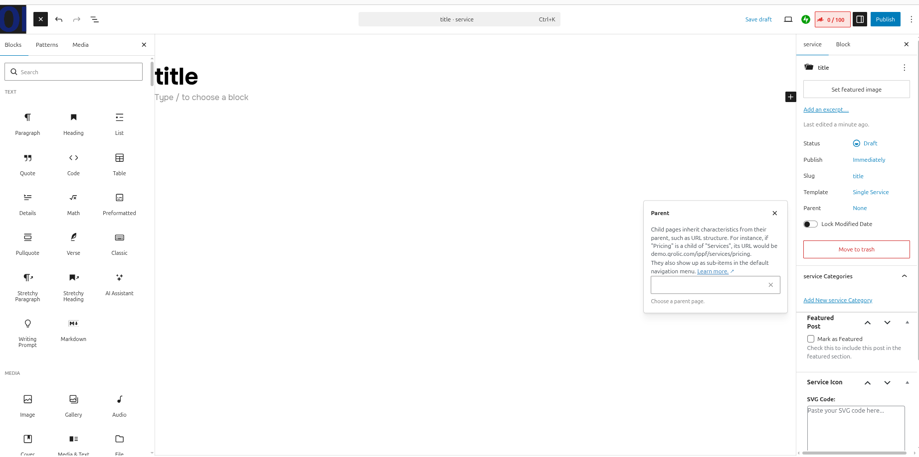

Assign a Parent Service
- On the right-hand settings panel, locate the Parent option.
- Select a Parent Service if this service is a sub-service.

All Services List:
https://your-site-name/services
Single Service Page:
https://your-site-name/services/single-service-name

6. Managing Testimonials
Testimonials on the IPPF website are managed using a Custom Post Type called Testimonials. These testimonials are displayed on the frontend in the testimonial sections across the website.

Add a New Testimonial
- From the left-hand menu, go to Testimonials → Add New Testimonials.
- Enter the Testimonial Title (usually the name of the person or organization).
- On the right-hand side, add a Featured Image (this is typically the person’s photo or company logo).
- Scroll down to the Excerpt section and enter the testimonial content.
- Below the editor, you will find Additional Details fields, such as:
  - Company Name
  - Rating
- These details are automatically displayed in the Testimonial section on the frontend.
- Click the Publish / Save button in the top-right corner to make the testimonial live.
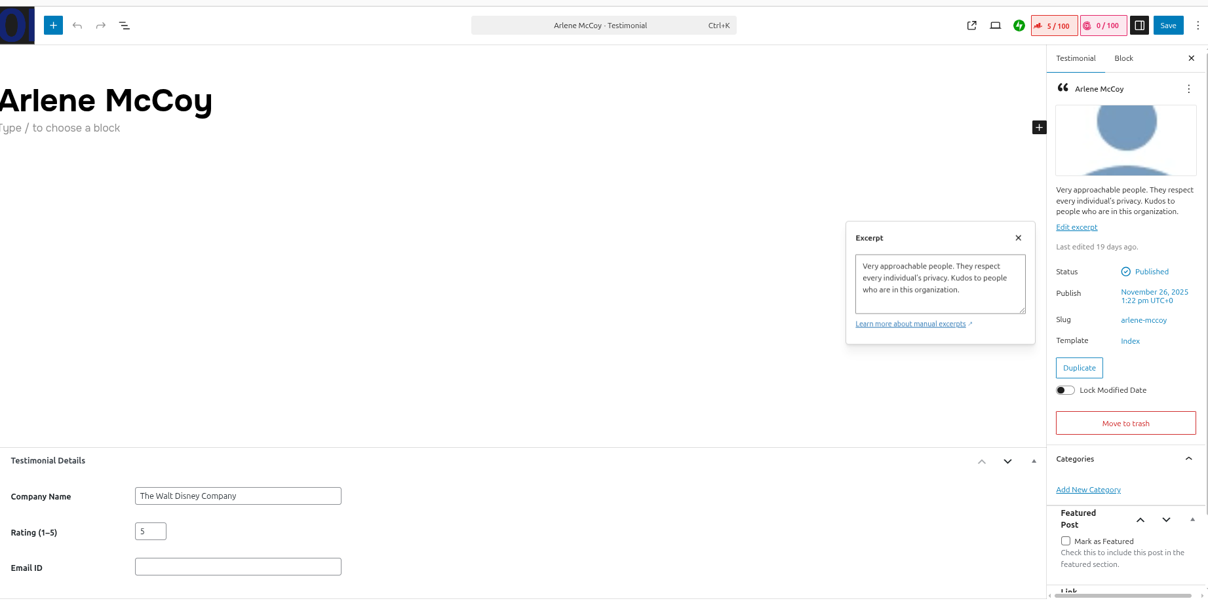

Edit an Existing Testimonial
- Go to Testimonials → All Testimonials.
- Click Edit under the testimonial you want to update.
- Update the title, excerpt content, featured image, or additional details.
- Click Update to save your changes.

7. Managing Blogs
Blogs on the IPPF website are managed using a Custom Post Type called Blog. You can create and update blog posts using the WordPress Block Editor.

Add a New Blog Post
- From the left-hand menu, go to Blog → Add New.
- Enter the Blog Title at the top.
- Add blog content by clicking the “+” (Plus) icon on the left side:
  - Paragraphs
  - Headings
  - Lists
  - Images and other blocks
- On the right-hand settings panel:
  - Add a Featured Image (this image appears on the blog listing and blog detail page).
  - Add a Short Description in the Excerpt field.
- Scroll down and select the appropriate Blog Category.
- Scroll down below the editor to find the Downloadable PDF option.
- Upload or select a PDF file from the Media Library.
This PDF will be available for users to download on the frontend.
- Click Publish / Save in the top-right corner to make the blog live.

Edit an Existing Blog Post
- Go to Blog → All Posts.
- Click Edit under the blog you want to update.
- Make the required content or image changes.
- Click Update to save your changes.
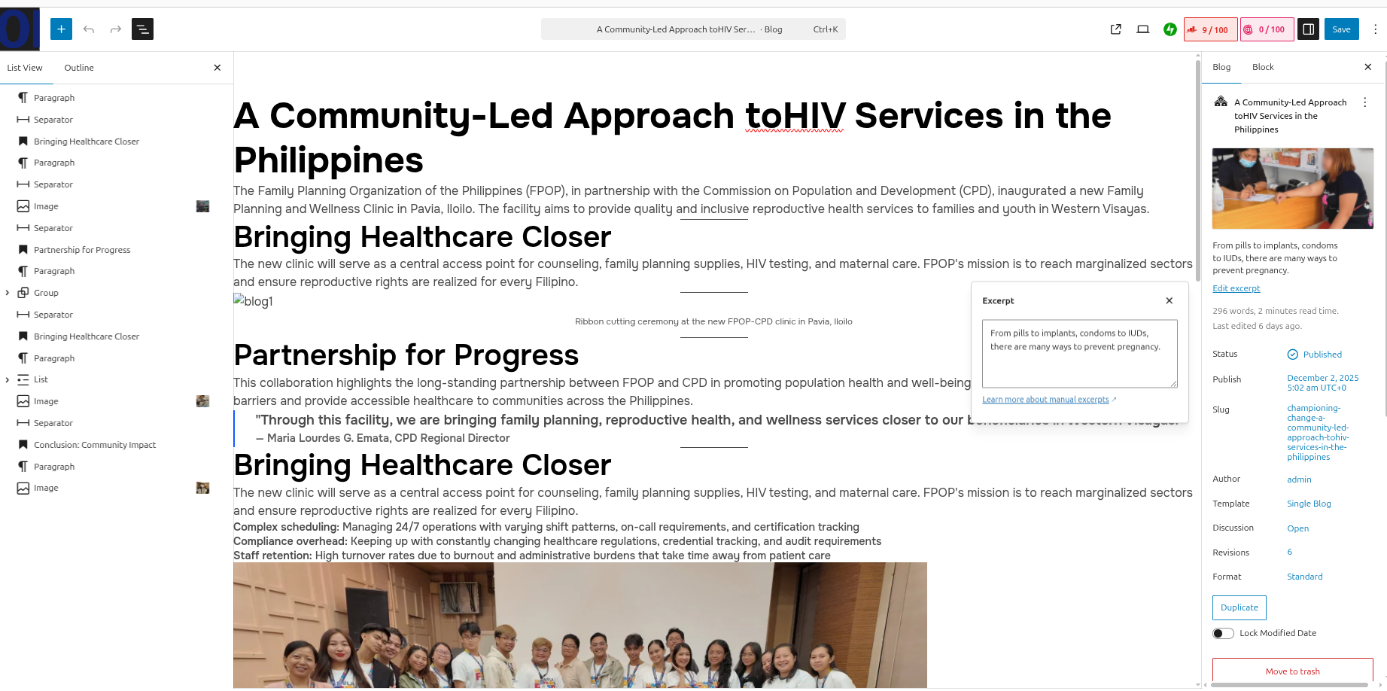
Blog Listing Page:
https://your-site-name/blog
Single Blog Post:
https://your-site-name/blog/blog-post-name

8. Managing Careers
Career listings on the IPPF website are managed using a Custom Post Type called Careers. You can add and manage job openings directly from the WordPress Dashboard.

Add a New Career
- From the left-hand menu, go to Careers → Add New.
- Enter the Career Title (job position name).
- Add career details by clicking the “+” (Plus) icon on the left side:
  - Paragraphs
  - Lists (job responsibilities, requirements, etc.)
  - Images or other blocks (if required)
- On the right-hand settings panel:
  - Add a Short Description in the Excerpt field.
  - Choose or add a Career Category.
  - Enter the Career Location.
  - Select the Job Type (e.g., Full-time, Part-time).
- Click Publish / Save in the top-right corner to make the career live.

Edit an Existing Career
- Go to Careers → All Careers.
- Click Edit under the career you want to update.
- Update content, category, location, or job type as needed.
- Click Update to save changes.
Careers Listing Page:
https://your-site-name/careers
Single Career Page:
https://your-site-name/careers/single-career-name

9. Managing Updates & Announcements
Updates & Announcements on the IPPF website are managed using a Custom Post Type called Updates & Announcements. This section is used for publishing press releases, official updates, and important announcements.

Add a New Update or Announcement
- From the left-hand menu, go to Updates & Announcements → Add New.
- Enter the Title of the update or announcement.
- On the right-hand settings panel:
  - Add a Featured Image.
  - Enter a Short Description in the Excerpt field.
  - Choose or add the appropriate Category.
- Add the main content using the “+” (Plus) icon on the left side:
  - Paragraphs
  - Headings
  - Lists
  - Images
  - Gallery blocks (if multiple images are needed)
- Review the content and layout.
- Click Publish / Save in the top-right corner to make it live.

Edit an Existing Update or Announcement
- Go to Updates & Announcements → All Posts.
- Click Edit under the post you want to update.
- Modify the title, content, images, excerpt, or category as needed.
- Click Update to save changes.
Updates & Announcements List page:
https://your-site-name/updates-announcements
Single Updates & Announcement:
https://your-site-name/updates-announcements/single-post-name

10. Managing Resources
Resources on the IPPF website are managed using a Custom Post Type called Resources. This section is used to publish downloadable materials such as PDFs, guides, reports, and reference documents.

Add a New Resource
- From the left-hand menu, go to Resources → Add New.
- Enter the Resource Title.
- On the right-hand settings panel:
  - Add a Featured Image.
  - Enter a Short Description in the Excerpt field.
- Scroll down and choose the appropriate Resource Category.
- In the editor area, locate the Upload PDF option.
- Upload or select a PDF file from the Media Library.
  - This file will be available for download on the frontend.
- Review all details and content.
- Click Save in the top-right corner to make the resource live.

Edit an Existing Resource
- Go to Resources → All Resources.
- Click Edit under the resource you want to update.
- Update the title, image, excerpt, category, or attached PDF.
- Click Update to save your changes.
Resource Listing Page:
https://your-site-name/resources

11. Managing Our Achievements
The Our Achievements section is managed using a Custom Post Type called Our Achievements. These posts are displayed in the “Celebrating Our Achievements” slider on the Home page.

Add a New Achievement
- From the left-hand menu, go to Our Achievements → Add New.
- Enter the Achievement Title.
- On the right-hand settings panel:
  - Add a Featured Image.
  - Enter a Short Description in the Excerpt field.
  - Choose or add the appropriate Category.
- Scroll down below the editor.
- Enter the Achievement Subtitle in the provided field.
- Click Publish / Save in the top-right corner to make the achievement live.

Edit an Existing Achievement
- Go to Our Achievements → All Achievements.
- Click Edit under the achievement you want to update.
- Update the title, image, excerpt, category, or subtitle as needed.
- Click Update to save changes.

12. Editing with Gutenberg Blocks and Patterns
Your website uses custom Gutenberg blocks and patterns created by Qrolic Technologies.

Custom Blocks
- Career List – Displays all careers on the Career page.
- Featured Blog – Displays featured blog on the blog page.
- Our Gallery – Displays images on the gallery page.
- Our Leadership - Displays leaders on our leadership page.

Patterns
Patterns are pre-designed sections such as:
- Home Hero Section
- Common Hero
The IPPF website uses predefined block patterns to maintain a consistent layout and design across all pages and posts. You can easily add these patterns from the Block Editor.

Steps to Add an Existing Pattern
- Open any page, post, or custom post type in the Block Editor.
- Click the “+” (Plus) icon on the left side of the editor.
- Go to the Patterns tab.
- Navigate to the IPPF Patterns section.
- You will see a list of patterns used across the website.
- Click on the required pattern to insert it into the editor.
- Once added, you can edit the text, images, and content inside the pattern as needed.

Search for a Pattern
- You can also search by pattern name using the search bar inside the Patterns panel.
- This is useful when you know the exact pattern name and want to add it quickly.

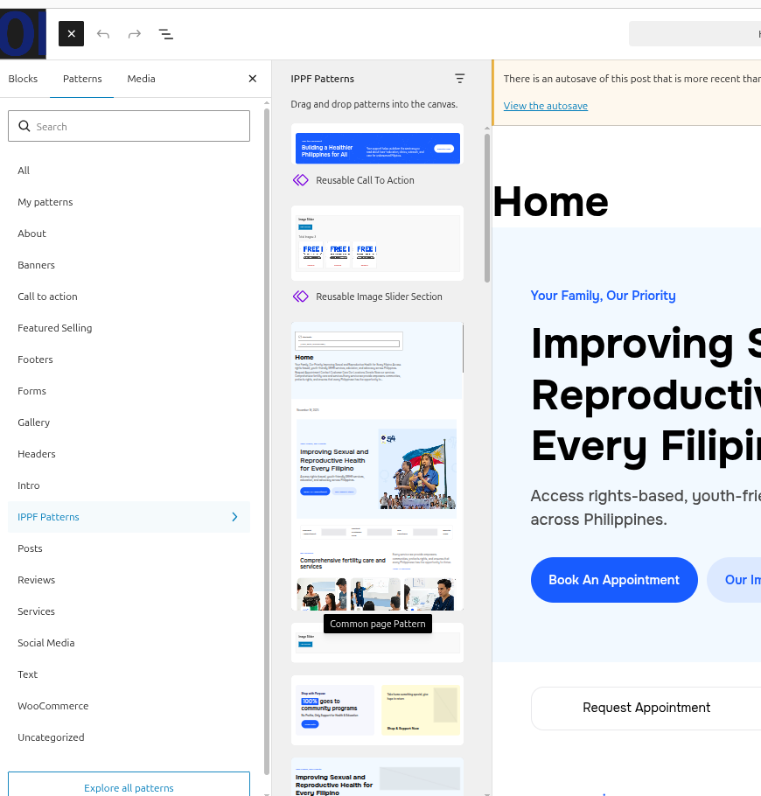

13. Managing Menus
Menus control the navigation links displayed in the website header, footer, and top bar. You can edit, add, or reorder menu items directly from the WordPress Dashboard.

Access Menus
- Log in to the WordPress Dashboard.
- Go to Appearance → Menus.
- You will find the following menus:
  - Header Menu
  - Discover Menu (Footer)
  - Our Work Menu (Footer)
  - Stay Informed Menu (Footer)
  - Top Bar Menu (Header)

Edit a Menu
- Select the menu you want to edit.
- Update the menu item name (label) or link (URL).
- Add new menu items or reorder existing items using drag and drop.
- Click Save Menu.

Apply Updated Menu to Header
After updating a header menu, reassign it to the header pattern:
- Go to Appearance → Patterns.
- Navigate to General → Header.
- Click the Navigation block on the left side.
- In the right-hand settings panel, reselect the updated menu.
- Save the changes.

Apply Updated Menu to Footer
After updating a footer menu, reassign it to the footer pattern:
- Go to Appearance → Patterns.
- Navigate to General → Footer.
- Select the Navigation block from the left-side structure panel.
- In the right-hand settings panel, reselect the required footer menu.
- Save the changes.

14. Editing Header and Footer
To edit the header or footer:
- Go to Appearance → Editor → Patterns → General
- Open Header or Footer.
- Edit logo, buttons, links, or social icons.
- Click Save to apply changes.

15. Managing Media
To manage images, videos, and documents:
- Go to Media → Library
- Here you’ll find all uploaded media.
- Click Add New to upload new files.
- Use uploaded files anywhere in pages or blocks.

16. Managing Templates
Templates control how different types of pages look (e.g., Services Single, etc.)
To manage them:
- Go to Appearance → Editor → Templates
- Click on any template to edit layout or design.
- Click Save when done.

17. Managing Contact Form
Your website uses Contact Form 7 for the contact page form.
To manage:
- Go to Contact → Contact Forms
- Click the form named Contact Form to edit fields or email settings.
- To add a new form, click Add New.
To add the form to a page: Open the required page → click Add Block (+) → select the Contact Form 7 block and choose the form into the page content.

18. Managing Donate Form Section
The Donate Form on the IPPF website is managed using the GiveWP plugin. This plugin allows you to update campaign details, images, and donation form fields.

Edit the Donate Campaign
- Log in to the WordPress Dashboard.
- From the left-hand menu, go to Donations / GiveWP → Campaigns.
- Locate the campaign:
“Help Us Empower Filipino Youth Reproductive Health Education”
- Click Edit under the campaign name.

Update Campaign Details

Update Campaign Name & Image
- Inside the campaign editor, go to the Settings section.
- Open the Form tab.
- Update:
  - Campaign Name
  - Campaign Image
- Save your changes.

Edit Donate Form Fields
- Edit the donation form fields as needed (amounts, labels, required fields, etc.).
- Click Save / Update to apply changes.

19. Managing Events
Events on the IPPF website are managed using the Eventin plugin. This plugin allows you to create, manage, and display events with details such as tickets, speakers, organizers, and branding.

Add a New Event
- Log in to the WordPress Dashboard.
- From the left-hand menu, go to Eventin → Events → Add New Event.
- Enter the Event Title.
- Add the Event Description in the content editor.
- Fill in all required event information such as date, time, location, and other event details.

Configure Event Details

Event Tickets & Speakers
- Go to the Second Tab (Event Settings / Tickets tab).
- Add Event Tickets as required.
- Select or assign:
  - Speakers
  - Organizers

Branding
- Open the Branding tab.
- Upload the Event Logo.
- Add a Featured Image for the event.

Publish the Event
- Review all event details carefully.
- Click Publish / Save to make the event live on the website.

20. Clinic Map Section
The Clinic Map on the IPPF website is managed using the WP Maps plugin. This allows you to add clinic locations, categorize them, and display them on an interactive map.

Step 1: Create a Clinic Category
- From the left-hand menu, go to WP Maps → Categories
- Click Add New Category.
- Enter the Category Name (e.g., Region or Clinic Type).
- Save the category.

Step 2: Add or Manage Clinic Locations
- Go to WP Maps → Manage Locations.
- Click Add New Location or edit an existing location.
- Fill in the Clinic Details:
  - Clinic Name
  - Address
  - Coordinates (latitude/longitude, if required)
  - Category (select the category you created)
- In the Infowindow Message field, add a list of contact details:
  - Phone number
  - Email
  - Website (if applicable)
- Save the location.

Step 3: Assign Locations to the Map
- Go to WP Maps → Manage Maps.
- Select the map you want to display on the frontend.
- Assign the clinic locations to the map by selecting from the list of available locations.
- Save the map.

21. Need Help?
If you ever face issues or need assistance, our team is here to help.
- info@qrolic.com
- https://qrolic.com
We’ll be happy to guide you through any updates or fixes.

